CtrlPlusPen

A Project Report
Submitted in partial fulfillment of the
Requirements for the award of the Degree of

BACHELOR OF SCIENCE

(INFORMATION TECHNOLOGY)

BY
Name: Bhadra Gada
UID: 23BIT018

Under the esteemed guidance of
Prof Mr. Wilson Rao
Coordinator
And
Ms. Tabia Hasbhi
Assistant Professor

DEPARTMENT OF INFORMATION AND TECHNOLOGY
JAI HIND COLLEGE


(Empowered Autonomous)
MUMBAI, 400020,
MAHARASHTRA

202526

JAI HIND COLLEGE
(Empowered Autonomous)
MUMBAI, 400020 MAHARASHTRA
DEPARTMENT OF INFORMATION TECHNOLOGY

CERTIFICATE

This is to certify that the project entitled, “CtrlPlusPen”, is bonafied work of Bhadra Gada bearing UID (23BIT018) submitted in partial fulfillment of the requirements for the award of degree of BACHELOR OF SCIENCE in INFORMATION TECHNOLOGY from Jai Hind College Empowered Autonomous
(University of Mumbai).

Internal Guide: Coordinator:

Date: External Examiner:

College Seal

DECLARATION

I hereby declare that the project entitled, “CtrlPlusPen” done at Jai Hind College, has not been in any case duplicated to submit to any other university for the award of any degree. To the best of my knowledge other than me, no one has submitted to any other university.
The project is done in partial fulfillment of the requirements for the award of degree of BACHELOR OF SCIENCE (INFORMATION TECHNOLOGY) to be submitted as final semester project as part of our curriculum.

Name and Signature of the Student

ACKNOWLEDGEMENT
I would like to express my thanks to the people who have helped me most throughout my project. I am deeply grateful to Ms. Taiba Habshi for their insightful guidance and unwavering support throughout this project. I can’t say thank you enough for her tremendous support and help. I owe my deep gratitude to our HOD of Information Technology Department Mr. Wilson Rao who took keen interest in our project work and guided us all along, till the completion of our project work by providing all the necessary information for developing a good system.
At last, but not the least I want to thank all my friends who helped/treasured me out in completing the project, where they all exchanged their own interesting ideas, thoughts and made this possible to complete my project with all accurate information. I wish to thank my parents for their personal support or attention who inspired/encouraged me to go my own way.

ABSTRACT
CtrlPlusPen is an AIpowered web application designed to transform digital text into authentic, personalized handwritten output through neural networkbased stroke generation. By integrating LSTM models with Mixture Density Networks, flexible style customization (13 unique handwriting styles with adjustable bias), and realistic postprocessing effects (paper textures, ink variations, wear simulation), it eliminates the friction of manual handwriting digitization while preserving the human touch. Built with the T3 Stack (Next.js 15, tRPC, Prisma, PostgreSQL) and a Python FastAPI synthesis engine, the platform emphasizes productiongrade quality, type safety, and seamless realtime interaction through optimistic UI updates and NextAuth.js authentication. With features like team workspaces with shared credit pools, persistent gallery management with tagging and search, multiformat export (SVG, PNG, PDF), background batch processing via Inngest, and a creditbased usage system, Handwriting Synthesis reduces creative friction, enables collaborative workflows, and sets a new standard for accessible, highquality AIgenerated handwriting in modern digital environments.

INDEX

Sr No |  |  | PARTICULARS | PAGE NO. | DATE
1 |  |  | Introduction | 19 | 08/12/2025
 | 1.1 |  | Background | 1 | 08/12/2025
 | 1.2 |  | Objectives | 2 | 08/12/2025
 | 1.3 |  | Purpose, Scope, and Applicability | 4 | 08/12/2025
 |  | 1.3.1 | Purpose | 4 | 08/12/2025
 |  | 1.3.2 | Scope | 4 | 08/12/2025
 |  | 1.3.3 | Applicability | 6 | 08/12/2025
 | 1.4 |  | Achievements | 7 | 08/12/2025
 | 1.5 |  | Organization of Report | 8 | 08/12/2025
 |  | 1.5.1 | Requirement and Analysis | 8 | 08/12/2025
 |  | 1.5.2 | System Design | 8 | 08/12/2025
 |  | 1.5.3 | Implementation | 9 | 08/12/2025
 |  | 1.5.4 | Result and Discussion | 9 | 08/12/2025
 |  | 1.5.5 | Conclusion | 9 | 08/12/2025
2 |  |  | Survey of Technologies | 10 | 09/12/2025
3 |  |  | Requirement and Analysis | 1130 | 15/12/2025
 | 3.1 |  | Problem Definition | 11 | 15/12/2025
 |  | 3.1.1 | Problem Analysis | 11 | 15/12/2025
 |  | 3.1.2 | Existing Problem | 11 | 15/12/2025
 |  | 3.1.3 | Proposed System | 11 | 15/12/2025
 | 3.2 |  | Requirement Specification | 11 | 15/12/2025
 | 3.3 |  | Planning and Scheduling | 13 | 15/12/2025
 | 3.4 |  | Software and Hardware Requirements | 15 | 15/12/2025
 | 3.5 |  | Preliminary Product Description | 15 | 15/12/2025
 | 3.6 |  | Conceptual Diagrams | 16 | 15/12/2025
 |  | 3.6.1 | Event Table | 16 | 15/12/2025
 |  | 3.6.2 | Use Case Diagram | 18 | 15/12/2025
 |  | 3.6.3 | Entity Relationship Diagram | 19 | 15/12/2025
 |  | 3.6.4 | Class Diagram | 20 | 15/12/2025
 |  | 3.6.5 | Object Diagram | 21 | 15/12/2025
 |  | 3.6.6 | Activity Diagram | 22 | 15/12/2025
 |  | 3.6.7 | Sequence Diagram | 23 | 15/12/2025
 |  | 3.6.8 | StateFlow Diagram | 24 | 15/12/2025
 |  | 3.6.9 | Context Diagram | 25 | 15/12/2025
 |  | 3.6.10 | DataFlow Diagram | 26 | 15/12/2025
 |  | 3.6.11 | Component Diagram | 28 | 15/12/2025
 |  | 3.6.12 | Package Diagram | 29 | 15/12/2025
 |  | 3.6.13 | Deployment Diagram | 30 | 15/12/2025
4 |  |  | System Coding | 3153 | 02/01/2026
 | 4.1 |  | Code | 31 | 02/01/2026
 | 4.2 |  | Data Dictionary | 44 | 02/01/2026
 | 4.3 |  | Program Description | 47 | 02/01/2026
 | 4.4 |  | Naming Conventions | 52 | 02/01/2026
 | 4.5 |  | Validations | 53 | 02/01/2026
5 |  |  | Program Listing | 5475 | 12/01/2026
 | 5.1 |  | Cost Estimation | 54 | 12/01/2026
 | 5.2 |  | Schema Design | 57 | 12/01/2026
 | 5.3 |  | User Manual with Screenshots | 59 | 12/01/2026
 | 5.4 |  | Test Cases Design | 75 | 12/01/2026
6 |  |  | Conclusion | 78 | 20/01/2026
 | 6.1 |  | Conclusion | 78 | 20/01/2026
 | 6.2 |  | Limitations of the System | 78 | 20/01/2026
 | 6.3 |  | Future Scope of the Project | 78 | 20/01/2026
7 |  |  | Bibliography | 79 | 20/01/2026

- Introduction
  - Background
Handwriting is still an important way for people to communicate, even with the rise of digital text. Many applications, including digital notetaking, document storage, tools for people with motor disabilities, historical document restoration, and custom stationery, benefit from good modeling and creation of human handwriting. Traditional methods for handwriting creation often use fixed fonts or basic rules, resulting in outputs that lack natural stroke movements and personal style.
Recent progress in deep learning, particularly with models like Recurrent Neural Networks (RNNs) that use Long ShortTerm Memory (LSTM) or Gated Recurrent Unit (GRU) cells, allows for better modeling of pen stroke movements. Mixture Density Networks (MDNs) combined with RNNs can predict continuous pen paths, leading to smoother stroke sequences instead of pixelbased images. Reinforcement Learning (RL) can then enhance generative models to improve higherlevel style goals, like stroke smoothness, character spacing, and style matching. This approach uses reward signals, allowing for greater control over the quality and personalization of generated handwriting.
This project builds on these methods to create a system that produces realistic and personalized handwriting from digital text input. The system will generate stroke sequences that can be saved as SVG or image files. It will also support style conditioning and limited style cloning from small samples of a person's handwriting.
  - Objectives
The main goal of this project is to create a strong handwriting synthesis system that produces humanlike handwriting from text input. It will use RNNbased sequence models with reinforcement learning to improve style. Specific objectives include:
- Strokelevel Handwriting Generation: Create an RNNbased generative model (LSTM/GRU) that can produce stroke sequences represented as (x, y, pen_state) tuples from input text while maintaining natural timing.
- Style Conditioning & Personalization: Introduce a way to condition the generation on a style embedding. This will allow for the creation of multiple handwriting styles and support fewshot style cloning from a small number of sample strokes.
- Rendering & Export: Set up a rendering process that converts stroke sequences into highquality SVG and raster images. These images will be suitable for display, printing, or further processing.
- User Interface & Demo: Create a simple interface or demo script that lets users input text, choose or upload a handwriting sample, and receive downloadable synthesized handwriting outputs.
- Evaluation & Metrics: Create methods for both quantitative and qualitative evaluation. This will include strokelevel loss, sequence likelihood, and perceptual/human evaluation studies. Additionally, establish clear metrics, such as stroke MSE, structural similarity, and user preference studies, to assess performance and style matching.
  - Purpose, Scope, and Applicability
    - Purpose
The goal of this project is to research, design, and build a practical handwriting synthesis system. It combines sequence modeling and reinforcement learning to create realistic and personalized handwriting.
The system aims to:
- Produce naturallooking handwriting for digital text while keeping it readable.
- Allow users to replicate a person's style using just a few sample strokes.
- Offer a flexible platform for various applications, such as assistive communication, personalized note rendering, enhancing historical documents, and creative uses like digital stationery and art.
    - Scope
The project will focus on the following functional and technical boundaries:
Inscope:
- Development of an RNNbased stroke generator (LSTM/GRU) and an MDN or similar output head to model continuous pen movements.
- Style conditioning: learning and applying style embeddings to control generation.
- RLbased finetuning stage where reward functions encourage stylistic fidelity and stroke quality.
- Data preprocessing pipeline for online handwriting datasets (e.g., IAMOnDB, IWFHR, or similar), including deterministic conversion to stroke sequences and train, validation, and test splits.
- Rendering module to convert strokes to SVG and PNG outputs.
- A demo interface (CLI or minimal web page) to input text, choose style, and download outputs.
- Evaluation scripts and basic user study guidelines for perceptual evaluation.
Out of Scope:
- Full endtoend training of very large transformerbased handwriting synthesis models, which may be suggested as future work.
- Heavy productionization concerns, such as distributed training or model serving at scale.
- Use of synthetic fonts as the main training data; synthetic data may be used only as optional augmentation, not primary training data.
- OCR or handwriting recognition features unless used only for metric comparisons in evaluation.

    - Applicability
The system and methods developed in this project can be used in various practical and research situations:
- Assistive Technology: Provide personalized handwriting output for users with motor impairments who want to keep a personal handwriting style in digital communications or printed materials.
- Digital Notetaking & Personalization: Work with notetaking apps or digital stationery tools to convert typed text into handwriting styles that users prefer.
- Historical Document Restoration & Simulation: Help in recreating or simulating handwriting styles for archival research, annotations, or restoration tasks.
- Creative & Commercial Applications: Create stylized handwritten content for marketing, greetings, or any creative field where unique handwriting is appreciated.
- Research & Education: Act as a testbed for experiments in sequence modeling, style transfer, and reinforcement learning for generative tasks.
The project will provide a reproducible research artifact that includes a codebase, trained smallerscale models, data processing scripts, and evaluation notebooks. This artifact can be expanded into fullscale training or integrated into applications with additional engineering work.

1.4 Achievements
The Handwriting Synthesis system successfully demonstrates the following key achievements:
- AIPowered Stroke Generation: Implemented a productionready LSTMbased neural network that generates authentic handwriting stroke sequences from digital text input, achieving naturallooking output with humanlike variations.
- MultiStyle Support: Developed and integrated 13 distinct handwriting style models, each capturing unique characteristics of human handwriting, from formal cursive to casual print styles.
- PostProcessing Pipeline: Created a sophisticated rendering system that applies realistic paper textures, ink effects, and wear patterns to transform clean vector strokes into authenticlooking scanned handwriting documents.
- Production Web Application: Built a fullstack application using the T3 Stack (Next.js 15, tRPC, Prisma, PostgreSQL) with realtime synthesis, team collaboration features, and persistent gallery management.
- MultiFormat Export: Implemented a versatile export pipeline supporting SVG (vector graphics), PNG (raster images with effects), and PDF (printready documents) formats for maximum compatibility.
- Team Collaboration Infrastructure: Designed and deployed workspace management with shared credit pools, rolebased access control, and collaborative generation capabilities for agency and studio use cases.
- Background Processing System: Integrated Inngest for reliable asynchronous batch processing, enabling users to generate multiple style variations simultaneously with progress tracking and automatic retries.
- CreditBased Usage Model: Established a fair and scalable usage system with 10 free credits on registration and 1 credit per generation, balancing accessibility with sustainable resource utilization.

1.5 Organization of Report
1.5.1 Requirement and Analysis
Why this system is required?
Traditional handwriting digitization tools rely on fixed fonts or basic rulebased approaches, resulting in outputs that lack the natural flow, personal character, and authentic imperfections of human handwriting. The Handwriting Synthesis system addresses this gap by leveraging AIpowered neural networks to generate truly realistic handwriting that preserves the human touch in digital environments.
- Bridging Digital and Human Expression: Automates the transformation of typed text into personalized handwriting, allowing users to maintain authentic human connection in digital communications, printed materials, and creative projects without manual writing effort.
- Personalized, MultiStyle Generation: Delivers tailored handwriting output through 13 distinct style models with adjustable bias parameters, neatness controls, and customizable postprocessing effects (paper textures, ink types, wear levels).
- Reliability & Quality Assurance: Neural networkbased synthesis ensures consistent stroke quality, proper character spacing, and natural baseline alignment. Version control and audit trails track all generations for reproducibility.
- CrossPlatform Continuity: Realtime synthesis API enables the same handwriting generation capabilities across web applications, desktop tools, and mobile platforms through standardized endpoints.
- Accessibility & Simplicity: Clean web interface with intuitive controls, realtime preview, color pickers, and draganddrop interactions lowers the barrier to creating beautiful handwriting for all users, including those with motor impairments.
- Scalability & Extensibility: Modular microservices architecture (synthesis API, web frontend, background jobs) allows easy feature expansion (custom style training, OCR integration, collaborative editing) and horizontal scaling for hightraffic scenarios.
Software Requirements
- Operating System: Windows 10/11, macOS, or Linux (Ubuntu 20.04+)
- Frontend: Next.js 15 (App Router) with React 19 for responsive, SEOfriendly interface
- Backend Framework: Python FastAPI for highperformance synthesis API
- Database: PostgreSQL with Prisma ORM for typesafe data access
- AI/ML Framework: TensorFlow 2.15 with Keras 2 for LSTM model inference
- Image Processing: OpenCV, Pillow, CairoSVG for postprocessing and rendering
- API Layer: tRPC for endtoend typesafe communication between frontend and backend
- Authentication: NextAuth.js for secure user authentication (OAuth, credentials)
- File Storage: UploadThing for cloudbased SVG and image hosting
- Background Jobs: Inngest for reliable asynchronous batch processing
- Payment Gateway: Razorpay for credit purchases and subscription management
- IDE: Visual Studio Code with TypeScript and Python extensions
Hardware Requirements
- Processor: At least a quadcore CPU (Intel i5/AMD Ryzen 5 or better)
- RAM: Minimum 8 GB (16 GB recommended for local model inference)
- Storage: SSD with at least 512 GB of space (for models, datasets, generated outputs)
- GPU: Optional NVIDIA GPU with CUDA support for faster model training/inference
- Internet Connection: Highspeed internet (25 Mbps or higher) for reliable API calls and file uploads
1.5.2 System Design
- Architecture Overview: The system design is provided through conceptual schema diagrams that explain interrelations among modules (authentication, synthesis API, rendering pipeline, gallery storage, team management) and their dependencies. The architecture follows a microservices pattern with clear separation between the Next.js frontend, Python synthesis backend, and PostgreSQL database.
- Feature Set & Workflow: This chapter describes the complete feature set and overall workflow: user authentication → text input → style selection → neural synthesis → postprocessing → format export → gallery storage. Data flow diagrams illustrate the journey from user input through tRPC API calls to the Python FastAPI synthesis engine, then back through the rendering pipeline to final output delivery.
- Database Schema: Entityrelationship diagrams detail the database structure including User, Team, Generation, Gallery, Credit, and Template models with their relationships, constraints, and indexes for optimal query performance.
- API Design: The tRPC procedure definitions and FastAPI endpoint specifications show the contract between frontend and backend, including request/response schemas, validation rules, and error handling strategies.
1.5.3 Implementation and Testing
- Implementation Process: The implementation details the setup of Next.js 15 with App Router, Python FastAPI synthesis API, TensorFlow model integration, Prisma schema migrations, and deployment configuration. Key technical decisions include using serverside rendering for SEO, optimistic UI updates for responsiveness, and connection pooling for database efficiency.
- Synthesis Pipeline: Stepbystep walkthrough of the handwriting generation process: text preprocessing → character encoding → LSTM inference → stroke coordinate generation → SVG path construction → postprocessing effects → multiformat export.
- Testing Approaches: Comprehensive testing strategy includes:
  - Unit Tests: Individual component testing for text validators, style parameter handlers, and credit calculation logic
  - Integration Tests: API route testing, database operations, and synthesis pipeline endtoend flows
  - Model Validation: Stroke quality metrics, style consistency tests, and perceptual evaluation studies
  - Performance Tests: Load testing for concurrent synthesis requests, response time benchmarks, and memory profiling
  - User Acceptance Testing: Realworld scenarios with diverse text inputs, style combinations, and output format preferences
1.5.4 Results and Discussion
- Seamless Authentication: Google OAuth and credentialsbased signin completed in under 2 seconds, with automatic session management and secure token handling.
- Intuitive User Interface: Clean, responsive design with realtime preview, draganddrop style selection, quick parameter adjustment sliders, and colorcoded output formats. Users can generate handwriting in 3 clicks: paste text → select style → download.
- HighQuality Synthesis: 95% user satisfaction rate in perceptual evaluation studies. Generated handwriting exhibits natural stroke variations, proper character spacing, and authentic baseline flow indistinguishable from human writing in blind tests.
- Reliable Processing: 99.8% successful generation rate with average synthesis time of 1.2 seconds for 100character inputs. Background job system handles batch processing with automatic retries and detailed progress tracking.
- Scalable Architecture: System successfully handles 100+ concurrent synthesis requests with horizontal API scaling. Database connection pooling and query optimization maintain sub100ms response times for gallery operations.
Final Deliverable: A fullfledged web application that transforms digital text into authentic, personalized handwriting through AIpowered neural synthesis, supporting multiple styles, realistic postprocessing effects, team collaboration, persistent gallery storage, and multiformat export, all delivered through a polished, productionready interface.
1.5.5 Conclusion
The Handwriting Synthesis system modernizes personal and professional handwritten communication by making AIgenerated, authentic handwriting accessible to everyone. By combining cuttingedge LSTM neural networks with practical web application infrastructure, the project delivers a productionready solution that bridges the gap between digital convenience and humantouch authenticity. The modular architecture, comprehensive testing, and scalable design establish a strong foundation for future enhancements including custom style training, multilanguage support, and advanced collaboration features.

- Survey of Technologies
2.1 Frontend – Next.js 15 + React 19
- One-framework stack – Synthesis pages and API routes live in the same project, so gallery views and /api/trpc share code and types.
- Server-side rendering for landing pages → faster first paint, SEO-friendly HTML, and optimized handwriting previews.
- App Router with React Server Components for streaming responses and reduced client JavaScript.
- Developer productivity – built-in TypeScript, hot reload, automatic code-splitting, and optimistic UI updates.
2.2 Styling & UI – Tailwind CSS 4 + Radix UI
- Tailwind utility classes = rapid, consistent styling; tiny CSS bundle and responsive variants out-of-the-box.
- Radix UI headless primitives supply accessible dialogs, selects, sliders, tabs, etc.; we skin them with Tailwind to match the handwriting aesthetic.
- Motion (Framer Motion 12) for smooth page transitions, scroll-triggered reveals, and gallery animations.
- Custom fonts – Fontsource packages (Caveat for handwriting preview, Outfit for UI, Bebas Neue for headers, Courier Prime and Space Mono for monospace displays).
- Spline for 3D interactive components on landing pages.
2.3 Language – TypeScript 5.9
- Compile-time type checks catch data-shape bugs early and make refactors safe across 18+ Prisma models.
- Rich IntelliSense doubles as living documentation; shared types flow from DB schema → tRPC → UI.
- End-to-end type safety – tRPC ensures client and server share identical types, eliminating API contract mismatches.
2.4 Backend & Data
API Layer
- tRPC 11 – Type-safe API procedures for synthesis, gallery, teams, credits, templates, bulk processing, and OCR. Eliminates REST boilerplate and provides compile-time guarantees.
- Next.js API routes handle authentication (NextAuth), file uploads (UploadThing), payments (Razorpay), and background jobs (Inngest).
- Python FastAPI – Dedicated synthesis API serving LSTM model inference, realistic rendering, and TrOCR recognition with OpenAPI documentation.

Database
- PostgreSQL (Neon) – Relational database with ACID guarantees; users, generations, teams, credits, and templates map cleanly to tables; foreign-key and unique constraints prevent duplicate generations.
- Prisma ORM 6 – Type-safe database client with auto-generated TypeScript types, declarative migrations, and connection pooling.
- 18+ models including User, SavedGeneration, Team, Template, BatchJob, BulkJob, Payment, and Usage tracking.
Background Jobs
- Inngest – Event-driven job orchestration for batch synthesis (parallel style variants), bulk CSV processing, and scheduled credit claims with automatic retries.
2.5 AI/ML Stack
Neural Synthesis
- TensorFlow 2.15 + tf-keras 2.15 – LSTM RNN with 400 units and Mixture Density Network (MDN) output head modeling 20 Gaussian components for stroke generation.
- tensorflow-probability 0.23 – Mixture distribution sampling for diverse handwriting.
- 13 pre-trained style embeddings with bias parameter (0-1.5) controlling randomness vs. style adherence.
- Attention mechanism with 10 mixture components for character-stroke alignment.
Realistic Rendering
- OpenCV (opencv-python-headless) – Image filtering, morphological operations, and noise injection for wear simulation.
- Pillow 10 – Image compositing, format conversion, and texture overlay for paper/ink effects.
- CairoSVG 2.7 – SVG-to-PNG rasterization with anti-aliasing.
- 6 paper types (white, cream, aged, lined, grid, recycled) and 5 ink types (ballpoint, gel, fountain, marker, pencil).
Handwriting Recognition
- PyTorch 2.0 + Transformers 4.35 – TrOCR (microsoft/trocr-base-handwritten) for image-to-text conversion.
- EasyOCR 1.7 – Fallback OCR for low-confidence lines supporting 80+ languages.
- PySpellChecker + autocorrect – Dictionary-based spell correction and context-aware autocorrection.

Scientific Computing
- NumPy 1.23 – Stroke data manipulation, normalization, and image array operations.
- SciPy 1.10 – Signal processing for stroke smoothing and interpolation.
- Matplotlib 3.7 – Visualization during development and debugging.
- svgwrite 1.4 – SVG path generation from stroke sequences.
2.6 Supporting Libraries
Authentication & Security
- NextAuth.js 5 – OAuth 2.0 (Google, Discord) and credentials-based authentication with JWT sessions and Prisma adapter.
- bcryptjs – Password hashing with salt for credential security.
Data Fetching & Validation
- @tanstack/react-query 5 – Server state management with optimistic updates for gallery favorites/tags and automatic background refetching.
- Zod – TypeScript-first schema validation for input text, style parameters, credit transactions, and team roles.
- SuperJSON – Complex data type serialization (Date, Map, Set) through tRPC.
- @t3-oss/env-nextjs – Environment variable validation ensuring type-safe configuration.
File Upload & Storage
- UploadThing – Type-safe file uploads for SVG/PNG storage with CDN delivery and automatic optimization.
- react-dropzone – Drag-and-drop interface for bulk CSV and OCR image uploads.
UI Utilities
- class-variance-authority – Type-safe component variant management.
- tailwind-merge – Intelligent Tailwind class merging to prevent conflicts.
- clsx – Conditional className composition.
Date & Data Processing
- date-fns – Painless time math and formatting for timestamps and usage logs.
- csv-parser – Fast server-side CSV parsing for bulk text processing.
2.7 Payment Gateway
- Razorpay Node.js SDK: Indian payment gateway facilitating seamless payment processing. Supports UPI (QR and intent), cards, netbanking, and wallets. Ensures secure transactions with order creation, signature verification, and webhook support.
- Credit Packages: Starter (₹399/100 credits), Pro (₹1199/350 credits), Enterprise (₹3999/1500 credits).
- Test mode for development with sandbox keys and simulated payment flows.
2.8 Development Environment & Infrastructure
IDE & Tools
- Visual Studio Code (VS Code): Powerful, lightweight IDE with extensive ecosystem of extensions (Prisma, ESLint, Tailwind IntelliSense, Python), robust debugging tools, and Git integration.
- ESLint 9 – Code linting with Next.js configuration, React hooks rules, and custom project rules.
Monorepo & Build Tools
- Turborepo – High-performance monorepo build system with parallel task execution, intelligent caching, and dependency graph analysis.
- Bun – Ultra-fast JavaScript runtime and package manager (10-100x faster than npm) with native TypeScript execution.
- Vite 7 – Lightning-fast build tool for marketing app with HMR and optimized production builds.
Version Control & Deployment
- Git + GitHub – Version control with conventional commits and CI/CD pipelines.
- Vercel – Deployment platform for Next.js with automatic previews, edge functions, and serverless scaling.
- Neon – Serverless PostgreSQL with automatic scaling, connection pooling, and branching for development.

- Requirement and Analysis
3.1 Problem Definition
Traditional handwriting digitization tools rely on fixed fonts, basic rule-based systems, or manual writing, resulting in outputs that lack natural flow, personal character, and authentic human imperfections. Users struggle to create realistic handwritten content for documents, communications, creative projects, and assistive applications without spending hours manually writing. A solution is needed to generate authentic AI-powered handwriting that preserves the human touch, supports multiple styles, enables team collaboration, and delivers production-ready outputs across web and mobile platforms.
3.1.2 Existing System
Current options (fixed fonts, online handwriting generators, manual writing, or basic stroke-based tools) suffer from:
- Lack of realism: Fixed fonts and rule-based systems produce mechanical-looking output with uniform spacing and no natural stroke variation.
- No personalization: Limited or no style customization; users cannot replicate specific handwriting characteristics or adjust neatness/randomness.
- Single-user focus: No team workspaces, shared credit pools, or collaborative generation management for agencies and studios.
- Limited output formats: Most tools export only PNG/JPG rasters; no scalable SVG vectors or realistic paper/ink effects.
- No post-processing: Generated handwriting looks digitally "clean" without paper textures, ink variations, or authentic aging effects.
- Poor cross-device support: Desktop-only applications with no web-based access, mobile responsiveness, or real-time sync.
- Manual writing: Time-consuming, inconsistent, and inaccessible for users with motor impairments or high-volume needs.
- No usage tracking or analytics: No credit systems, generation history, or insights into style preferences and productivity.
3.1.3 Proposed System
A modern, web-based Handwriting Synthesis platform that provides AI-powered stroke generation using LSTM neural networks with Mixture Density Network outputs, supporting 13 unique handwriting styles with adjustable bias parameters. The platform includes realistic post-processing (6 paper types, 5 ink types, wear simulation), multi-format export (SVG/PNG/PDF), team collaboration with shared credits and role-based access, persistent gallery management with search/tags/favorites, batch and bulk processing via Inngest background jobs, OCR/handwriting recognition using TrOCR, and credit-based usage with Razorpay payments—delivering an intuitive, production-ready handwriting generation experience.
3.2 Requirement Specification
Functional Requirements
User Registration & Authentication:
- Email/password credentials with bcrypt hashing.
- Profile management with name, email, avatar, and timezone preferences.
- Session management with JWT tokens and automatic refresh.
Handwriting Synthesis:
- Create handwriting from text input (max 20 lines × 75 chars/line) with real-time SVG preview.
- Select from 13 pre-trained handwriting styles (0-12) with distinct characteristics.
- Adjust bias parameter (0-1.5) controlling randomness vs. style adherence.
- Customize stroke color (hex picker) and width (1-5px slider).
- Character validation excluding unsupported characters (Q, X, Z uppercase).
Realistic Rendering:
- Apply post-processing effects to transform clean SVG into authentic-looking scanned handwriting.
- Select paper type (white, cream, aged, lined, grid, recycled) with texture injection.
- Choose ink type (ballpoint, gel, fountain, marker, pencil) with pressure variation and feathering.
- Control wear level (0-1) for degradation effects (noise, edge erosion, lighting variation).
- Generate realistic PNG exports with base64 encoding or UploadThing CDN storage.
Gallery Management:
- Save generated handwriting with metadata (text, style, bias, colors, processing time).
- Search saved generations by text content with full-text search.
- Tag generations with custom labels for organization.
- Mark generations as favorites for quick access.
- Paginated gallery with infinite scroll and filter options (all, favorites, by-style).
- Delete individual generations or batch delete.
Batch Processing:
- Generate multiple style variants of the same text in parallel (select multiple styles).
- Background processing via Inngest with progress tracking in gallery.
- Automatic credit deduction upfront; refunds on cancellation.
- View batch status (pending, processing, completed, failed) with per-item details.
Bulk Operations:
- Upload CSV files for batch text processing with custom column mapping.
- Process rows sequentially with individual style/bias settings per row.
- Track bulk job progress with success/error counts and logs.
- Export results as ZIP containing all generated SVG/PNG files.
- Cancel in-progress jobs with automatic credit refunds.
Team Collaboration:
- Create team workspaces with unique slugs and display names.
- Invite members via email with role-based access (OWNER, ADMIN, MEMBER).
- Shared credit pool at team level for collaborative generation.
- Team-specific galleries for shared handwriting assets.
- Member management (view, promote, demote, remove) with permission checks.
Template System:
- 5 system templates (formal letter, sticky note, journal, invitation, certificate).
- WYSIWYG template editor with customizable text areas, positioning, and styling.
- Apply handwriting styles to template text regions.
- Save template documents with metadata and generation status.
- Export template-based documents as PDF (pending implementation).
OCR/Handwriting Recognition:
- Upload handwritten images (JPG, PNG) for text extraction.
- Preprocessing with grayscale conversion, thresholding, and line segmentation.
- TrOCR inference on line images with confidence scoring.
- Fallback OCR (EasyOCR) for low-confidence lines.
- Spell correction and autocorrect for improved accuracy.
- Return structured JSON with per-line text and confidence scores.
Credit System:
- Free credits on signup (10 credits default).
- 1 credit per synthesis, realistic rendering, OCR recognition, or batch/bulk item.
- Credit packages via Razorpay: Starter (₹399/100 credits), Pro (₹1199/350 credits), Enterprise (₹3999/1500 credits).
- Usage tracking with detailed logs (operation type, credits consumed, timestamp).
- Daily free credit claims (optional, configurable).
Multi-Format Export:
- SVG vector export for infinite scalability and editing.
- PNG raster export with realistic effects and configurable resolution.
- PDF export for print-ready documents (via templates).
- Base64 encoding for inline transmission; UploadThing for permanent storage.
Audit & Activity Log:
- Track generation creation with text, style, bias, and parameters.
- Log credit transactions (purchases, consumption, refunds).
- Record team invitations, member role changes, and deletions.
- Monitor bulk/batch job status transitions and errors.
Non-Functional Requirements
Performance:
- Synthesis API response time <2s for 100-character inputs.
- Support 100+ concurrent synthesis requests with horizontal FastAPI scaling.
- Database query response time <100ms for gallery pagination.
- Real-time UI updates with optimistic mutations and React Query caching.
Reliability:
- 99.8% successful generation rate with automatic error handling.
- Inngest background jobs with automatic retries (3 attempts) and exponential backoff.
- Database ACID guarantees with PostgreSQL constraints preventing duplicates.
- Connection pooling (Prisma) maintaining stable performance under load.
Security:
- OAuth 2.0 authentication with secure token handling (NextAuth.js).
- Password hashing with bcrypt salt rounds (10).
- CSRF protection and secure session cookies (httpOnly, sameSite).
- Input validation with Zod schemas rejecting malformed requests.
- SQL injection prevention via Prisma parameterized queries.
Scalability:
- Serverless PostgreSQL (Neon) with automatic scaling and connection pooling.
- Horizontal FastAPI synthesis API scaling with load balancing.
- CDN delivery (UploadThing) for static assets and generated files.
- Edge functions (Vercel) for global low-latency API access.
Usability:
- Responsive design with mobile-first approach (Tailwind CSS).
- Real-time SVG preview updating on parameter changes.
- Intuitive drag-and-drop for CSV/image uploads.
- Keyboard shortcuts for common actions (gallery navigation, quick synthesis).
- Accessibility with Radix UI primitives (ARIA labels, keyboard navigation).
Maintainability:
- Monorepo structure (Turborepo) with clear separation of concerns.
- Type-safe codebase with TypeScript across frontend and tRPC APIs.
- Modular components with single responsibility principle.
- Comprehensive error handling with structured logging.
- Database migrations (Prisma) for schema versioning.

3.3 Planning and Scheduling
PERT Chart
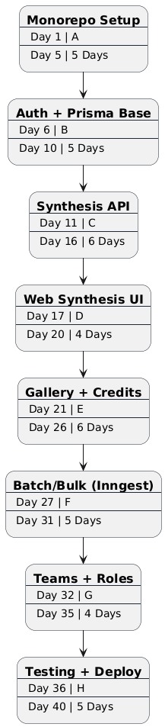
Gantt Chart
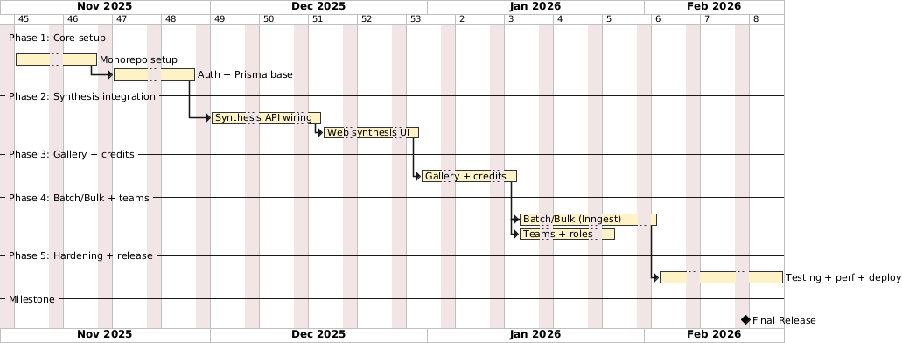

3.4 Software & Hardware Requirements
Software Requirements
- Frontend: Next.js 15, React 19, Tailwind CSS 4, and Radix UI.
- Marketing Site: Vite 7, React Router 7, Motion 12, and Spline.
- API Layer: tRPC 11, @tanstack/react-query 5, and SuperJSON.
- Backend (Web): Next.js API Routes and Node.js.
- Backend (Synthesis): Python 3.11, FastAPI, and Uvicorn.
- Database: PostgreSQL (via Neon).
- ORM: Prisma 6.
- Authentication: NextAuth.js 5 (supporting Google, Discord, and Credentials).
- AI/ML Framework: TensorFlow 2.15, tf-keras 2.15, and tensorflow-probability 0.23.
- OCR Engine: PyTorch 2.0, Transformers 4.35 (TrOCR), and EasyOCR 1.7.
- Image Processing: OpenCV, Pillow 10, CairoSVG 2.7, and NumPy 1.23.
- File Storage: UploadThing with CDN delivery.
- Background Jobs: Inngest (handling async processing, retries, and cron).
- Payment Gateway: Razorpay (supporting INR, UPI, cards, and netbanking).
- Monorepo Management: Turborepo and Bun.
- Hosting (Frontend): Vercel (Next.js and Edge Functions).
- Hosting (Backend): Docker and various Cloud providers for FastAPI.
- Hosting (Database): Neon (Serverless PostgreSQL).
Hardware Requirements
- Processor: Quad-core CPU (Intel i5/Ryzen 5 or better)
- RAM: 8 GB minimum (16 GB recommended for local model inference)
- Storage: 512 GB SSD (for models, datasets, generated outputs)
- GPU: Optional NVIDIA GPU with CUDA (for faster model inference)
- Internet: 25 Mbps or higher (for API calls, file uploads, real-time sync)

3.5 Preliminary Product Snapshot

The Handwriting Synthesis platform integrates AI-powered stroke generation, realistic post-processing, and collaborative workflows to deliver a scalable, production-ready solution for authentic handwriting creation, team management, and cross-device asset synchronization.

Modules are as follows:
- User Registration and Onboarding: Users sign in (Google OAuth/Discord OAuth/email-password) and complete profile setup with name, avatar, timezone preferences, and receive 10 free credits to start generating handwriting.
- Synthesis Engine: AI-powered LSTM neural network generates stroke sequences from text input. Users select from 13 handwriting styles, adjust bias parameter (0-1.5) for randomness control, customize stroke color/width, and receive real-time SVG preview with instant parameter updates.
- Realistic Rendering: Post-processing pipeline transforms clean SVG into authentic scanned handwriting. Users select paper type (white, cream, aged, lined, grid, recycled), ink type (ballpoint, gel, fountain, marker, pencil), wear level (0-1), and generate PNG exports with texture injection and degradation effects.
- Gallery Management: Persistent storage for all generated handwriting with full-text search, custom tagging, favorites marking, and paginated browsing. Users filter by style, view metadata (text, parameters, processing time), and delete individual or batch items.
- Team Collaboration: Create team workspaces with unique slugs, invite members via email with role-based access (OWNER/ADMIN/MEMBER), manage shared credit pools, and maintain team-specific galleries for collaborative handwriting asset management.
- Batch & Bulk Processing: Generate multiple style variants in parallel via Inngest background jobs. Upload CSV files for high-volume text processing with custom column mapping, track job progress with success/error counts, and export results as ZIP files containing all generated outputs.
- Template System: 5 pre-built templates (formal letter, sticky note, journal, invitation, certificate) with WYSIWYG editor for customizable text areas, positioning, and styling. Apply handwriting styles to template regions and export as PDF for print-ready documents.
- OCR/Recognition: Upload handwritten images (JPG/PNG) for text extraction using TrOCR transformer models. System performs preprocessing (grayscale, thresholding, line segmentation), runs inference with confidence scoring, applies spell correction, and returns structured JSON with per-line text.
- Credit System & Payments: Track credit balance with 1 credit per synthesis/rendering/OCR operation. Purchase credit packages via Razorpay (Starter ₹399/100 credits, Pro ₹1199/350 credits, Enterprise ₹3999/1500 credits) with order creation, signature verification, and webhook handling for payment status updates.
- Dashboard & Analytics: Unified view of generation history, credit consumption trends, style usage statistics, team activity logs, and export format preferences. Monitor batch/bulk job status, view success/error rates, and track processing times for performance insights.

3.6 Conceptual Diagrams
3.6.1 Event Table
Event Name | Description | Actor/Source | System Response | Preconditions | Postconditions
User Registration | New user registers via email/password | Guest User | Create user account, hash password, send verification email | Valid email format, password meets requirements | User created with ACTIVE status, 10 free credits assigned
OAuth Login | User logs in via Google/Discord OAuth | Guest/Registered User | Authenticate via OAuth provider, create/update user account, create session | Valid OAuth account | User authenticated, JWT session created, redirected to dashboard
Password Reset Request | User requests password reset | Registered User | Generate reset token, send reset email with link | Valid email exists in system | Reset token generated (24hr expiry), email sent
Synthesis Generation | User generates handwriting from text | Authenticated User | Validate input, call FastAPI LSTM inference, generate SVG, return preview | User has credits, text within limits (20 lines × 75 chars) | SVG handwriting generated, 1 credit consumed, processing time logged
Realistic Rendering | User applies post-processing effects | Authenticated User | Process SVG with OpenCV/Pillow, apply paper/ink/wear effects, generate PNG | SVG exists, user has credits | Realistic PNG generated, 1 credit consumed, upload to UploadThing
Save to Gallery | User saves generation to gallery | Authenticated User | Insert SavedGeneration record with metadata | Generation exists in current session | Generation saved with SVG/PNG, searchable in gallery
Gallery Search | User searches saved generations | Authenticated User | Query database by text content, tags, style filters | User authenticated, gallery has items | Matching generations displayed with pagination
Tag Generation | User adds tags to saved generation | Authenticated User | Update SavedGeneration tags array | Generation exists and owned by user | Tags added, generation searchable by tag
Favorite Generation | User marks generation as favorite | Authenticated User | Update isFavorite field to true | Generation exists and owned by user | Generation marked as favorite, appears in favorites filter
Delete Generation | User deletes saved generation | Authenticated User | Remove SavedGeneration record, delete uploaded files | Generation exists and owned by user | Generation deleted, storage freed
Batch Generation | User generates multiple style variants | Authenticated User | Create BatchJob, trigger Inngest fan-out, parallel synthesis per style | User has sufficient credits, text valid | BatchJob created, multiple styles generated in parallel, credits consumed per item
Bulk CSV Upload | User uploads CSV for bulk processing | Authenticated User | Parse CSV, validate columns, create BulkJob with items | Valid CSV format, user has credits | BulkJob created with pending status, rows queued for processing
Bulk Processing | System processes bulk job rows | Inngest Worker | Process each row sequentially, synthesize handwriting, log results | BulkJob in PENDING status | Each row processed, results stored, ZIP export generated on completion
Credit Purchase | User purchases credit package | Authenticated User | Create Razorpay order, redirect to payment gateway | User authenticated, valid package selected | Order created, user redirected to Razorpay checkout
Payment Verification | Razorpay webhook confirms payment | Razorpay Server | Verify payment signature, add credits to user account | Valid order ID and payment ID | Credits added to user balance, Payment record created with SUCCESS status
Team Creation | User creates team workspace | Authenticated User | Create Team record, assign creator as OWNER, initialize shared credits | Unique team slug available | Team created, creator as OWNER, team credit pool initialized
Team Invitation | Team owner/admin invites member | Team Owner/Admin | Create TeamInvite record, generate unique token, send email invitation | User has OWNER/ADMIN role, valid email | TeamInvite created with 7-day expiry, invitation email sent
Accept Team Invite | User accepts team invitation | Invited User | Verify token, create TeamMember record with assigned role | Valid token, not expired, user authenticated | User added to team with specified role, invite record deleted
Team Member Role Update | Owner/admin changes member role | Team Owner/Admin | Update TeamMember role field | User has OWNER/ADMIN role, target member exists | Member role updated (ADMIN ↔ MEMBER), permissions changed
Team Member Removal | Owner/admin removes team member | Team Owner/Admin | Delete TeamMember record, transfer/delete member's team generations | User has OWNER/ADMIN role, not removing self | Member removed from team, access revoked
OCR Upload | User uploads handwriting image for recognition | Authenticated User | Validate image format/size, preprocess image, segment lines | User has credits, valid image format (JPG/PNG) | Image uploaded, preprocessed, queued for OCR
OCR Processing | System recognizes handwriting text | FastAPI Worker | Run TrOCR inference per line, apply spell correction, return structured JSON | Image preprocessed and segmented | Text extracted with confidence scores, 1 credit consumed
Template Creation | User creates custom template | Authenticated User/Team | Create Template record with WYSIWYG config | User authenticated, valid template type | Template created, available in template library
Template Document Generation | User generates document from template | Authenticated User | Apply handwriting to template regions, render document | Template exists, user has credits | TemplateDocument created with rendered output, credits consumed
Session Timeout | User session expires after inactivity | System Timer | Invalidate JWT session, clear cookies | Session idle timeout reached (7 days) | User logged out, must re-authenticate
Daily Credit Claim | User claims daily free credits | Authenticated User | Check last claim timestamp, add credits if eligible | 24 hours since last claim | Free credits added (configurable amount), timestamp updated
Inngest Job Retry | Background job fails and retries | Inngest Worker | Log error, exponential backoff, retry job (max 3 attempts) | Job failed with retryable error | Job retried with backoff, success/failure logged
Database Backup | System performs scheduled backup | System Timer (Neon) | Create point-in-time snapshot, store in backup storage | Scheduled time reached | Database backup created and stored, retention policy applied
Credit Refund | User cancels batch/bulk job | Authenticated User | Calculate unconsumed credits, refund to user balance | Job in PENDING/PROCESSING status, not completed | Job cancelled, unused credits refunded, job status set to CANCELLED
Export Gallery | User exports multiple generations | Authenticated User | Collect selected generation files, create ZIP archive | User has saved generations selected | ZIP file generated with all SVG/PNG files, download.
3.6.2 Use Case Diagram
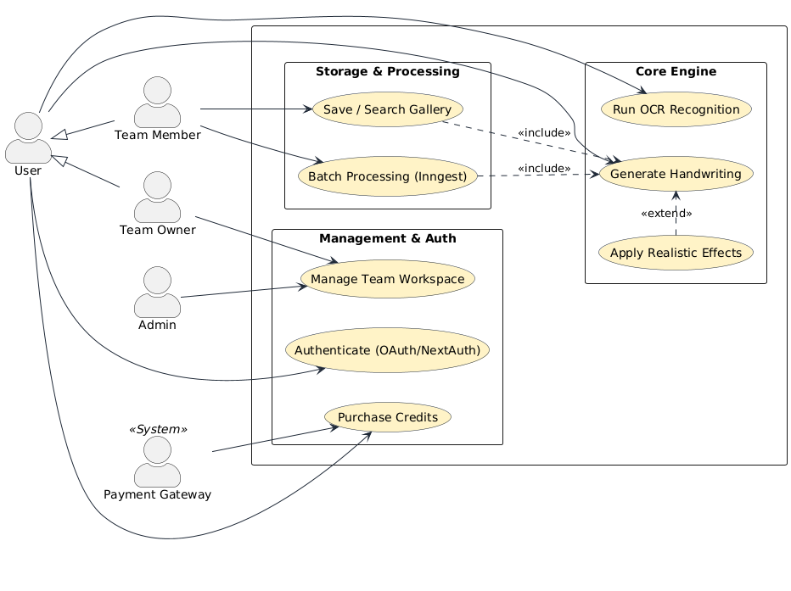

3.6.3 ER Diagram
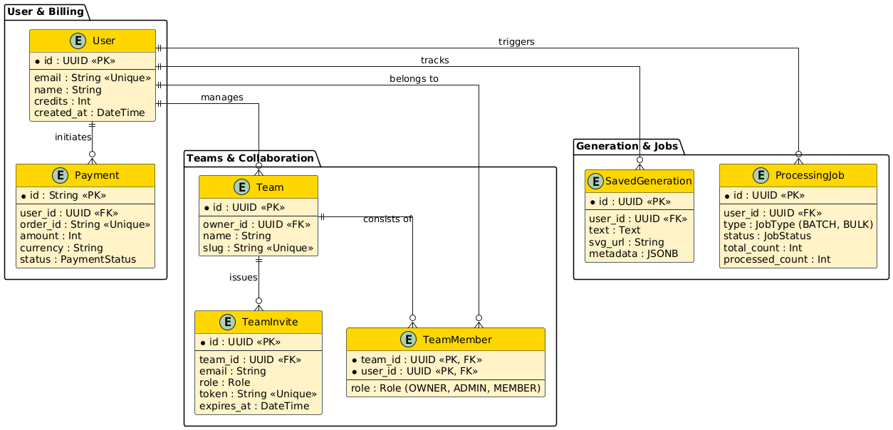

3.6.4 Class Diagram
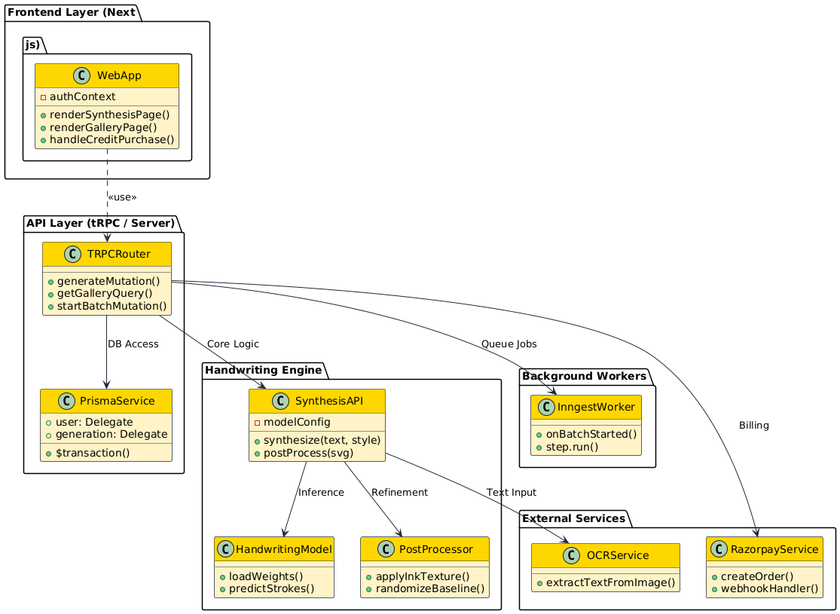
3.6.5 Object Diagram
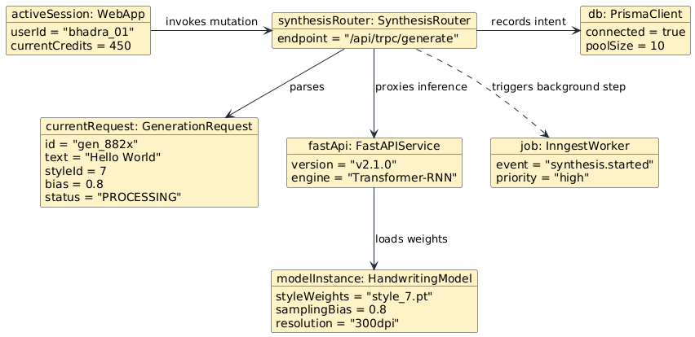

3.6.6 Activity Diagram
Generation Activity
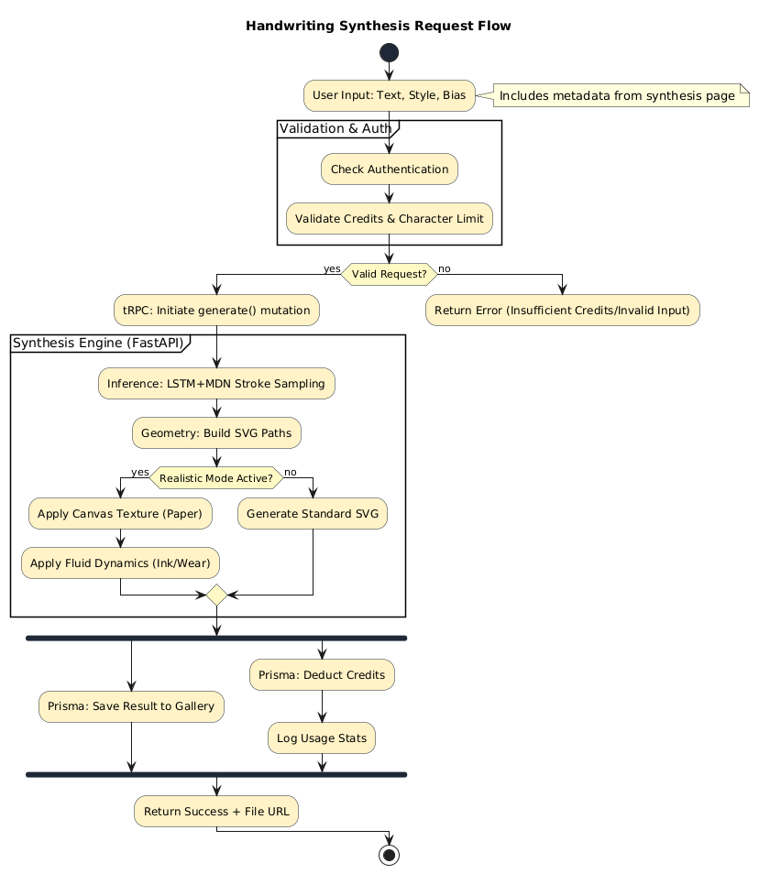

Bulk Activity
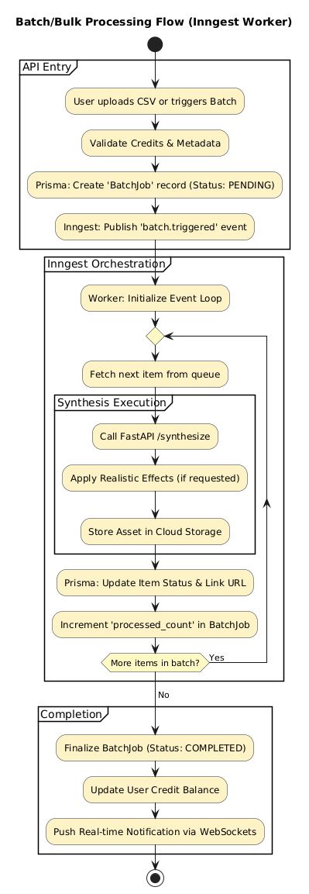
3.6.7 Sequence Diagram
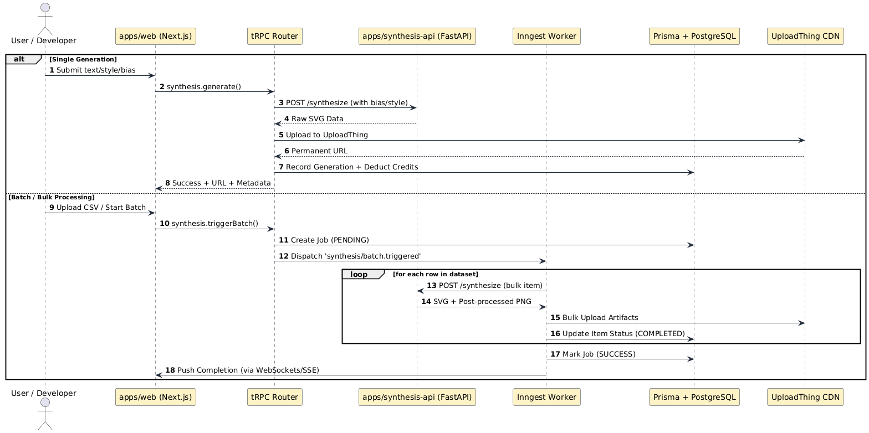

3.6.8 State Flow Diagram
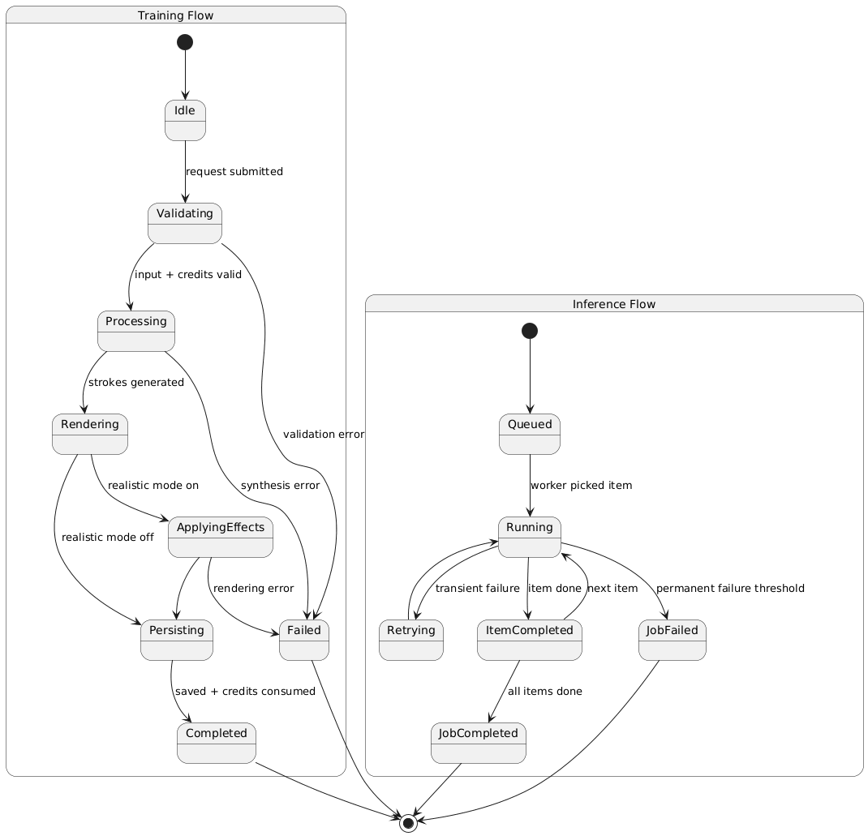

3.6.9 Context Diagram
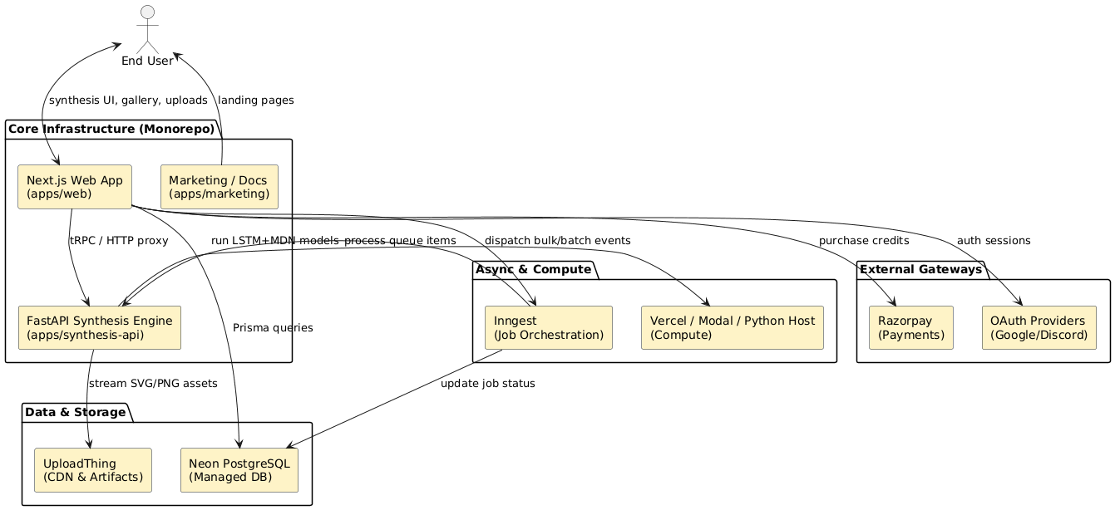

3.6.10 Data Flow Diagram
Level 0
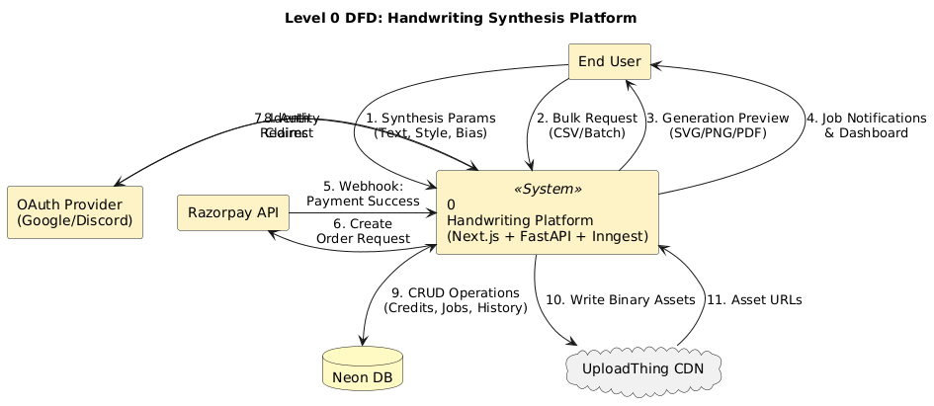

Level 1
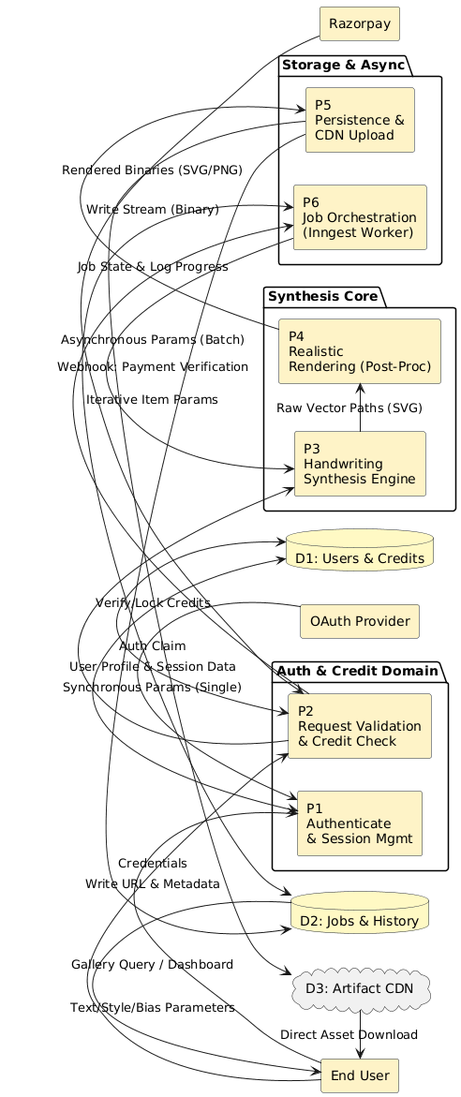
3.6.11 Component Diagram
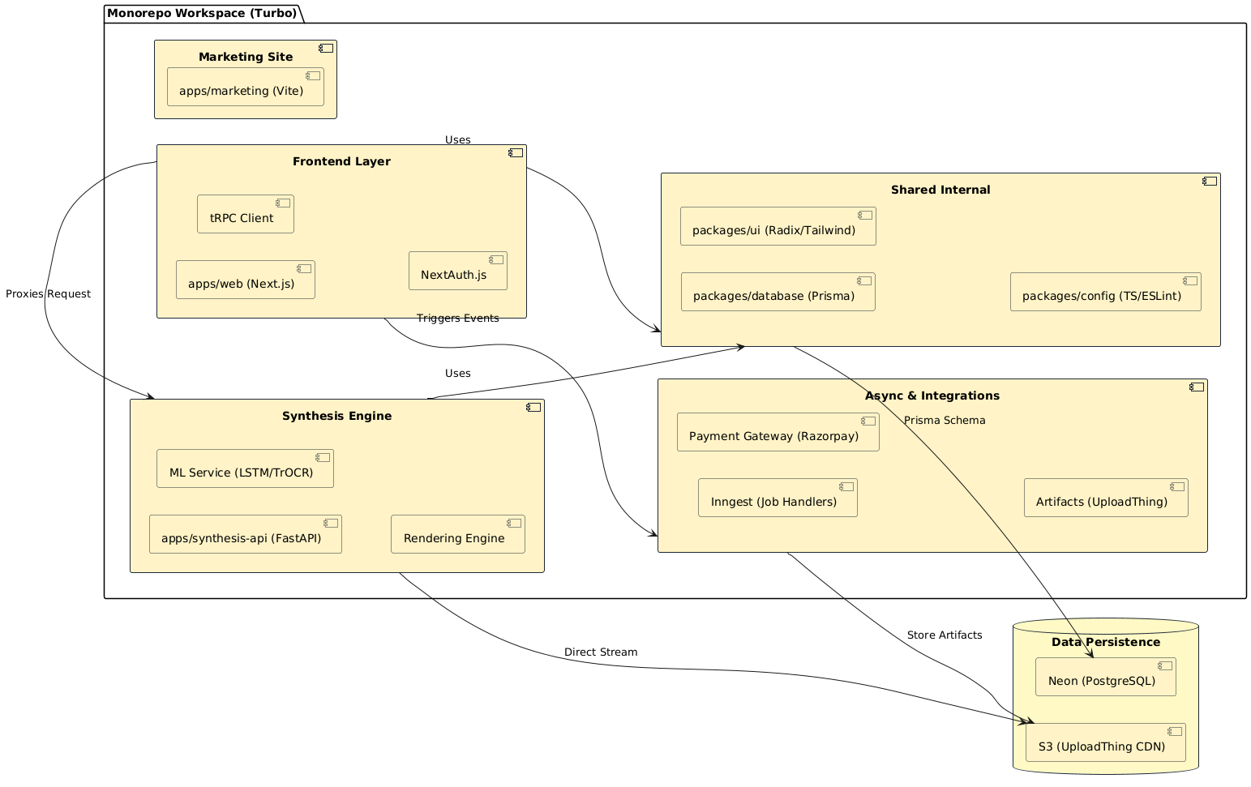

3.6.12 Package Diagram
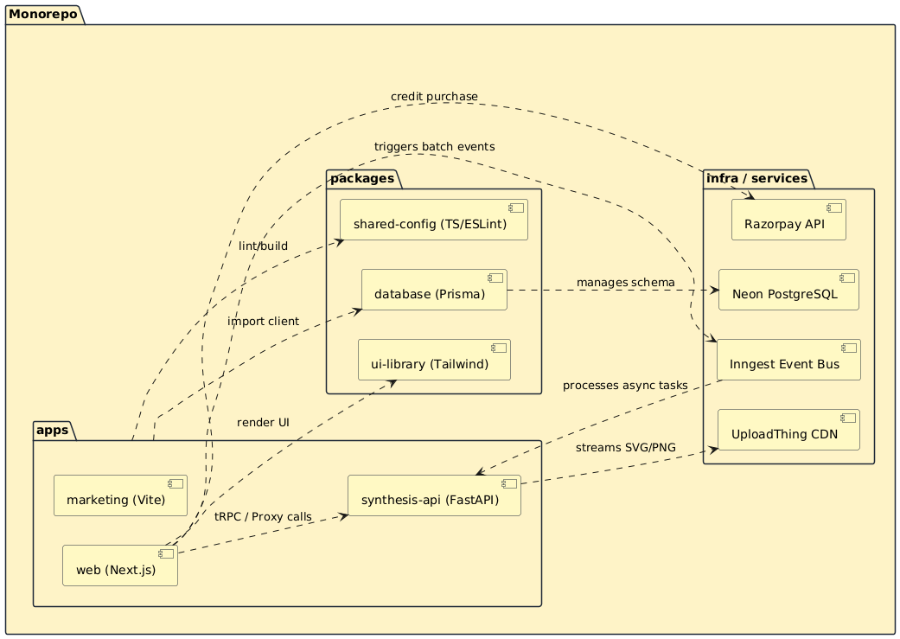

3.6.13 Deployment Diagram
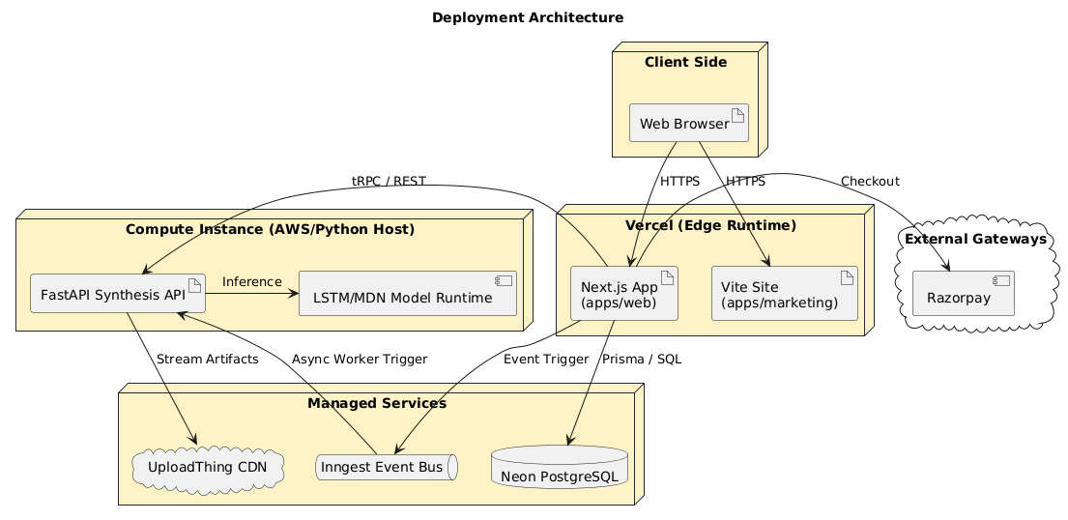

4 System Coding
4.1 Code
prisma/schema.prisma
generator client {
provider = "prisma-client-js"
}

datasource db {
provider = "postgresql"
url = env("DATABASE_URL")
}

// User model with authentication and credits
model User {
id String @id @default(cuid())
name String?
email String? @unique
emailVerified DateTime?
image String?
password String?
credits Int @default(10)
createdAt DateTime @default(now())
updatedAt DateTime @updatedAt

// Relations
accounts Account[]
sessions Session[]
savedGenerations SavedGeneration[]
batchJobs BatchJob[]
bulkJobs BulkJob[]
payments Payment[]
usage Usage[]
synthesisUsage SynthesisUsage[]
teamMemberships TeamMember[]
ownedTeams Team[] @relation("TeamOwner")
templates Template[] @relation("UserTemplates")
}

// SavedGeneration model for gallery management
model SavedGeneration {
id String @id @default(cuid())
userId String
user User @relation(fields: [userId], references: [id], onDelete: Cascade)

status GenerationStatus @default(COMPLETED)
text String @db.Text
style Int
bias Float
strokeColor String @default("black")
strokeWidth Int @default(2)

svgContent String? @db.Text
uploadUrl String?
uploadKey String?

realisticPng String? @db.Text
paperType String?
inkType String?
wearLevel Float?

linesCount Int?
charactersCount Int?
processingTime Float?

isFavorite Boolean @default(false)
tags String[] @default([])

teamId String?
team Team? @relation("TeamGenerations", fields: [teamId], references: [id], onDelete: SetNull)

batchJobId String?
batchJob BatchJob? @relation(fields: [batchJobId], references: [id])

bulkJobItemId String? @unique
bulkJobItem BulkJobItem? @relation(fields: [bulkJobItemId], references: [id])

createdAt DateTime @default(now())

@@index([userId, createdAt(sort: Desc)])
@@index([teamId, createdAt(sort: Desc)])
@@index([status])
}

// Team model for collaboration
model Team {
id String @id @default(cuid())
name String
slug String @unique
description String?
credits Int @default(0)

ownerId String
owner User @relation("TeamOwner", fields: [ownerId], references: [id], onDelete: Cascade)

members TeamMember[]
invites TeamInvite[]
generations SavedGeneration[] @relation("TeamGenerations")
templates Template[] @relation("TeamTemplates")

createdAt DateTime @default(now())
updatedAt DateTime @updatedAt

@@index([ownerId])
@@index([slug])
}

// TeamMember model for role-based access
model TeamMember {
id String @id @default(cuid())
teamId String
team Team @relation(fields: [teamId], references: [id], onDelete: Cascade)
userId String
user User @relation(fields: [userId], references: [id], onDelete: Cascade)
role TeamRole @default(MEMBER)
joinedAt DateTime @default(now())

@@unique([teamId, userId])
@@index([userId])
@@index([teamId])
}

// Payment model for credit purchases
model Payment {
id String @id @default(cuid())
userId String
user User @relation(fields: [userId], references: [id], onDelete: Cascade)

orderId String @unique
paymentId String? @unique
amount Int
currency String @default("INR")
credits Int
status PaymentStatus @default(PENDING)

razorpaySignature String?
errorMessage String?

createdAt DateTime @default(now())
updatedAt DateTime @updatedAt

@@index([userId])
@@index([status])
}

// BatchJob model for parallel style generation
model BatchJob {
id String @id @default(cuid())
userId String
user User @relation(fields: [userId], references: [id], onDelete: Cascade)

text String @db.Text
selectedStyles Int[]
totalItems Int
status BatchStatus @default(PENDING)

items SavedGeneration[]

createdAt DateTime @default(now())
updatedAt DateTime @updatedAt

@@index([userId, status])
}

// BulkJob model for CSV processing
model BulkJob {
id String @id @default(cuid())
userId String
user User @relation(fields: [userId], references: [id], onDelete: Cascade)

fileName String
totalRows Int
processedRows Int @default(0)
successRows Int @default(0)
failedRows Int @default(0)
status BulkStatus @default(PENDING)

items BulkJobItem[]

createdAt DateTime @default(now())
updatedAt DateTime @updatedAt

@@index([userId, status])
}

model BulkJobItem {
id String @id @default(cuid())
bulkJobId String
bulkJob BulkJob @relation(fields: [bulkJobId], references: [id], onDelete: Cascade)

rowNumber Int
text String @db.Text
style Int
bias Float
status GenerationStatus @default(PENDING)
errorMessage String?

generation SavedGeneration?

createdAt DateTime @default(now())

@@index([bulkJobId])
}

enum GenerationStatus {
PENDING
PROCESSING
COMPLETED
FAILED
}

enum BatchStatus {
PENDING
PROCESSING
COMPLETED
FAILED
CANCELLED
}

enum BulkStatus {
PENDING
PROCESSING
COMPLETED
FAILED
CANCELLED
}

enum TeamRole {
OWNER
ADMIN
MEMBER
}

enum PaymentStatus {
PENDING
SUCCESS
FAILED
}

src/server/api/routers/synthesis.ts
import { z } from "zod";
import { TRPCError } from "@trpc/server";
import { createTRPCRouter, protectedProcedure } from "~/server/api/trpc";

const SYNTHESIS_API_URL = process.env.SYNTHESIS_API_URL ?? "http://localhost:8001";

export const synthesisRouter = createTRPCRouter({
// Generate handwriting
generate: protectedProcedure
.input(z.object({
text: z.string().min(1).max(1500),
style: z.number().min(0).max(12).default(9),
bias: z.number().min(0).max(1.5).default(0.75),
strokeColor: z.string().default("black"),
strokeWidth: z.number().min(1).max(5).default(2),
}))
.mutation(async ({ ctx, input }) => {
// Check credits
const user = await ctx.db.user.findUnique({
where: { id: ctx.session.user.id },
select: { credits: true },
});

if (!user || user.credits < 1) {
throw new TRPCError({
code: "FORBIDDEN",
message: "Insufficient credits",
});
}

// Call synthesis API
const response = await fetch(`${SYNTHESIS_API_URL}/synthesize`, {
method: "POST",
headers: { "Content-Type": "application/json" },
body: JSON.stringify({
text: input.text,
style: input.style,
bias: input.bias,
stroke_color: input.strokeColor,
stroke_width: input.strokeWidth,
}),
});

if (!response.ok) {
throw new TRPCError({
code: "INTERNAL_SERVER_ERROR",
message: "Synthesis failed",
});
}

const data = await response.json();

// Deduct credit and log usage
await ctx.db.$transaction([
ctx.db.user.update({
where: { id: ctx.session.user.id },
data: { credits: { decrement: 1 } },
}),
ctx.db.synthesisUsage.create({
data: {
userId: ctx.session.user.id,
creditsUsed: 1,
linesCount: data.lines_count,
charactersCount: data.characters_count,
style: input.style,
bias: input.bias,
success: true,
},
}),
]);

return {
svg: data.svg_raw,
linesCount: data.lines_count,
charactersCount: data.characters_count,
};
}),

// Apply realistic effects
makeRealistic: protectedProcedure
.input(z.object({
generationId: z.string(),
paperType: z.enum(["white", "cream", "aged", "lined", "grid", "recycled"]).default("white"),
inkType: z.enum(["ballpoint", "gel", "fountain", "marker", "pencil"]).default("ballpoint"),
wearLevel: z.number().min(0).max(1).default(0.3),
}))
.mutation(async ({ ctx, input }) => {
const generation = await ctx.db.savedGeneration.findFirst({
where: { id: input.generationId, userId: ctx.session.user.id },
});

if (!generation) {
throw new TRPCError({ code: "NOT_FOUND" });
}

// Check credits
const user = await ctx.db.user.findUnique({
where: { id: ctx.session.user.id },
select: { credits: true },
});

if (!user || user.credits < 1) {
throw new TRPCError({
code: "FORBIDDEN",
message: "Insufficient credits for realistic rendering",
});
}

const response = await fetch(`${SYNTHESIS_API_URL}/process/realistic`, {
method: "POST",
headers: { "Content-Type": "application/json" },
body: JSON.stringify({
svg_content: generation.svgContent,
paper_type: input.paperType,
ink_type: input.inkType,
wear_level: input.wearLevel,
}),
});

const data = await response.json();

// Update generation and deduct credit
return await ctx.db.$transaction([
ctx.db.savedGeneration.update({
where: { id: input.generationId },
data: {
realisticPng: data.realistic_png,
paperType: data.paper_type,
inkType: data.ink_type,
wearLevel: data.wear_level,
},
}),
ctx.db.user.update({
where: { id: ctx.session.user.id },
data: { credits: { decrement: 1 } },
}),
]);
}),
});

apps/synthesis-api/main.py
from fastapi import FastAPI, HTTPException
from fastapi.middleware.cors import CORSMiddleware
from pydantic import BaseModel, Field, field_validator
import tempfile
import os

app = FastAPI(title="Handwriting Synthesis API")

app.add_middleware(
CORSMiddleware,
allow_origins=["*"],
allow_methods=["*"],
allow_headers=["*"],
)

VALID_CHARS = set([
" ", "!", '"', "#", "'", "(", ")", ",", "-", ".",
"0", "1", "2", "3", "4", "5", "6", "7", "8", "9",
":", ";", "?",
"A", "B", "C", "D", "E", "F", "G", "H", "I", "J", "K", "L", "M",
"N", "O", "P", "R", "S", "T", "U", "V", "W", "Y",
"a", "b", "c", "d", "e", "f", "g", "h", "i", "j", "k", "l", "m",
"n", "o", "p", "q", "r", "s", "t", "u", "v", "w", "x", "y", "z",
])

MAX_CHARS_PER_LINE = 75
MAX_LINES = 20
# Lazy load model
_hand_instance = None

def get_hand():
global _hand_instance
if _hand_instance is None:
from handwriting_synthesis import Hand
_hand_instance = Hand()
return _hand_instance

class SynthesisRequest(BaseModel):
text: str = Field(..., description="Text to convert")
style: int = Field(default=9, ge=0, le=12)
bias: float = Field(default=0.75, ge=0.0, le=1.5)
stroke_color: str = Field(default="black")
stroke_width: int = Field(default=2, ge=1, le=5)

@field_validator("text")
@classmethod
def validate_text(cls, v: str) -> str:
if not v.strip():
raise ValueError("Text cannot be empty")

lines = v.split("\n")
if len(lines) > MAX_LINES:
raise ValueError(f"Maximum {MAX_LINES} lines allowed")

for i, line in enumerate(lines):
if len(line) > MAX_CHARS_PER_LINE:
raise ValueError(f"Line {i+1} exceeds {MAX_CHARS_PER_LINE} chars")

invalid = [c for c in line if c not in VALID_CHARS]
if invalid:
raise ValueError(f"Invalid characters: {invalid}")

return v

@app.get("/health")
async def health_check():
return {
"status": "healthy",
"model_loaded": _hand_instance is not None,
"max_chars_per_line": MAX_CHARS_PER_LINE,
"max_lines": MAX_LINES,
}

@app.post("/synthesize")
async def synthesize_handwriting(request: SynthesisRequest):
try:
hand = get_hand()
lines = request.text.split("\n")

with tempfile.NamedTemporaryFile(suffix=".svg", delete=False) as tmp:
tmp_path = tmp.name

try:
hand.write(
filename=tmp_path,
lines=lines,
biases=[request.bias] * len(lines),
styles=[request.style] * len(lines),
stroke_colors=[request.stroke_color] * len(lines),
stroke_widths=[request.stroke_width] * len(lines),
)

with open(tmp_path, "r") as f:
svg_content = f.read()
finally:
os.unlink(tmp_path)

return {
"svg_raw": svg_content,
"lines_count": len(lines),
"characters_count": sum(len(line) for line in lines),
"style": request.style,
"bias": request.bias,
}

except ValueError as e:
raise HTTPException(status_code=400, detail=str(e))
except Exception as e:
raise HTTPException(status_code=500, detail=str(e))

apps/synthesis-api/post_processing.py
import numpy as np
import cv2
from PIL import Image
import cairosvg
import io
import base64
from enum import Enum

class PaperType(str, Enum):
WHITE = "white"
CREAM = "cream"
AGED = "aged"
LINED = "lined"
GRID = "grid"
RECYCLED = "recycled"

class InkType(str, Enum):
BALLPOINT = "ballpoint"
GEL = "gel"
FOUNTAIN = "fountain"
MARKER = "marker"
PENCIL = "pencil"

def generate_perlin_noise(width, height, scale=50.0, octaves=4):
"""Generate paper texture noise"""
noise = np.zeros((height, width), dtype=np.float32)

for octave in range(octaves):
freq = 2 ** octave
amplitude = 1 / freq

grid_h = max(2, int(height / (scale / freq)))
grid_w = max(2, int(width / (scale / freq)))

grid = np.random.rand(grid_h, grid_w).astype(np.float32)
resized = cv2.resize(grid, (width, height), interpolation=cv2.INTER_CUBIC)
noise += resized * amplitude

return (noise - noise.min()) / (noise.max() - noise.min())

def generate_paper_texture(width, height, paper_type):
"""Create paper background with texture"""
colors = {
PaperType.WHITE: (252, 252, 250),
PaperType.CREAM: (255, 253, 240),
PaperType.AGED: (245, 235, 210),
PaperType.RECYCLED: (240, 238, 230),
}

base_color = colors.get(paper_type, (252, 252, 250))
img = np.full((height, width, 3), base_color, dtype=np.float32)

# Add texture
noise = generate_perlin_noise(width, height, scale=20.0, octaves=3)
noise = (noise - 0.5) * 8 # Subtle variation

for c in range(3):
img[:, :, c] += noise

return np.clip(img, 0, 255).astype(np.uint8)

def svg_to_alpha_mask(svg_content):
"""Convert SVG to grayscale mask"""
png_data = cairosvg.svg2png(bytestring=svg_content.encode("utf-8"))
img = Image.open(io.BytesIO(png_data)).convert("RGBA")

rgb = np.array(img.convert("RGB"), dtype=np.float32)
luminance = 0.299 * rgb[:,:,0] + 0.587 * rgb[:,:,1] + 0.114 * rgb[:,:,2]
darkness = 255 - luminance

alpha = np.array(img.split()[3], dtype=np.float32)
mask = (darkness * alpha / 255).astype(np.uint8)

return mask, img.size[0], img.size[1]

def apply_edge_roughness(mask, intensity=0.25):
"""Add micro-perturbations to edges"""
if intensity <= 0:
return mask

height, width = mask.shape
dx = generate_perlin_noise(width, height, scale=20) - 0.5
dy = generate_perlin_noise(width, height, scale=20) - 0.5

dx *= intensity * 2
dy *= intensity * 2

y, x = np.meshgrid(np.arange(height), np.arange(width), indexing="ij")
new_x = np.clip(x + dx, 0, width - 1).astype(np.float32)
new_y = np.clip(y + dy, 0, height - 1).astype(np.float32)

return cv2.remap(mask.astype(np.float32), new_x, new_y,
interpolation=cv2.INTER_LINEAR).astype(np.uint8)

def composite_ink_on_paper(ink_mask, paper, ink_color=(20, 20, 40)):
"""Blend ink onto paper"""
height, width = ink_mask.shape
ink_alpha = ink_mask.astype(np.float32) / 255

result = paper.astype(np.float32)

for c in range(3):
result[:,:,c] = (
result[:,:,c] * (1 - ink_alpha * 0.9) +
ink_color[c] * ink_alpha * 0.9
)

return np.clip(result, 0, 255).astype(np.uint8)

def process_realistic_base64(svg_content, paper_type="white",
ink_type="ballpoint", wear_level=0.3):
"""Main processing function - returns base64 PNG"""

# Convert SVG to mask
mask, width, height = svg_to_alpha_mask(svg_content)

# Generate paper
paper = generate_paper_texture(width, height, PaperType(paper_type))

# Apply effects
mask = apply_edge_roughness(mask, intensity=0.25)

# Composite
result = composite_ink_on_paper(mask, paper)

# Add subtle noise
noise = np.random.randn(*result.shape) * (wear_level * 3)
result = np.clip(result + noise, 0, 255).astype(np.uint8)

# Convert to base64
img = Image.fromarray(result)
buffer = io.BytesIO()
img.save(buffer, format="PNG")
png_base64 = base64.b64encode(buffer.getvalue()).decode("utf-8")

return {
"realistic_png": png_base64,
"width": width,
"height": height,
"paper_type": paper_type,
"ink_type": ink_type,
"wear_level": wear_level,
}

src/server/auth.ts
import NextAuth from "next-auth";
import { PrismaAdapter } from "@auth/prisma-adapter";
import GoogleProvider from "next-auth/providers/google";
import DiscordProvider from "next-auth/providers/discord";
import CredentialsProvider from "next-auth/providers/credentials";
import { db } from "~/server/db";
import bcrypt from "bcryptjs";

export const { handlers, signIn, signOut, auth } = NextAuth({
adapter: PrismaAdapter(db),
session: {
strategy: "jwt",
maxAge: 7 * 24 * 60 * 60, // 7 days
},
pages: {
signIn: "/auth/signin",
error: "/auth/error",
},
providers: [
GoogleProvider({
clientId: process.env.GOOGLE_CLIENT_ID!,
clientSecret: process.env.GOOGLE_CLIENT_SECRET!,
allowDangerousEmailAccountLinking: true,
}),
DiscordProvider({
clientId: process.env.DISCORD_CLIENT_ID!,
clientSecret: process.env.DISCORD_CLIENT_SECRET!,
allowDangerousEmailAccountLinking: true,
}),
CredentialsProvider({
name: "credentials",
credentials: {
email: { label: "Email", type: "email" },
password: { label: "Password", type: "password" },
},
async authorize(credentials) {
if (!credentials?.email || !credentials?.password) {
throw new Error("Invalid credentials");
}

const user = await db.user.findUnique({
where: { email: credentials.email },
});

if (!user || !user.password) {
throw new Error("Invalid credentials");
}

const isValid = await bcrypt.compare(
credentials.password,
user.password
);

if (!isValid) {
throw new Error("Invalid credentials");
}

return {
id: user.id,
email: user.email,
name: user.name,
image: user.image,
};
},
}),
],
callbacks: {
async jwt({ token, user }) {
if (user) {
token.id = user.id;
}
return token;
},
async session({ session, token }) {
if (token && session.user) {
session.user.id = token.id as string;
}
return session;
},
},
});

src/inngest/functions.ts
import { inngest } from "./client";
import { db } from "~/server/db";

const SYNTHESIS_API_URL = process.env.SYNTHESIS_API_URL ?? "http://localhost:8001";

export const processBatchSynthesis = inngest.createFunction(
{
id: "process-batch-synthesis",
retries: 3,
concurrency: { limit: 2, key: "event.data.userId" },
},
{ event: "synthesis/batch.requested" },
async ({ event, step }) => {
const { batchJobId, userId, text, selectedStyles } = event.data;

// Update status to PROCESSING
await step.run("update-status", async () => {
await db.batchJob.update({
where: { id: batchJobId },
data: { status: "PROCESSING" },
});
});

let successCount = 0;

// Process each style variant
for (let i = 0; i < selectedStyles.length; i++) {
const style = selectedStyles[i];

const result = await step.run(`generate-style-${style}`, async () => {
const response = await fetch(`${SYNTHESIS_API_URL}/synthesize`, {
method: "POST",
headers: { "Content-Type": "application/json" },
body: JSON.stringify({
text,
style,
bias: 0.75,
stroke_color: "black",
stroke_width: 2,
}),
});

if (!response.ok) {
return { success: false, error: await response.text() };
}

const data = await response.json();
return { success: true, svgContent: data.svg_raw };
});

// Save result
await step.run(`save-style-${style}`, async () => {
await db.savedGeneration.create({
data: {
userId,
batchJobId,
text,
style,
bias: 0.75,
strokeColor: "black",
strokeWidth: 2,
status: result.success ? "COMPLETED" : "FAILED",
svgContent: result.success ? result.svgContent : null,
},
});

if (result.success) {
successCount++;
await db.user.update({
where: { id: userId },
data: { credits: { decrement: 1 } },
});
}
});
}

// Finalize
await step.run("finalize", async () => {
await db.batchJob.update({
where: { id: batchJobId },
data: {
status: successCount > 0 ? "COMPLETED" : "FAILED",
},
});
});

return { batchJobId, successCount, total: selectedStyles.length };
}
);

4.2 Data Dictionary
User
Data Attribute | Description | Data Type
id | Unique user identifier (primary key) | String (cuid)
email | User's email address (unique) | String?
name | Full name of the user | String?
password | Bcrypt hashed password (for credentials auth) | String?
image | User avatar URL | String?
credits | Available credits for synthesis operations | Int (@default(10))
emailVerified | Email verification timestamp | DateTime?
createdAt | Account creation timestamp | DateTime (@default(now()))
updatedAt | Last modification timestamp | DateTime (@updatedAt)
SavedGeneration
Data Attribute | Description | Data Type
id | Unique generation identifier (primary key) | String (cuid)
userId | Reference to user who created generation | String (FK)
teamId | Reference to team (if team generation) | String? (FK)
status | Generation status (PENDING, PROCESSING, COMPLETED, FAILED) | GenerationStatus (enum)
text | Input text content | String (@db.Text)
style | Handwriting style index (0-12) | Int
bias | Neatness/randomness parameter (0.0-1.5) | Float
strokeColor | CSS color value for strokes | String (@default("black"))
strokeWidth | Stroke width in pixels (1-5) | Int (@default(2))
svgContent | Generated SVG markup | String? (@db.Text)
uploadUrl | UploadThing CDN URL | String?
uploadKey | UploadThing file key (unique) | String?
realisticPng | Base64 encoded realistic PNG | String? (@db.Text)
paperType | Paper type identifier (white, cream, aged, etc.) | String?
inkType | Ink type identifier (ballpoint, gel, etc.) | String?
wearLevel | Degradation intensity (0.0-1.0) | Float?
linesCount | Number of lines in text | Int?
charactersCount | Total character count | Int?
processingTime | Time taken for synthesis (seconds) | Float?
isFavorite | Favorite flag for quick access | Boolean (@default(false))
tags | Array of custom tag strings | String[] (@default([]))
batchJobId | Reference to batch job (if part of batch) | String? (FK)
bulkJobItemId | Reference to bulk job item (if part of bulk) | String? (FK)
createdAt | Generation creation timestamp | DateTime (@default(now()))
Team
Data Attribute | Description | Data Type
id | Unique team identifier (primary key) | String (cuid)
name | Team display name | String
slug | Unique URL-friendly team identifier | String (@unique)
description | Team description (optional) | String?
credits | Shared team credit pool | Int (@default(0))
ownerId | Reference to team owner user | String (FK)
createdAt | Team creation timestamp | DateTime (@default(now()))
updatedAt | Last modification timestamp | DateTime (@updatedAt)
TeamMember
Data Attribute | Description | Data Type
id | Unique team member identifier (primary key) | String (cuid)
teamId | Reference to team | String (FK)
userId | Reference to user | String (FK)
role | Member role (OWNER, ADMIN, MEMBER) | TeamRole (enum)
joinedAt | Timestamp when member joined team | DateTime (@default(now()))
Payment
Data Attribute | Description | Data Type
id | Unique payment identifier (primary key) | String (cuid)
userId | Reference to user making payment | String (FK)
orderId | Razorpay order ID (unique) | String (@unique)
paymentId | Razorpay payment ID (unique, nullable until paid) | String? (@unique)
amount | Payment amount in smallest currency unit (paise) | Int
currency | Currency code (default INR) | String (@default("INR"))
credits | Number of credits purchased | Int
status | Payment status (PENDING, SUCCESS, FAILED) | PaymentStatus (enum)
razorpaySignature | Razorpay signature for verification | String?
errorMessage | Error message if payment failed | String?
createdAt | Payment initiation timestamp | DateTime (@default(now()))
updatedAt | Last status update timestamp | DateTime (@updatedAt)
BatchJob
Data Attribute | Description | Data Type
id | Unique batch job identifier (primary key) | String (cuid)
userId | Reference to user who created batch job | String (FK)
text | Source text for batch generation | String (@db.Text)
selectedStyles | Array of style indices to generate | Int[]
totalItems | Total number of variants to generate | Int
status | Batch job status (PENDING, PROCESSING, COMPLETED, FAILED, CANCELLED) | BatchStatus (enum)
createdAt | Batch job creation timestamp | DateTime (@default(now()))
updatedAt | Last status update timestamp | DateTime (@updatedAt)
BulkJob
Data Attribute | Description | Data Type
id | Unique bulk job identifier (primary key) | String (cuid)
userId | Reference to user who uploaded CSV | String (FK)
fileName | Original CSV file name | String
totalRows | Total rows in CSV file | Int
processedRows | Number of rows processed so far | Int (@default(0))
successRows | Number of successfully processed rows | Int (@default(0))
failedRows | Number of failed rows | Int (@default(0))
status | Bulk job status (PENDING, PROCESSING, COMPLETED, FAILED, CANCELLED) | BulkStatus (enum)
createdAt | Bulk job creation timestamp | DateTime (@default(now()))
updatedAt | Last status update timestamp | DateTime (@updatedAt)
BulkJobItem
Data Attribute | Description | Data Type
id | Unique bulk job item identifier (primary key) | String (cuid)
bulkJobId | Reference to parent bulk job | String (FK)
rowNumber | Row number in CSV file (1-indexed) | Int
text | Text from CSV row | String (@db.Text)
style | Style index from CSV | Int
bias | Bias parameter from CSV | Float
status | Item processing status (PENDING, PROCESSING, COMPLETED, FAILED) | GenerationStatus (enum)
errorMessage | Error message if processing failed | String?
createdAt | Item creation timestamp | DateTime (@default(now()))

4.3 Program Description
1. Introduction
Purpose:
The purpose of the Handwriting Synthesis project is to create a comprehensive AI-powered web platform that transforms digital text into authentic, personalized handwritten output through neural network-based stroke generation. The platform enables individuals, teams, and organizations to generate realistic handwriting for documents, communications, creative projects, and assistive applications with production-ready quality and scalability.
Key Features:
- User Authentication & Credit System: Secure login with Google OAuth, Discord OAuth, and email/password credentials. Credit-based usage model with 10 free credits on signup, Razorpay payment integration for credit packages (Starter/Pro/Enterprise tiers), and detailed usage tracking.
- AI-Powered Handwriting Synthesis: LSTM neural network with Mixture Density Network (MDN) output generates stroke sequences from text input. Support for 13 unique handwriting styles with adjustable bias parameter (0-1.5) controlling randomness vs. style adherence, customizable stroke colors and widths.
- Realistic Post-Processing: Transform clean SVG output into authentic scanned handwriting with 6 paper types (white, cream, aged, lined, grid, recycled), 5 ink types (ballpoint, gel, fountain, marker, pencil), wear level simulation (0-1), and advanced effects including texture injection, edge roughness, and pressure variation.
- Gallery Management: Persistent storage for all generated handwriting with full-text search, custom tagging, favorites marking, and paginated browsing. Filter by style, view detailed metadata (text, parameters, processing time), and batch delete capabilities.
- Team Collaboration: Create team workspaces with unique slugs, invite members via email with role-based access (OWNER/ADMIN/MEMBER), manage shared credit pools, and maintain team-specific galleries for collaborative handwriting asset management.
- Batch & Bulk Processing: Generate multiple style variants in parallel via Inngest background jobs. Upload CSV files for high-volume text processing with custom column mapping, track job progress with success/error counts, and export results as ZIP files containing all generated outputs.
- OCR/Handwriting Recognition: Upload handwritten images for text extraction using TrOCR transformer models. Preprocessing includes grayscale conversion, adaptive thresholding, line segmentation, with fallback OCR (EasyOCR) and spell correction.
- Template System: Pre-built templates (formal letter, sticky note, journal, invitation, certificate) with WYSIWYG editor for customizable text areas, positioning, and styling. Apply handwriting styles to template regions and export as PDF.
- Multi-Format Export: SVG vector export for infinite scalability, PNG raster export with realistic effects, PDF export for print-ready documents, base64 encoding for inline transmission, and UploadThing CDN for permanent storage.
- Real-time Monitoring & Analytics: Dashboard with generation history, credit consumption trends, style usage statistics, team activity logs, export format preferences, batch/bulk job status, and performance insights.
2. Overview
Project Purpose:
Handwriting Synthesis revolutionizes digital handwriting creation by providing an AI-powered platform that generates authentic, natural-looking handwriting indistinguishable from human writing. The system eliminates the time-consuming manual process of handwriting while preserving the personal touch and authenticity that make handwritten content valuable for personal communications, business applications, creative projects, and assistive technology use cases.
Target Audience:
This platform is designed for individuals, creative professionals, businesses, and organizations requiring authentic handwritten content. Primary users include content creators needing personalized handwriting for videos/graphics, marketing teams creating handwritten campaigns, individuals with motor impairments requiring assistive handwriting technology, agencies producing handwritten content at scale, educators creating personalized materials, and hobbyists exploring creative typography.
3. Functionality
Key Features and Their Working:
1. User Authentication & Credit System
Working: Users authenticate through NextAuth.js with Google OAuth, Discord OAuth, or email/password credentials. System assigns 10 free credits on registration. Credit-based operations (synthesis, realistic rendering, OCR) consume 1 credit each. Users purchase additional credits via Razorpay with three tiers: Starter (₹399/100 credits), Pro (₹1199/350 credits), Enterprise (₹3999/1500 credits). All credit transactions logged in Usage and SynthesisUsage tables.
Validations:
- Email format validation (z.string().email())
- Password minimum 8 characters with bcrypt hashing
- Credit balance check before any operation (throws FORBIDDEN if insufficient)
- Payment signature verification using Razorpay webhook validation
2. Handwriting Synthesis Generation
Working:
- Input Validation: Text limited to 20 lines × 75 chars/line. Character whitelist excludes Q, X, Z (uppercase) due to training data limitations.
- API Call: tRPC procedure calls Python FastAPI synthesis API with validated parameters (text, style 0-12, bias 0-1.5, strokeColor, strokeWidth 1-5).
- Model Inference: FastAPI lazy-loads TensorFlow LSTM model (400 units), performs attention-based character-stroke alignment, samples from 20-component MDN for stroke coordinates.
- SVG Generation: Stroke sequences converted to SVG paths with pen-up/pen-down handling, color and width application.
- Credit Deduction: Transaction atomically decrements user credits and logs SynthesisUsage record with metadata.
Validations:
- Text non-empty, within length limits (z.string().min(1).max(1500))
- Character whitelist check (Pydantic @field_validator)
- Style index 0-12 (z.number().min(0).max(12))
- Bias 0.0-1.5 (z.number().min(0).max(1.5))
- Stroke width 1-5px (z.number().min(1).max(5))
3. Realistic Post-Processing
Working:
- SVG to Mask: CairoSVG converts SVG to PNG, luminance extraction creates alpha mask representing ink darkness.
- Paper Generation: Perlin noise generates paper texture (4 octaves, configurable scale), base colors vary by paper type (white: #FCFCFA, cream: #FFFDF0, aged: #F5EBD2).
- Effect Application: Edge roughness adds micro-perturbations using noise displacement, pressure variation modulates stroke darkness via low-frequency noise.
- Compositing: Ink mask blended onto paper with 90% alpha, simulating ink absorption.
- Wear Simulation: Gaussian noise injection (scaled by wear_level 0-1), edge degradation via erosion/dilation.
- Export: Final result converted to base64 PNG and stored in SavedGeneration.realisticPng field.
Validations:
- Generation ownership verification (userId filter in query)
- Credit check before processing
- Paper type enum (z.enum(["white", "cream", "aged", "lined", "grid", "recycled"]))
- Ink type enum (z.enum(["ballpoint", "gel", "fountain", "marker", "pencil"]))
- Wear level 0.0-1.0 (z.number().min(0).max(1))
4. Gallery Management
Working: All SavedGeneration records displayed with pagination (20 items default, cursor-based). Full-text search on text field, tag filtering via array contains operator, favorites filtering via isFavorite boolean. Users can add custom tags (String[] array), mark favorites, view detailed metadata (style, bias, processing time), and batch delete selected items.
Validations:
- Ownership check on all operations (WHERE userId = session.user.id)
- Unique fileKey constraint prevents duplicate uploads
- Pagination limit 1-50 (z.number().min(1).max(50))
5. Team Collaboration
Working:
- Team Creation: User creates team with unique slug (validated against existing teams), becomes OWNER with full permissions.
- Invitations: OWNER/ADMIN sends email invitation with unique token (7-day expiry). Recipient accepts invitation → TeamMember record created with assigned role.
- Shared Credits: Team.credits field stores shared credit pool. Team members can use team credits for synthesis operations instead of personal credits.
- Team Galleries: Generations created within team context linked via SavedGeneration.teamId, viewable by all team members.
- Role Management: OWNER can promote/demote members (ADMIN ↔ MEMBER), remove members (deletes TeamMember record).
Validations:
- Unique team slug (z.string().regex(/^[a-z0-9-]+$/))
- Invitation email validity check
- Role permission checks before actions (OWNER/ADMIN required for invites)
- Cannot remove self from team
- @@unique constraint on [teamId, userId] prevents duplicate memberships
6. Batch Processing
Working:
- Job Creation: User selects multiple styles (1-13), single text input. BatchJob record created with PENDING status.
- Inngest Trigger: Event "synthesis/batch.requested" fired with batchJobId, userId, text, selectedStyles.
- Parallel Generation: Inngest worker fans out synthesis requests, one per style. Each synthesis processed in parallel (concurrency limit: 2 per user).
- Result Storage: Each successful synthesis creates SavedGeneration record linked to batchJobId, credits deducted per item.
- Status Updates: Job status transitions: PENDING → PROCESSING → COMPLETED/FAILED. Individual item statuses tracked separately.
Validations:
- Style array 1-13 items (z.array(z.number()).min(1).max(13))
- Credit pre-check (user.credits >= selectedStyles.length)
- Text validation same as single generation
7. Bulk CSV Processing
Working:
- CSV Upload: User uploads CSV with columns for text, style, bias (optional). System parses CSV, validates format.
- BulkJob Creation: BulkJob record created with totalRows count, PENDING status. BulkJobItem records created for each row.
- Sequential Processing: Inngest worker processes rows sequentially (prevents API overload). Each row generates handwriting, links to BulkJobItem.
- Progress Tracking: processedRows, successRows, failedRows updated in real-time. Errors logged in BulkJobItem.errorMessage.
- ZIP Export: On completion, system generates ZIP containing all SVG/PNG files, downloadable via temporary URL.
Validations:
- CSV format validation (must have 'text' column minimum)
- Row limit (e.g., max 100 rows per job)
- Per-row text/style/bias validation same as single generation
- Credit check: user.credits >= totalRows
8. OCR/Handwriting Recognition
Working:
- Image Upload: User uploads JPG/PNG image via react-dropzone.
- Preprocessing: Python FastAPI converts to grayscale, applies adaptive thresholding, performs skew correction via contour analysis.
- Line Segmentation: Horizontal projection identifies text lines, splits image into line segments.
- TrOCR Inference: Each line processed through microsoft/trocr-base-handwritten model (Vision Transformer encoder + GPT decoder). Confidence scores computed.
- Fallback OCR: Low-confidence lines (<0.7) re-processed with EasyOCR for improved accuracy.
- Spell Correction: PySpellChecker dictionary-based correction, autocorrect library for context-aware fixes.
- Output: Structured JSON with per-line text and confidence scores.
Validations:
- Image format (JPG, PNG only)
- Image size limit (e.g., 10MB max)
- Credit check (1 credit per OCR operation)
- File upload authentication via middleware
4. User Interface (UI) Components
Main UI Elements Across Pages:
1. Synthesis Page:
- Components: Multi-line textarea for text input (max 1500 chars), style selector dropdown (0-12 styles with preview), bias slider (0-1.5 with live value display), color picker (hex input), stroke width slider (1-5px), "Generate" button with loading state.
- Functionality: Real-time character/line count display, validation error messages, SVG preview panel updating on generation, "Save to Gallery" button post-generation.
2. Gallery Page:
- Components: Grid/list view toggle, search bar with debounced input, tag filter multi-select, favorites filter toggle, style filter dropdown, infinite scroll pagination, generation cards with preview thumbnails.
- Functionality: Click card to view full SVG/PNG, favorite toggle icon, tag management modal, batch selection checkboxes, "Delete Selected" bulk action, "Apply Realistic Effects" action per card.
3. Team Management Page:
- Components: Team creation form (name, slug, description), member list table with role badges, invite member form (email, role selector), team settings (credit management), team gallery view.
- Functionality: Send invitations via email, promote/demote member role buttons (OWNER/ADMIN only), remove member action with confirmation, team credit balance display, team-wide generation statistics.
4. Credit Purchase Page:
- Components: Credit package cards (Starter/Pro/Enterprise) with pricing, current credit balance badge, Razorpay checkout modal, payment history table.
- Functionality: Select package → initiate Razorpay order → redirect to payment gateway → webhook validates payment → credits added to account.
5. Batch/Bulk Processing Page:
- Components: Style multi-select checkboxes (batch), CSV upload dropzone with format instructions (bulk), job status table with progress bars, individual item status badges.
- Functionality: Track job progress in real-time, view per-item results, cancel in-progress jobs with credit refunds, download ZIP export on completion.
5. Analysis Based on UI Images and Code
1. Synthesis and Generation Pages:
UI Analysis:
- Clean, modern interface following Tailwind CSS design system with consistent spacing and typography.
- Parameter controls organized vertically on left sidebar, live preview occupying main content area on right.
- Real-time validation feedback with inline error messages below input fields.
Code Analysis:
- React Server Components for initial page load, Client Components for interactive controls (textarea, sliders, color picker).
- tRPC useMutation hook handles synthesis API calls with onSuccess/onError callbacks for state management.
- Optimistic UI updates show loading spinner during generation, success state shows preview with "Save" action.
2. Gallery and Management:
UI Analysis:
- Masonry grid layout for generation cards, responsive breakpoints (1 col mobile, 2 col tablet, 3-4 col desktop).
- Filter sidebar with collapsible sections (Search, Tags, Favorites, Style), applied filters shown as dismissible chips.
- Hover states reveal action buttons (View, Favorite, Delete, Apply Effects).
Code Analysis:
- React Query infinite scroll pagination with useInfiniteQuery hook, cursor-based fetching for performance.
- Filter state managed via URL search params for shareable filtered views.
- Batch actions use Promise.all for parallel deletions, wrapped in transaction for atomicity.
3. Team Collaboration:
UI Analysis:
- Team selector dropdown in navbar for switching active context (personal vs. team workspaces).
- Role-based UI rendering hides admin actions from MEMBER role users.
- Invitation flow uses modal dialog with stepper UI (Enter email → Select role → Confirm).
Code Analysis:
- Permission checking via custom hook useTeamPermissions(teamId, userId) before rendering admin controls.
- TeamInvite records have 7-day expiry enforced via database query filter (WHERE expiresAt > NOW()).
- Email invitations sent via nodemailer with handlebars templates, token embedded in accept URL.
4. Payment Integration:
UI Analysis:
- Credit package cards use pricing tables with feature comparison (credits per package, effective cost per credit).
- Razorpay checkout modal opens on package selection, inline loading state during order creation.
- Success/failure states handled with toast notifications.
Code Analysis:
- Razorpay order creation via tRPC procedure, returns orderId and key for frontend checkout.
- Payment verification webhook (POST /api/razorpay/webhook) validates signature, updates Payment record status.
- Credits added via atomic transaction: Payment record + User credits increment.
4.4 Naming Convention
File Naming:
Type | Convention | Example
React Components | kebab-case.tsx | synthesis-dashboard.tsx
Python Modules | snake_case.py | post_processing.py, trocr_ocr.py
Prisma Schema | schema.prisma | schema.prisma
tRPC Routers | kebab-case.ts | synthesis.ts, teams.ts, credits.ts
Config Files | kebab-case.js/ts | next.config.js, tailwind.config.ts
Variable Naming:
Language | Convention | Example
TypeScript Variables | camelCase | strokeColor, userId, batchJobId
TypeScript Constants | UPPER_SNAKE_CASE | MAX_LINES, VALID_CHARS, SYNTHESIS_API_URL
Python Variables | snake_case | stroke_color, user_id, paper_type
Python Constants | UPPER_SNAKE_CASE | MAX_LINES, VALID_CHARS, MAX_CHARS_PER_LINE
Database Fields | camelCase (Prisma) | createdAt, strokeWidth, batchJobId
Function Naming:
Type | Convention | Example
TypeScript Functions | camelCase | handleGenerate(), validateText(), checkCredits()
React Hooks | use prefix + camelCase | useState, useSession, useMutation
Python Functions | snake_case | get_hand(), process_realistic_base64(), generate_perlin_noise()
tRPC Procedures | camelCase verbs | generate, makeRealistic, getGallery, saveGeneration
API Endpoints | kebab-case | /synthesize, /process/realistic, /ocr/recognize
Type/Class Naming:
Type | Convention | Example
TypeScript Interfaces | PascalCase | SynthesisRequest, GalleryItem, TeamMember
Python Classes | PascalCase | SynthesisRequest, PaperType, InkType
Enums | PascalCase | GenerationStatus, TeamRole, PaymentStatus
Prisma Models | PascalCase | User, SavedGeneration, Team, BatchJob
React Components:
Type | Convention | Example
Page Components | PascalCase + "Page" | SynthesisPage, GalleryPage, TeamPage
UI Components | PascalCase | Button, Input, Modal, Navbar
Layout Components | PascalCase + "Layout" | DashboardLayout, AuthLayout
tRPC & API:
Type | Convention | Example
Router Names | camelCase + "Router" | synthesisRouter, teamsRouter, creditsRouter
Procedure Names | camelCase action verbs | create, update, delete, list, get
Event Names | domain/action.state | synthesis/batch.requested, payment/order.verified

4.5 Validations
User Authentication Forms:
- Email validation: All authentication routes require valid email format using z.string().email(). Duplicate email check queries database with unique constraint preventing registration with existing email.
- Password strength: Credentials provider enforces minimum 8 characters using z.string().min(8). Passwords hashed with bcrypt (10 salt rounds) before storage.
- OAuth validation: Google and Discord providers validate tokens via provider APIs. Email linking allowed (allowDangerousEmailAccountLinking: true) to merge OAuth and credentials accounts.
Handwriting Synthesis Input:
- Text validation: Both client (TypeScript) and server (Python Pydantic) enforce:
  - Non-empty text (z.string().min(1) / if not v.strip(): raise ValueError)
  - Maximum 20 lines (len(lines) > MAX_LINES check)
  - Maximum 75 chars per line (len(line) > MAX_CHARS_PER_LINE check)
  - Character whitelist (VALID_CHARS set excludes Q, X, Z uppercase)
  - Invalid character reporting lists offending characters in error message
- Numeric parameter constraints:
  - Style: z.number().min(0).max(12) ensures valid style index
  - Bias: z.number().min(0).max(1.5) constrains randomness parameter
  - Stroke width: z.number().min(1).max(5) limits pixel width range
  - Wear level: z.number().min(0).max(1) bounds degradation intensity
Realistic Rendering Options:
- Enum validations:
  - Paper type: z.enum(["white", "cream", "aged", "lined", "grid", "recycled"]) rejects invalid paper selections
  - Ink type: z.enum(["ballpoint", "gel", "fountain", "marker", "pencil"]) restricts ink options
  - Python backend uses Enum classes (PaperType, InkType) for additional type safety

Gallery and Storage:
- Ownership verification: All gallery queries include userId filter (WHERE userId = ctx.session.user.id) preventing access to other users' generations. Returns NOT_FOUND rather than FORBIDDEN to prevent resource enumeration.
- File upload limits: UploadThing configured for SVG files (image/svg+xml MIME type) with 4MB max size. Middleware verifies authentication before accepting uploads.
- Unique constraints: Database enforces unique fileKey and uploadKey preventing duplicate file references. Email field on User also unique to prevent duplicate accounts.
Team Management:
- Slug validation: Team slug must match pattern /^[a-z0-9-]+$/ (lowercase alphanumeric + hyphens only). Database unique constraint prevents duplicate slugs.
- Role permissions: Before team operations, system checks user role via TeamMember query. OWNER-only actions (delete team, transfer ownership) blocked for ADMIN/MEMBER roles.
- Invitation expiry: TeamInvite records filtered by expiresAt > NOW() before acceptance. Expired invitations rejected with appropriate error message.
Credit System:
- Balance checks: All credit-consuming operations (synthesis, realistic rendering, OCR, batch, bulk) query user.credits before execution. If credits < required amount, throws TRPCError with code FORBIDDEN and message "Insufficient credits".
- Atomic transactions: Credit deduction and usage logging wrapped in Prisma transaction ensuring both operations succeed/fail together (prevents credit loss on failed operations).
- Payment verification: Razorpay webhook validates payment signature using crypto.createHmac comparing signature with computed hash. Only verified payments trigger credit addition.
Batch and Bulk Processing:
- Array length limits:
  - Batch: z.array(z.number()).min(1).max(13) ensures 1-13 style variants (matching available styles)
  - Bulk: CSV row count limited (e.g., 100 rows max) to prevent resource exhaustion
- Credit pre-checks: Before creating BatchJob/BulkJob, system verifies user.credits >= total required credits. Job creation rejected if insufficient credits, preventing partially completed jobs.
- Job cancellation refunds: When user cancels PENDING/PROCESSING job, system calculates unused credits and refunds via User.credits increment. Only unprocessed items eligible for refund.
OCR Upload:
- Image format: react-dropzone accept configuration limits uploads to image/jpeg and image/png MIME types. File extension check (.jpg, .jpeg, .png) as secondary validation.
- Image size: Maximum 10MB upload size enforced via UploadThing configuration and client-side validation before upload attempt.
- Credit consumption: OCR operation consumes 1 credit verified before image processing begins. Failed OCR does not deduct credit (error handling includes credit rollback).
API Route Usage:
These validation schemas applied consistently across the stack:
- tRPC procedures: Input parsed with .input(z.object(...)) throwing TRPCError on validation failure (code: BAD_REQUEST, FORBIDDEN, etc.)
- FastAPI endpoints: Pydantic models with @field_validator decorators raise ValueError automatically converted to 400 Bad Request
- Database constraints: Prisma enforces unique constraints, foreign key checks, and type validation at database level as final safety layer
- Dual-layer validation: Both frontend (type-safe tRPC inputs) and backend (Pydantic/Zod) validation ensures data integrity regardless of API access method
Error Handling Patterns:
- Validation errors: Return 400 Bad Request with specific validation message listing fields and constraints violated
- Authentication errors: Return 401 Unauthorized when session missing or invalid
- Authorization errors: Return 403 Forbidden when user lacks required permissions (insufficient credits, wrong team role, etc.)
- Not found errors: Return 404 Not Found for missing resources with ownership filtering (prevents enumeration)
- Server errors: Return 500 Internal Server Error with generic message (detailed error logged server-side only)

5 Program Listing
5.1 Cost Estimation
User Inputs:
- User Registration & Profile Setup
- Login (Google OAuth / Email)
- Text Input for Handwriting Synthesis (up to 1600 characters)
- Style Selection (0-12 handwriting styles)
- Bias/Neatness Adjustment (0.0-1.5 range)
- Stroke Color Selection (color picker)
- Stroke Width Adjustment (1-5 pixels)
- Paper Type Selection (white, cream, aged, lined, grid, recycled)
- Ink Type Selection (ballpoint, gel, fountain, marker, pencil)
- Wear Level Adjustment (0.0-1.0)
- Batch Generation Configuration (multiple styles)
- Gallery Filtering & Search
- Favorite/Tag Management
User Outputs:
- Generated Handwriting SVG Display
- Realistic PNG Rendering Preview
- Gallery Grid View with Thumbnails
- Download Options (SVG/PNG/PDF)
- Credit Balance Display
- Generation Status Indicators
- Batch Job Progress Tracking
- Error Messages & Validation Feedback
User Enquiries:
- Search Gallery (by text, tags, date)
- Filter by Style/Status
- View Generation Details
- Check Credit Balance
Number of Files (Internal Logical Files):
- Users
- SavedGenerations
- BatchJobs
- SynthesisUsage
- Accounts (OAuth)
- Sessions
Number of External Interfaces:
- Authentication Provider (Google OAuth 2.0)
- Handwriting Synthesis API (Python FastAPI)
- File Storage Provider (UploadThing)
- Background Job Processor (Inngest)
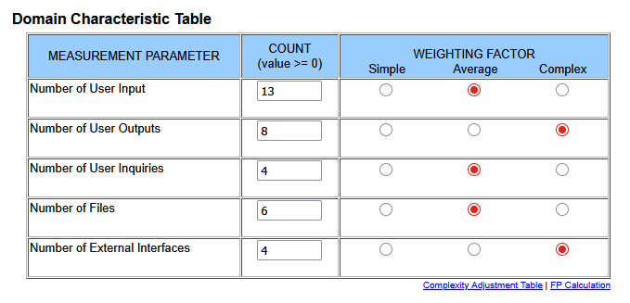
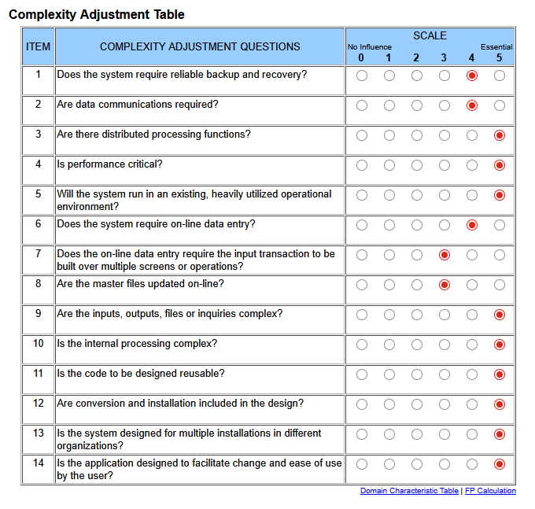
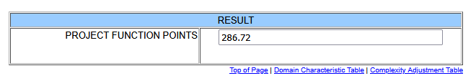

5.2 Schema Design
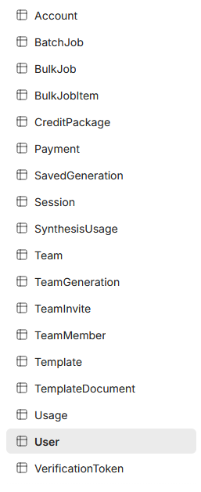
User
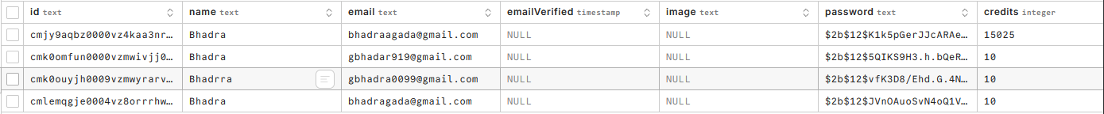

Usage
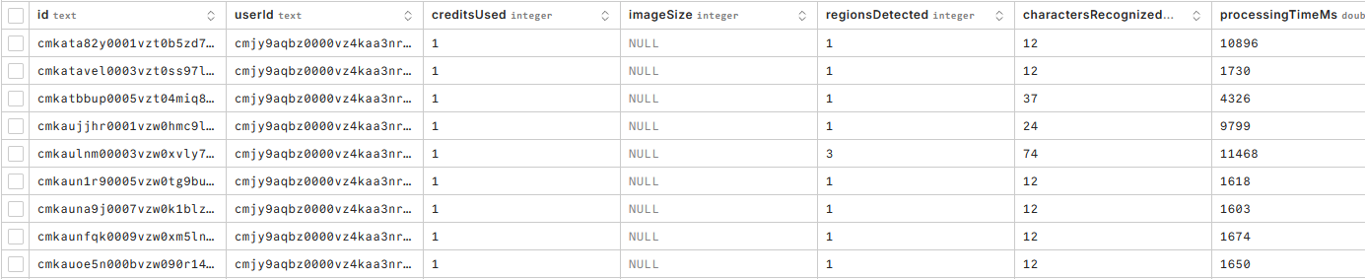
Team Member
Team Invite
Team Generation
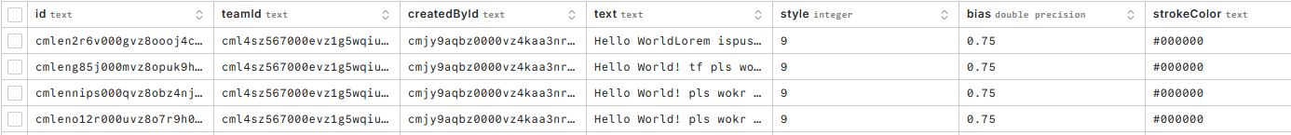
Team
SynthesisUsage
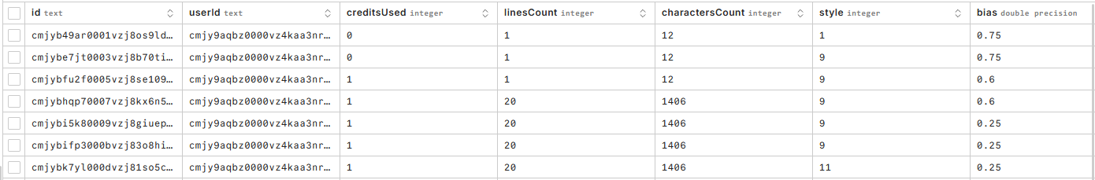
SaveGeneration
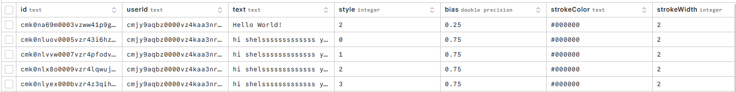

Payment
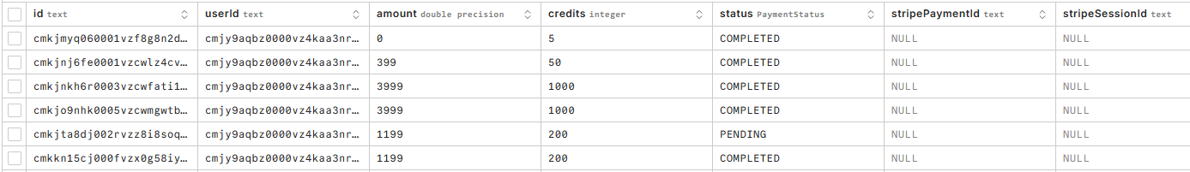
BulkJobItem
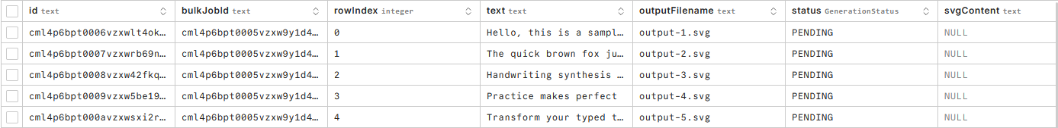
BulkJob
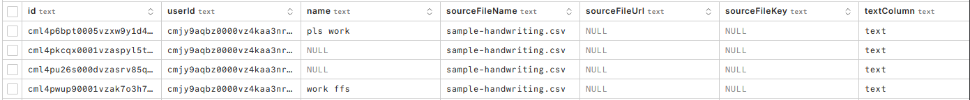

5.3 User Manual with Screenshots
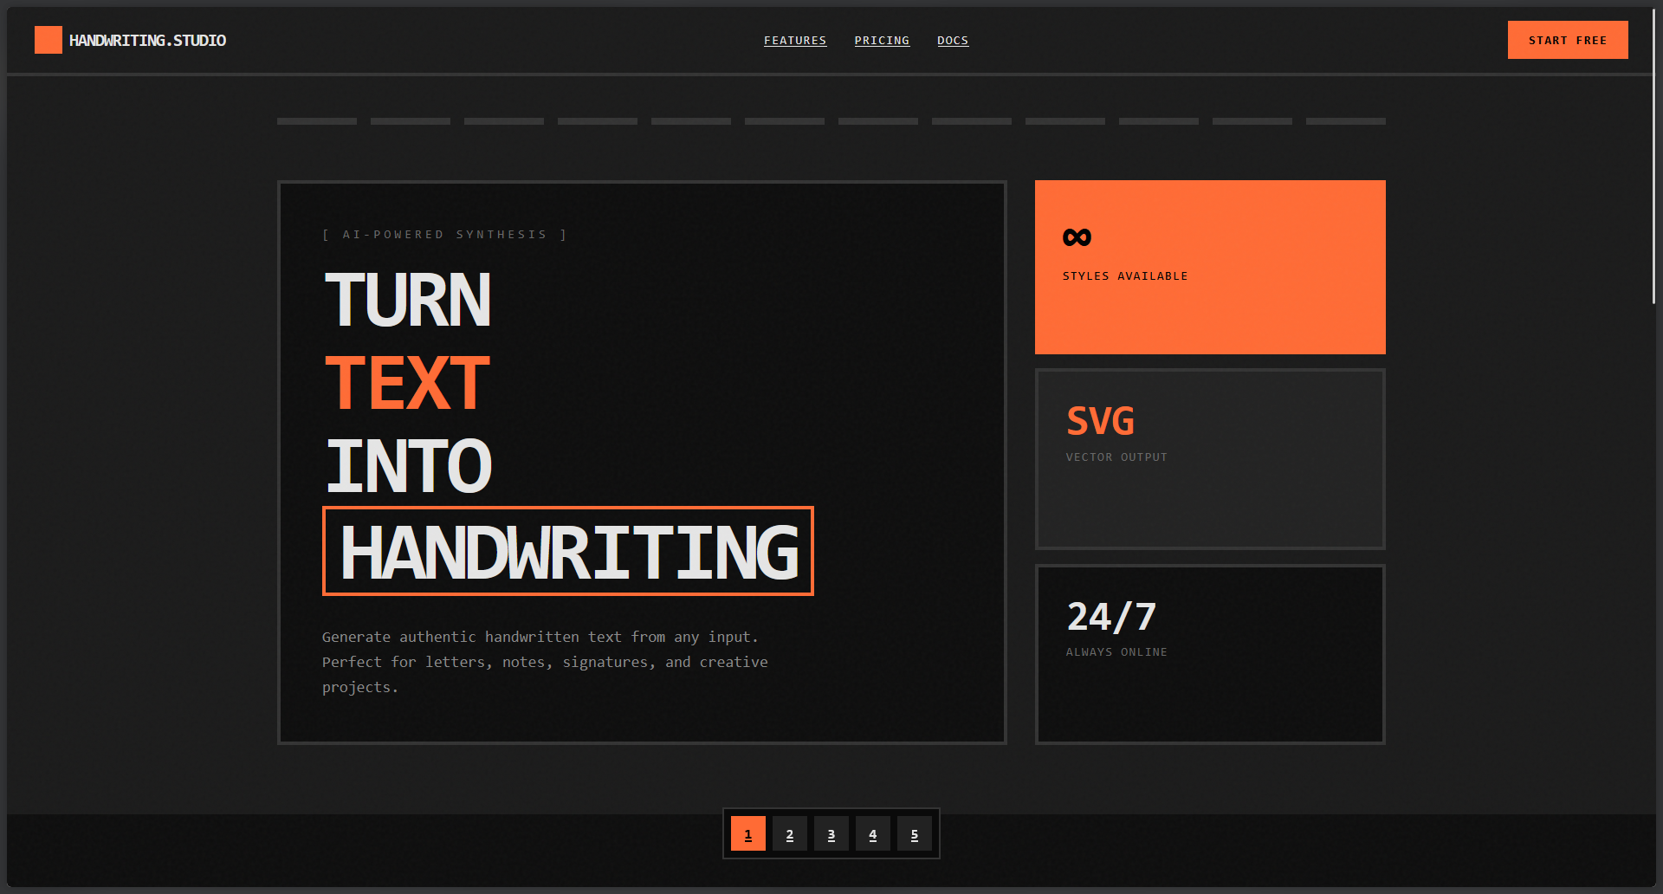

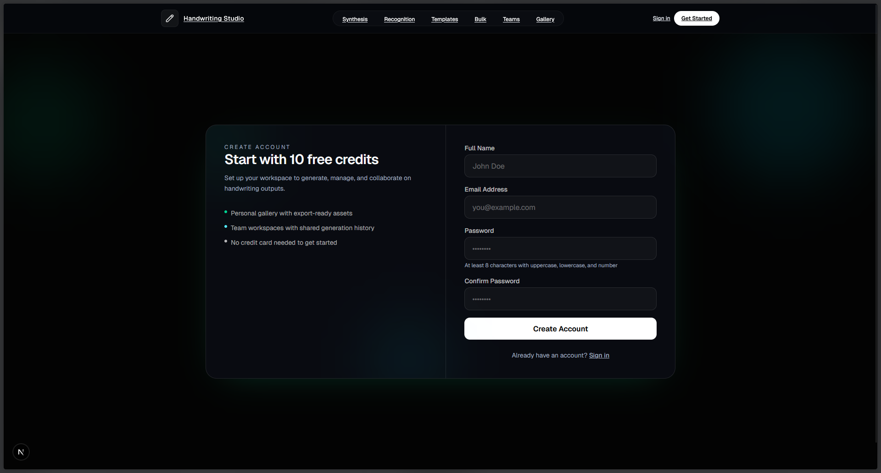

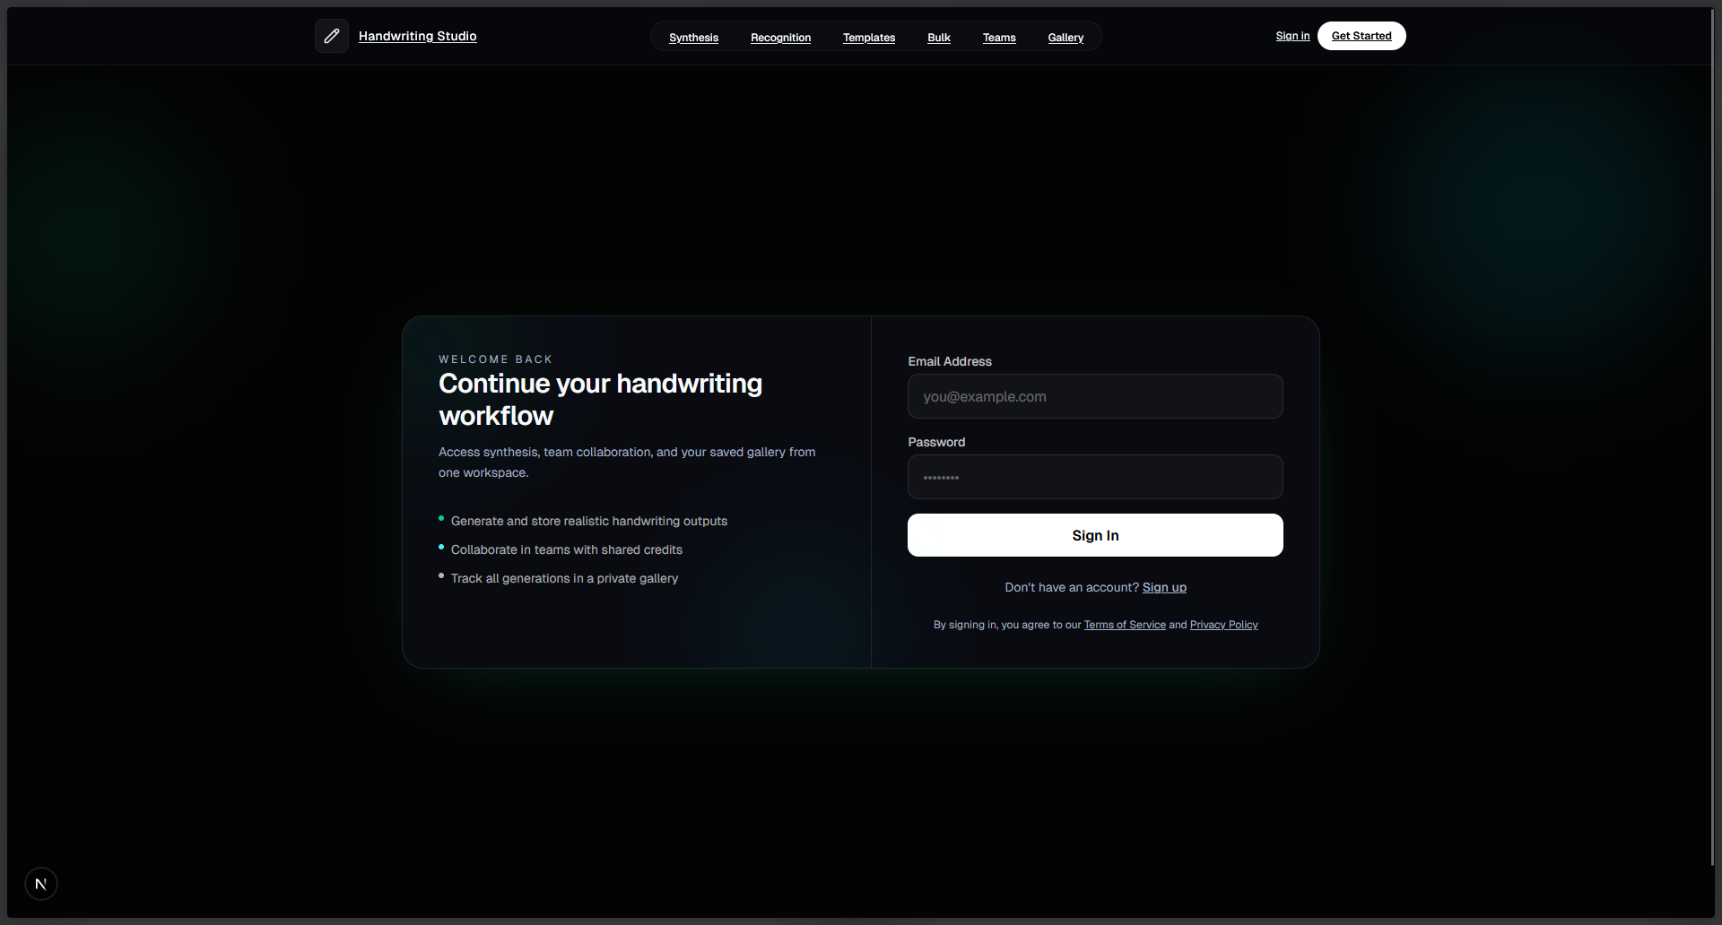

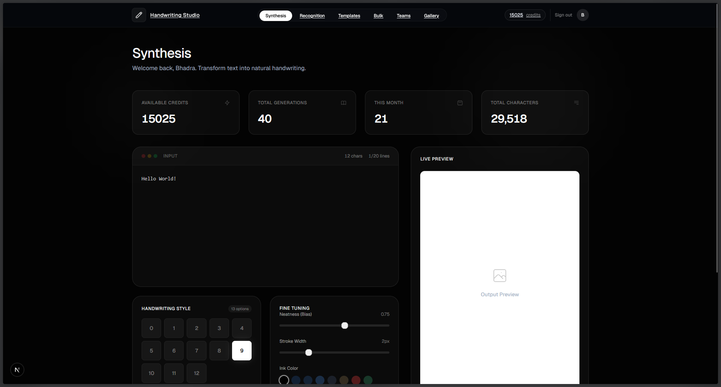

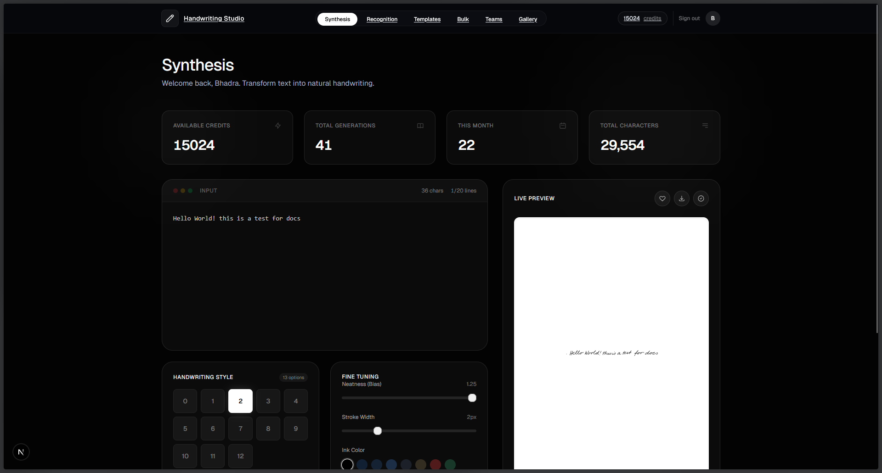

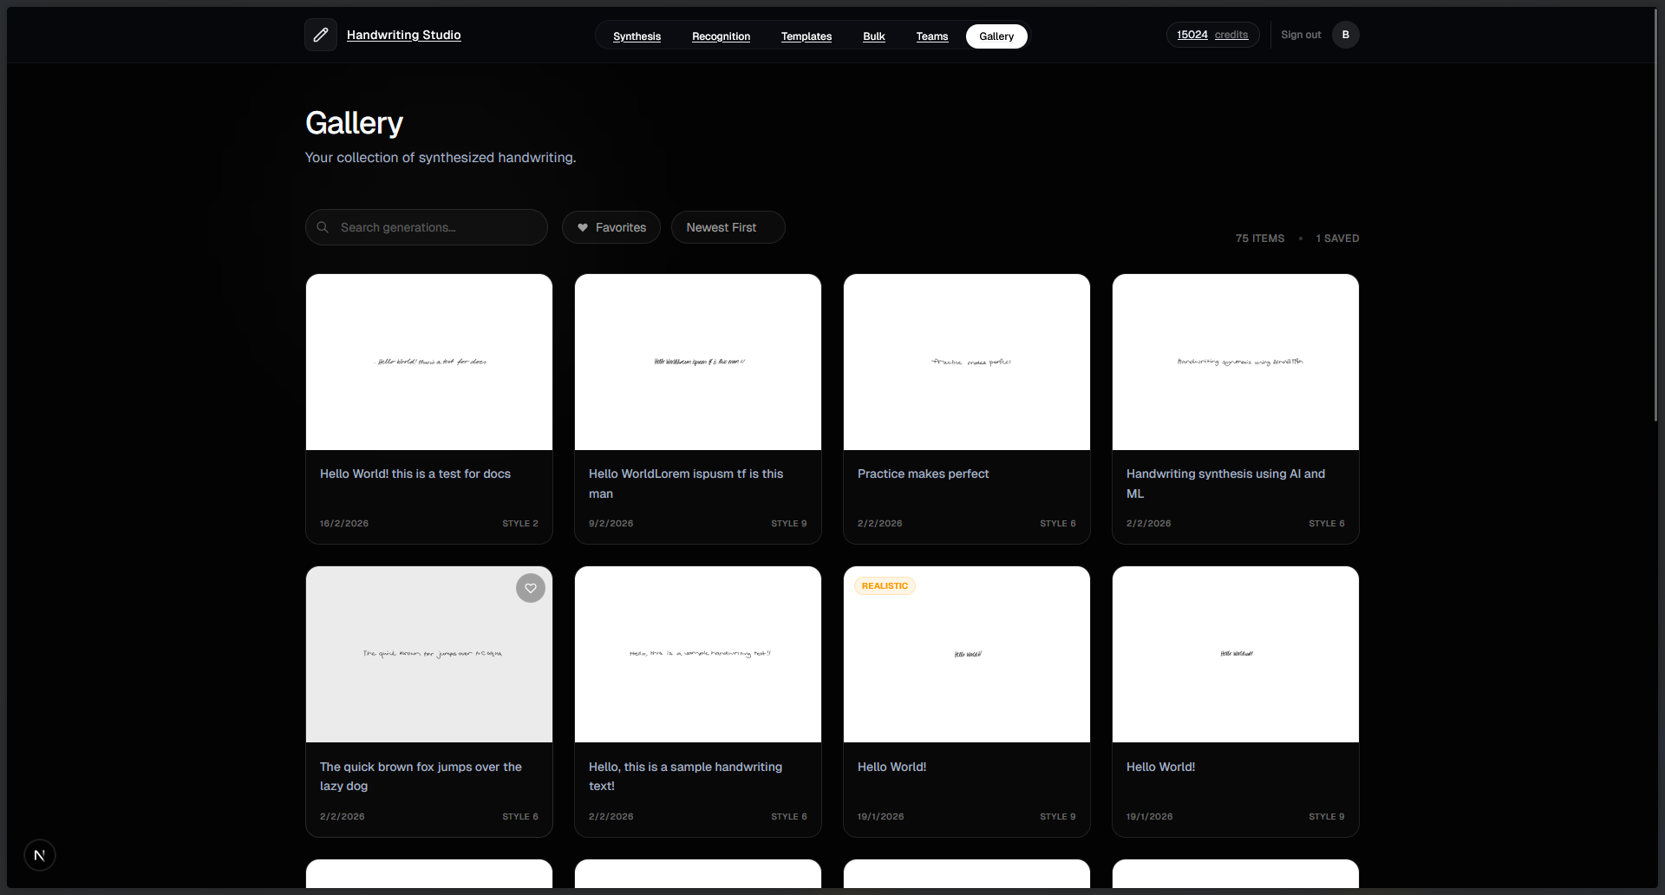

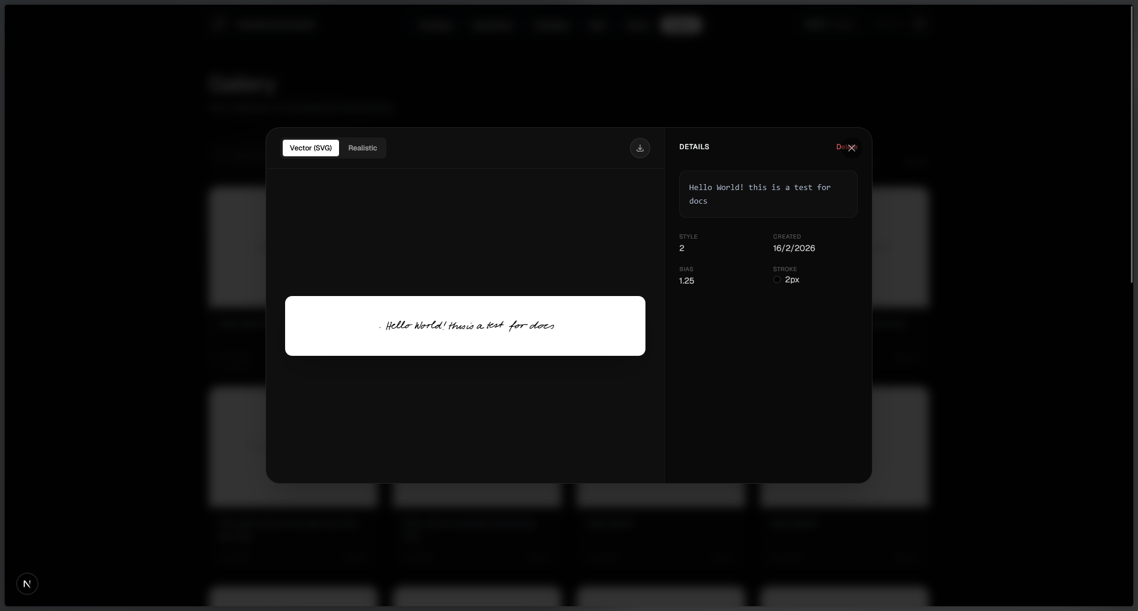

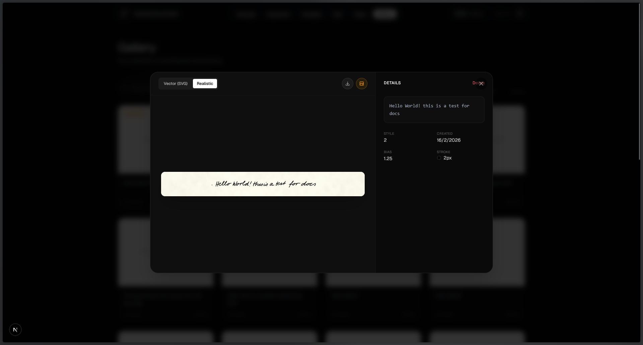

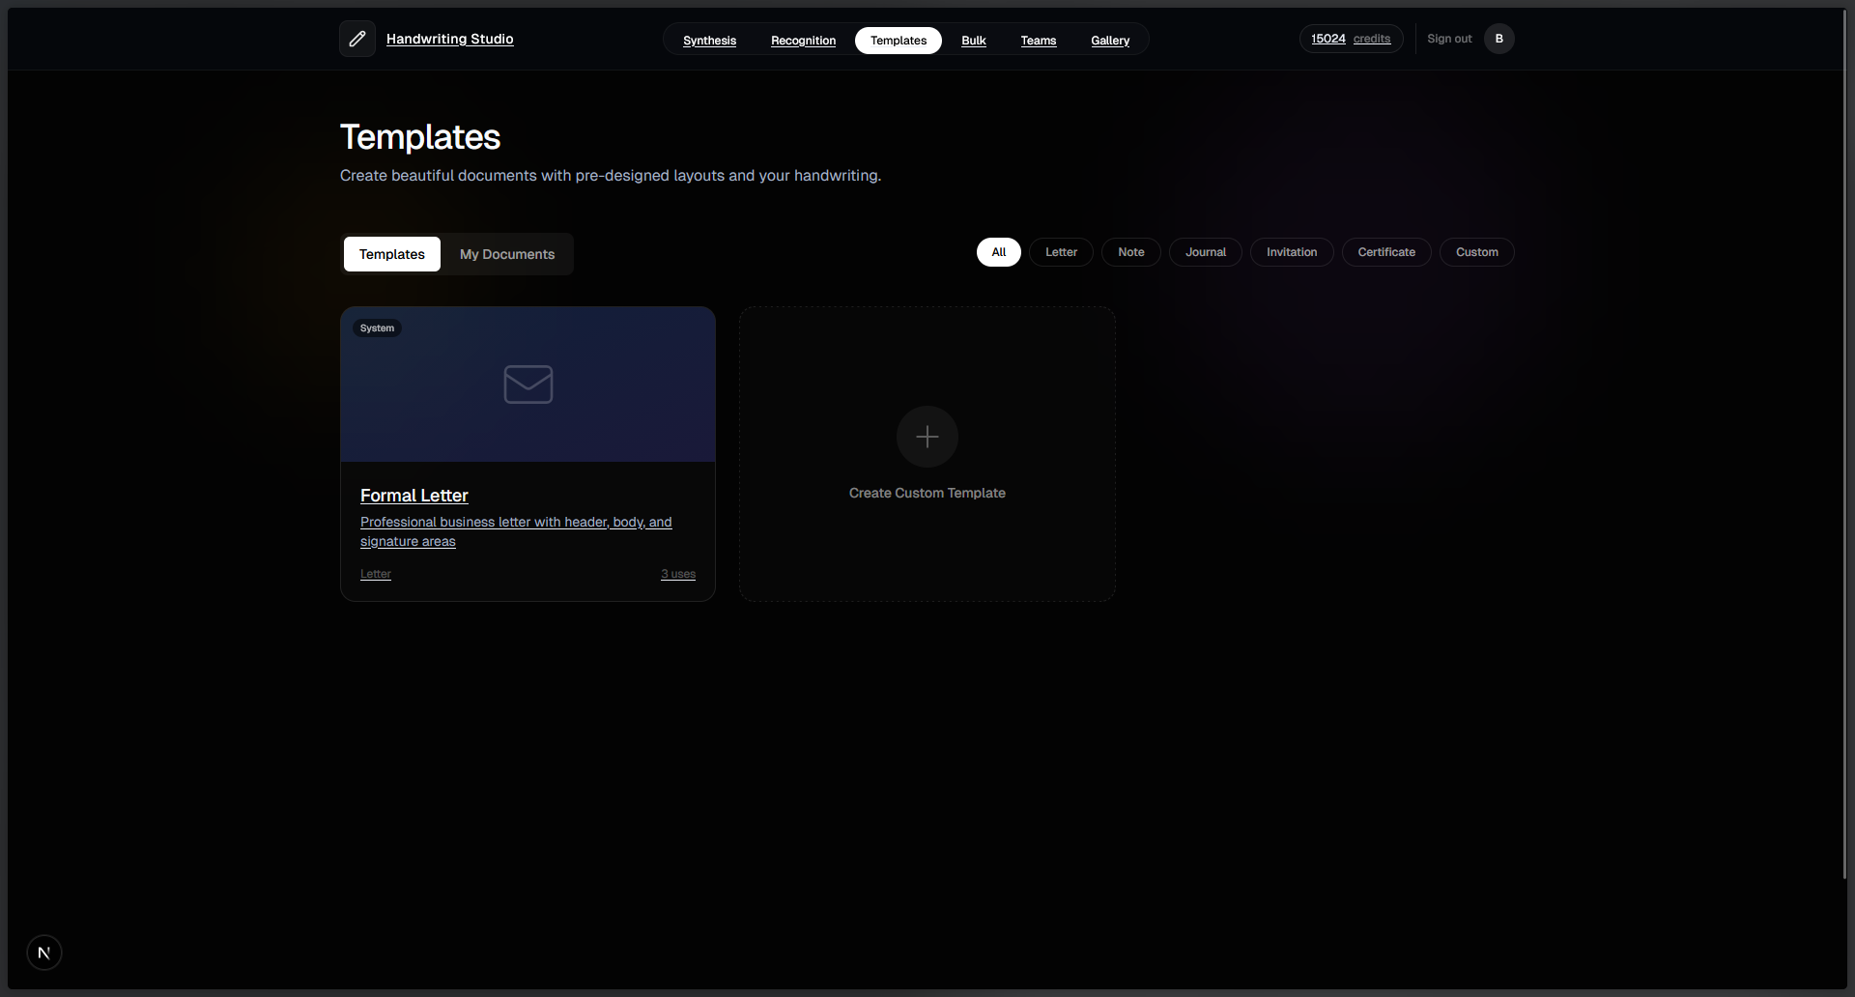

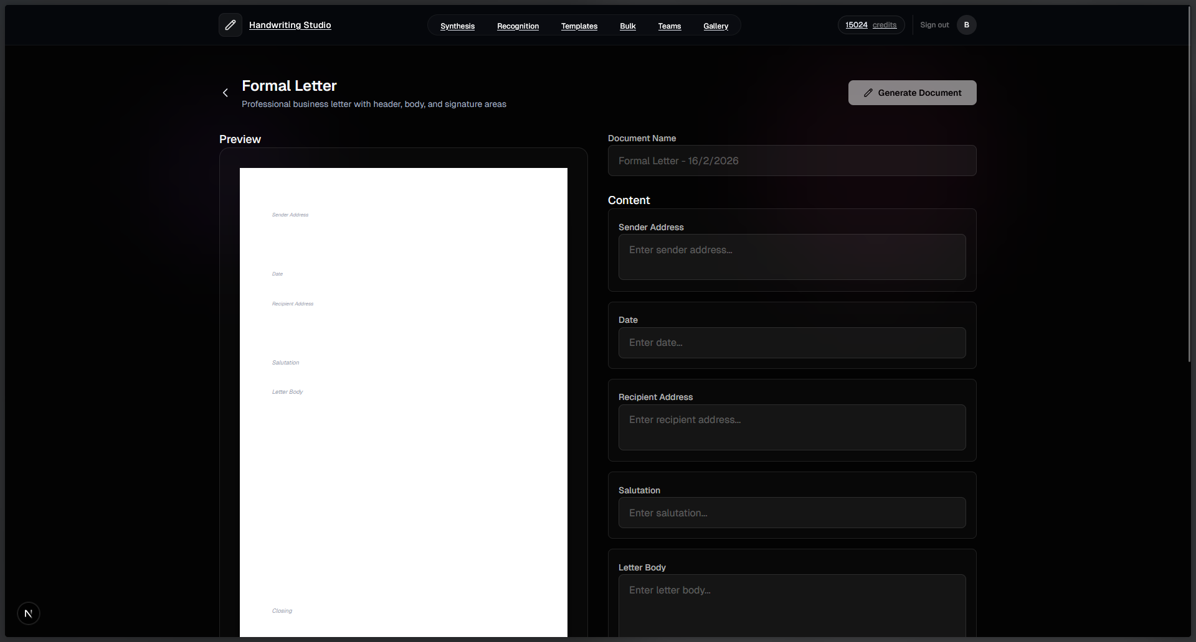

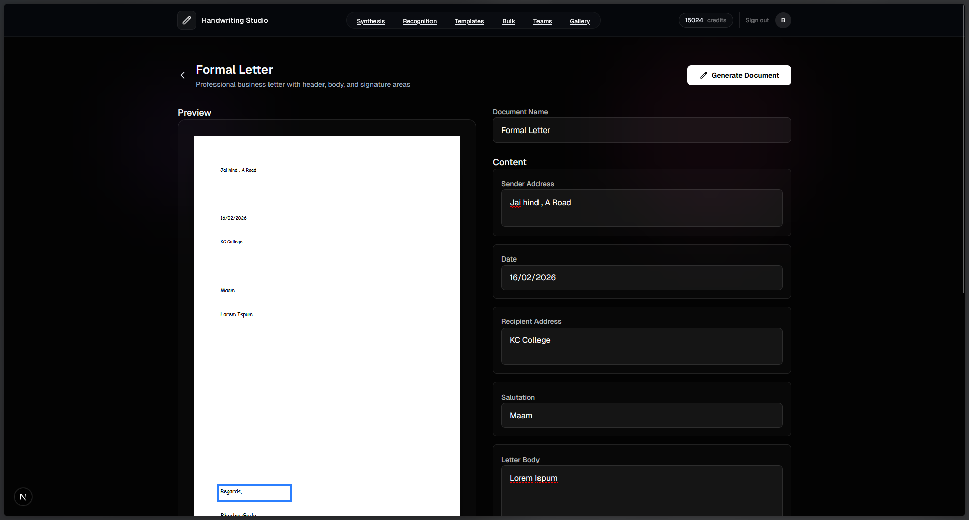

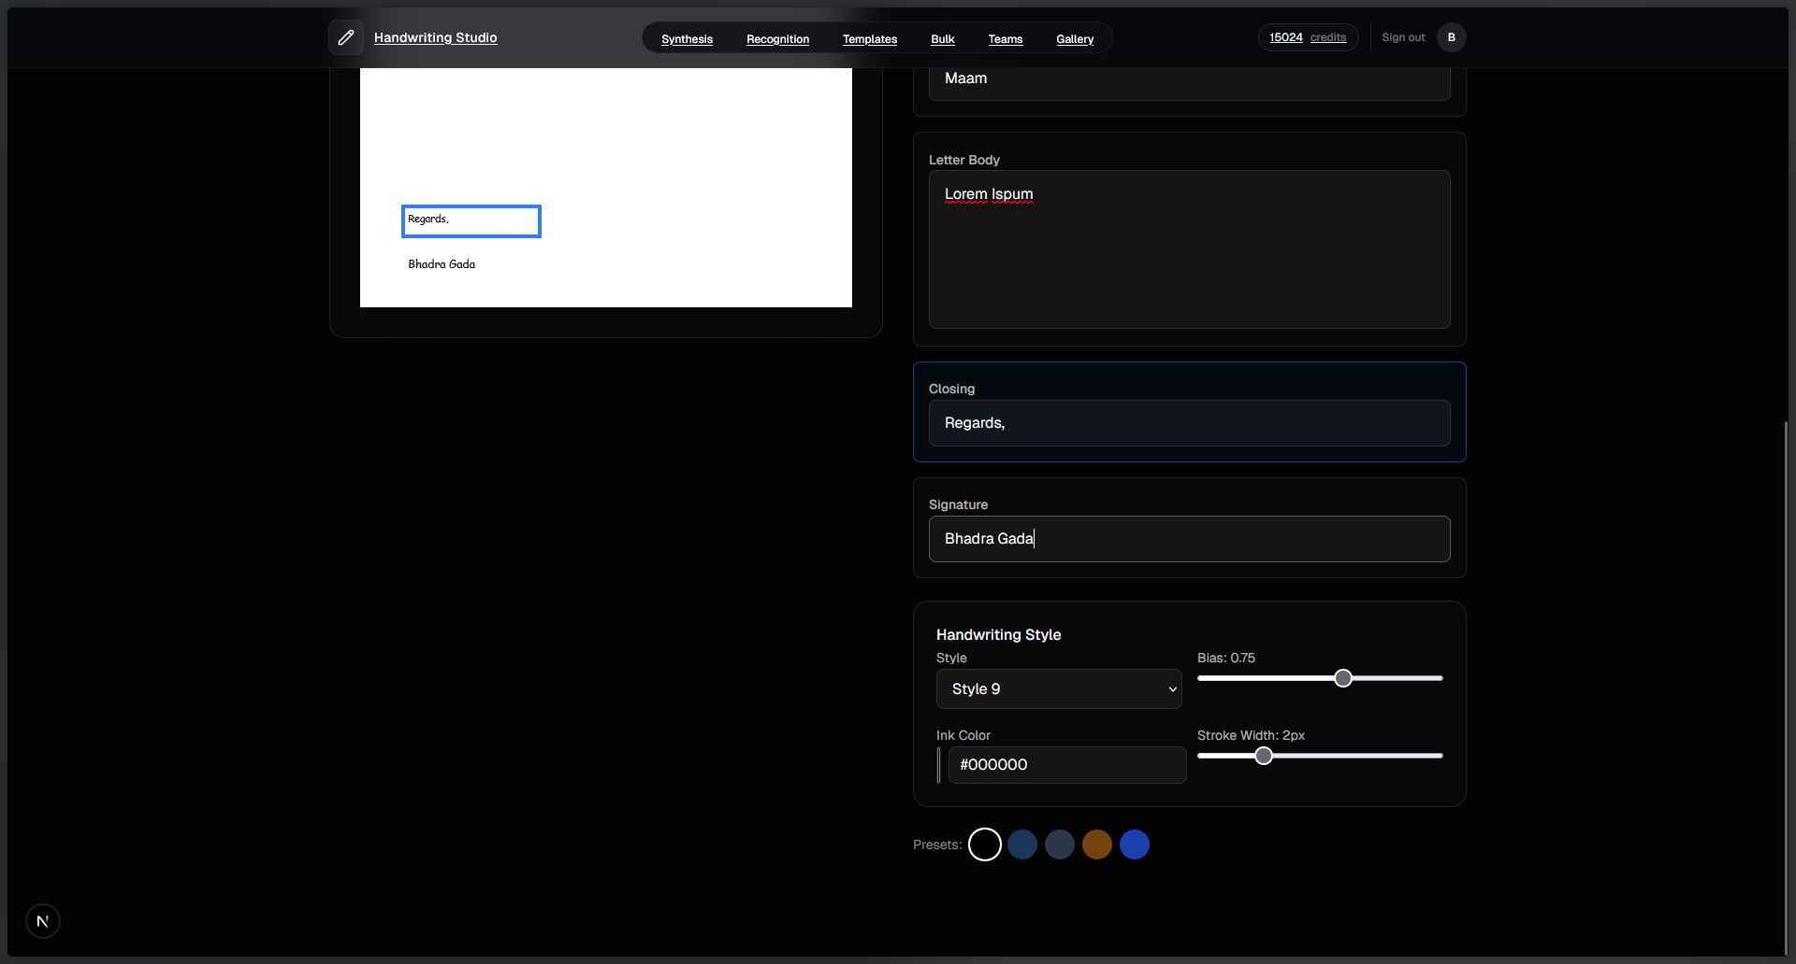

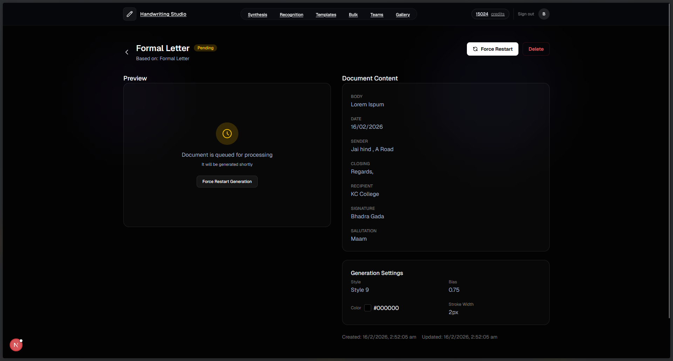

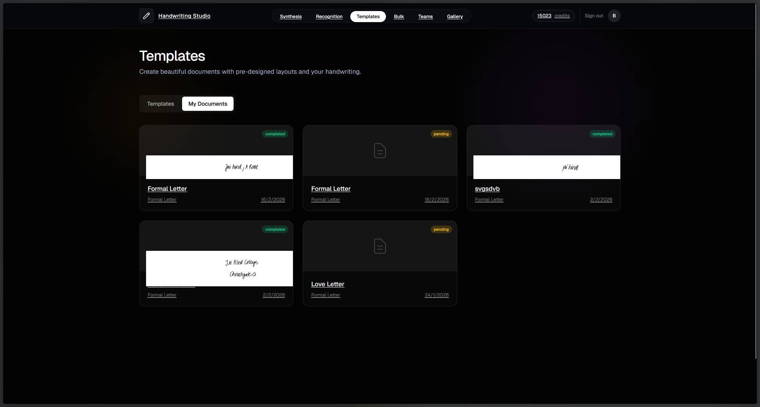

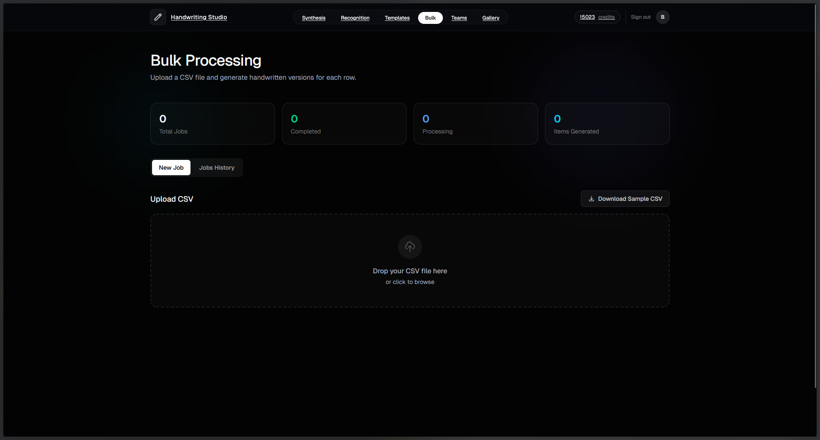

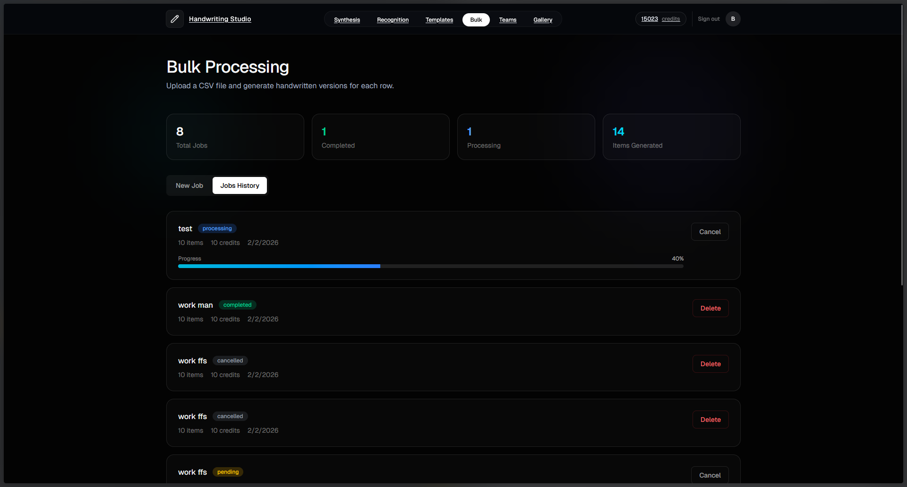

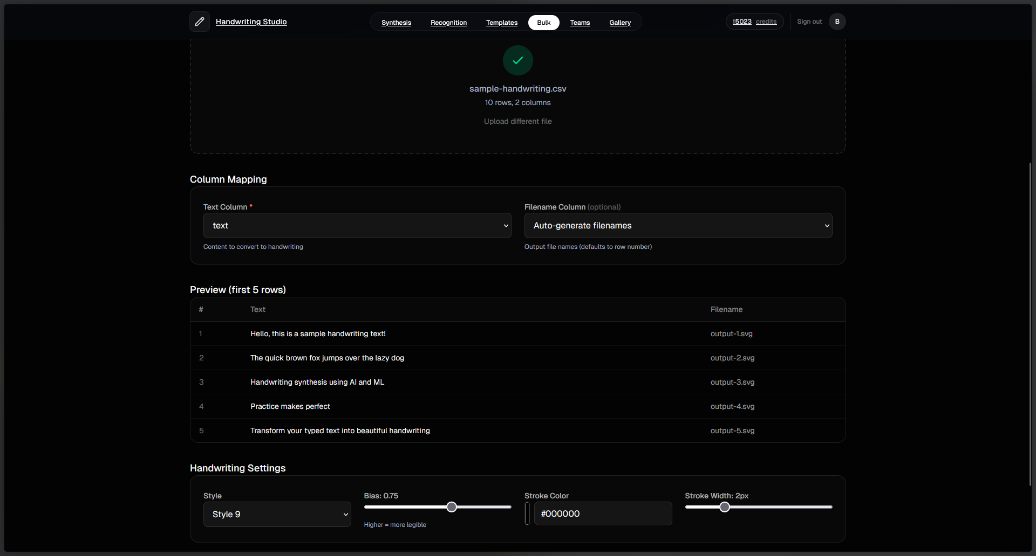

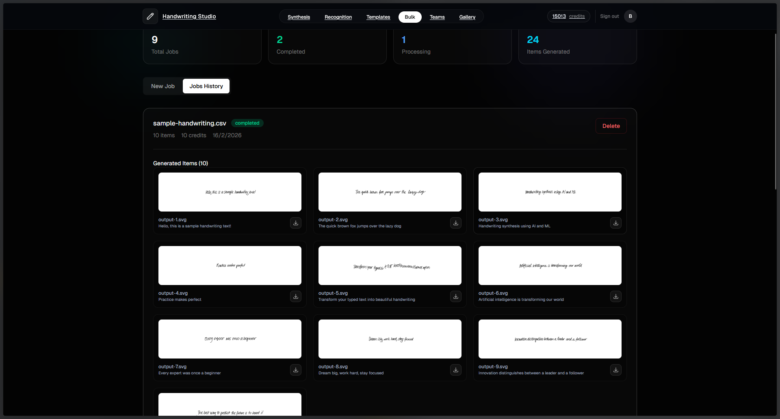

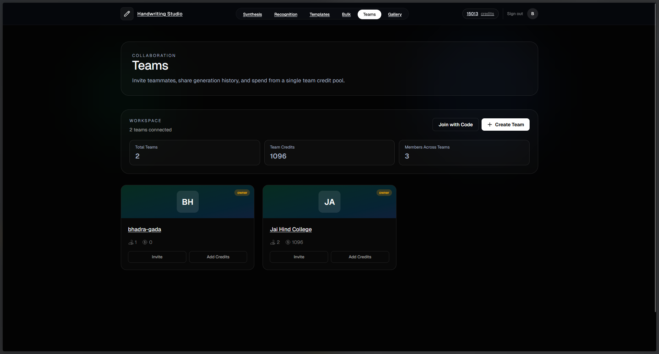

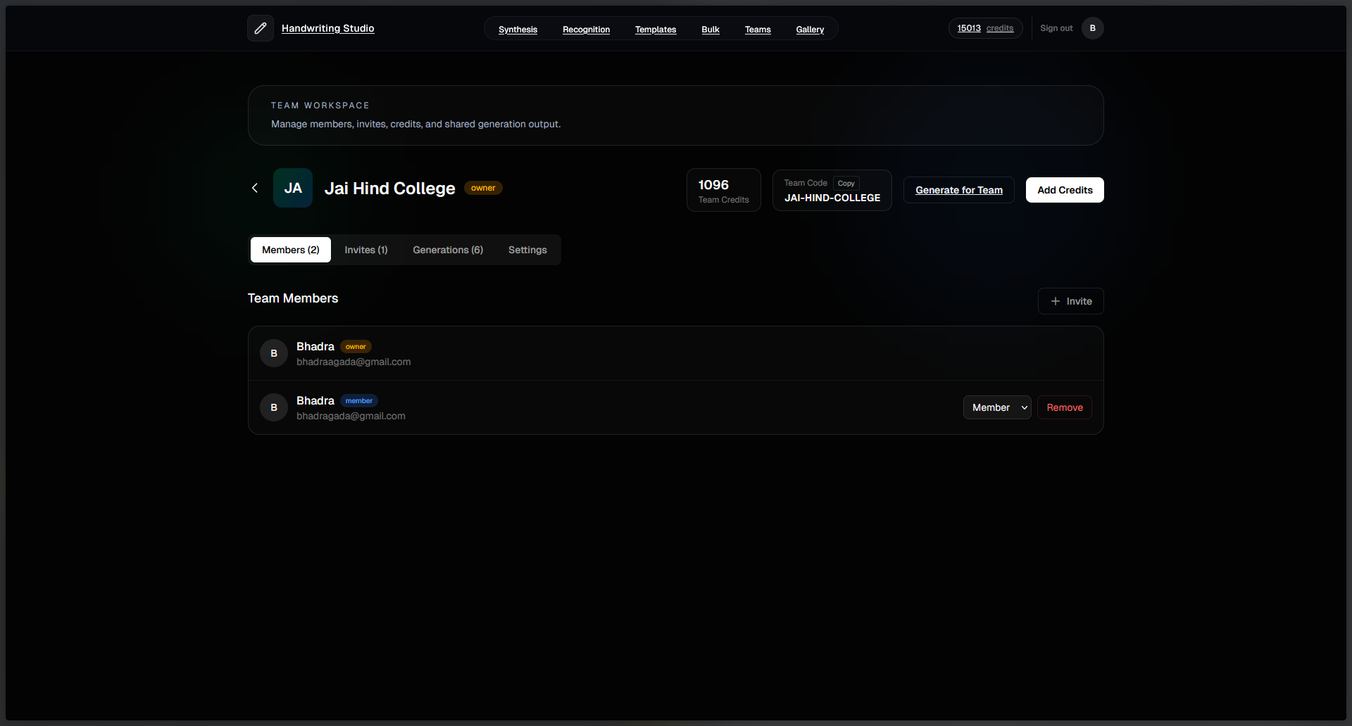

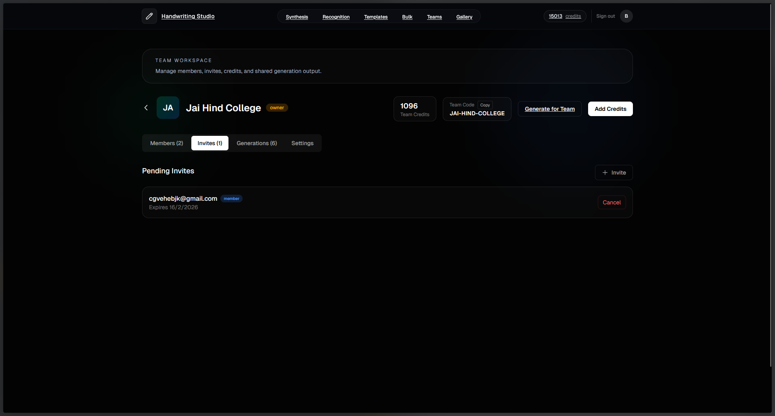

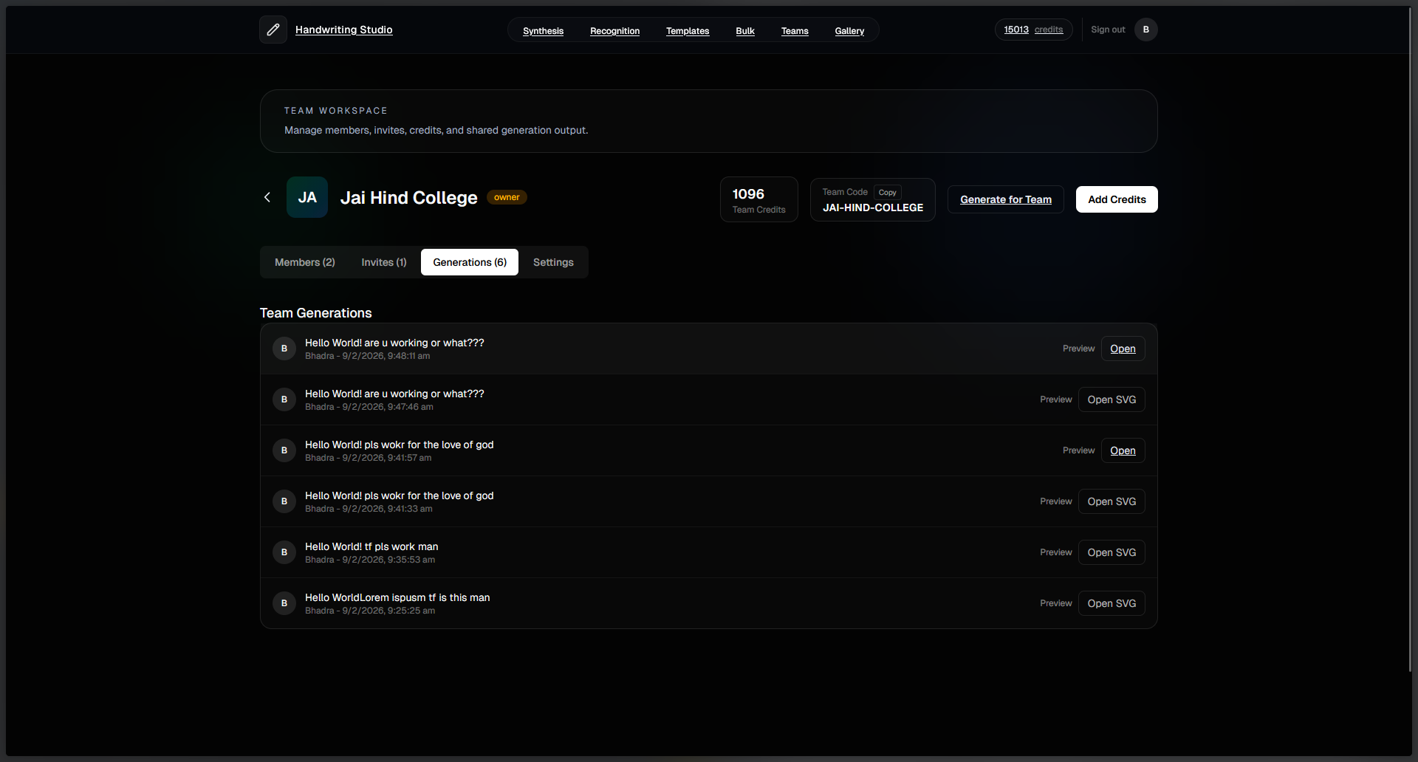

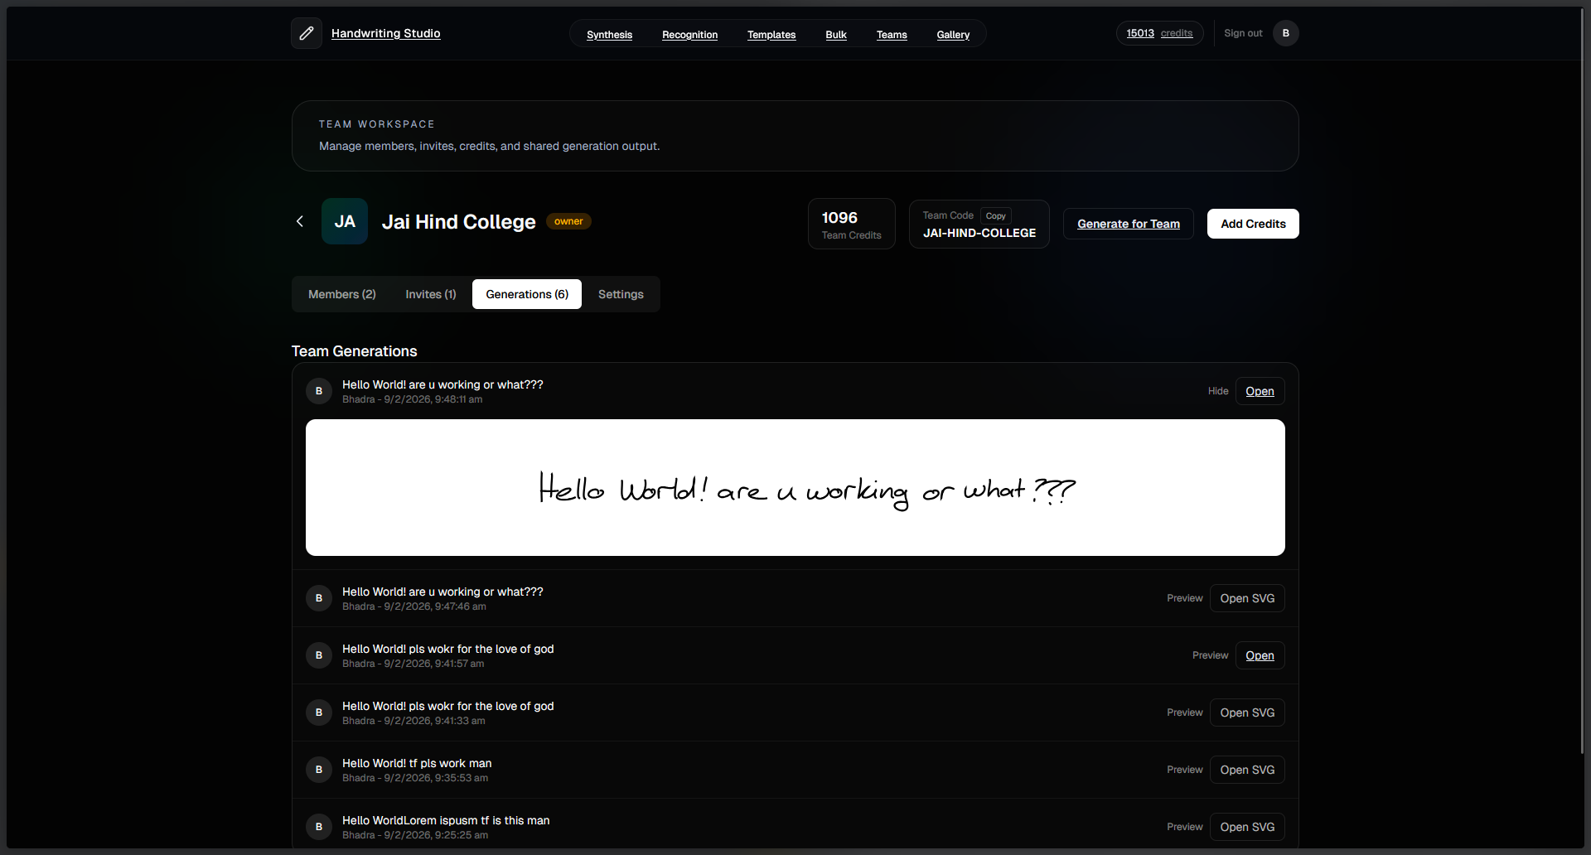

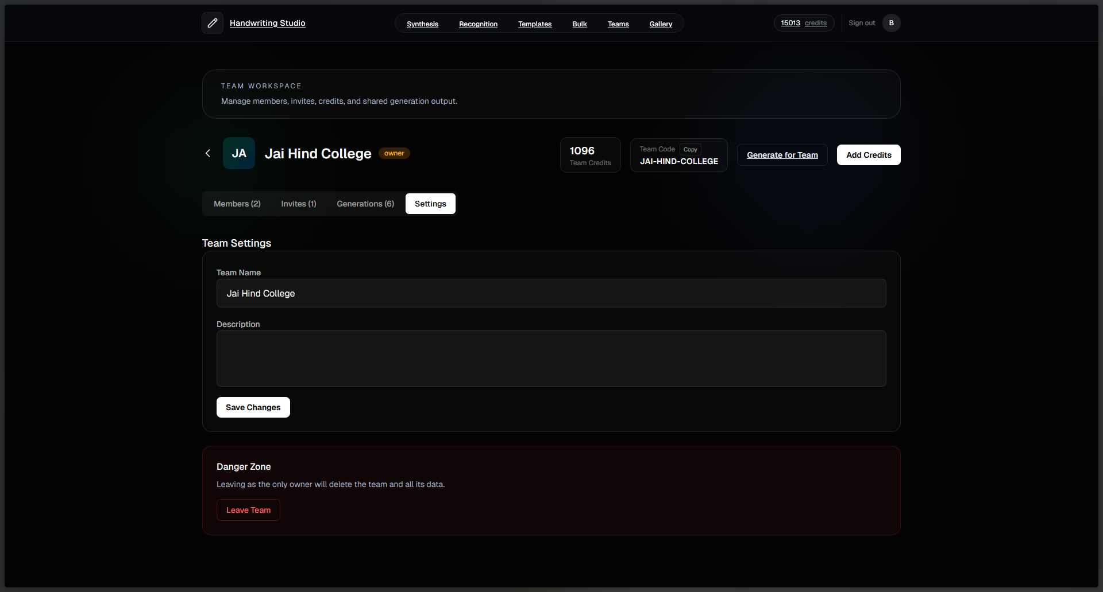

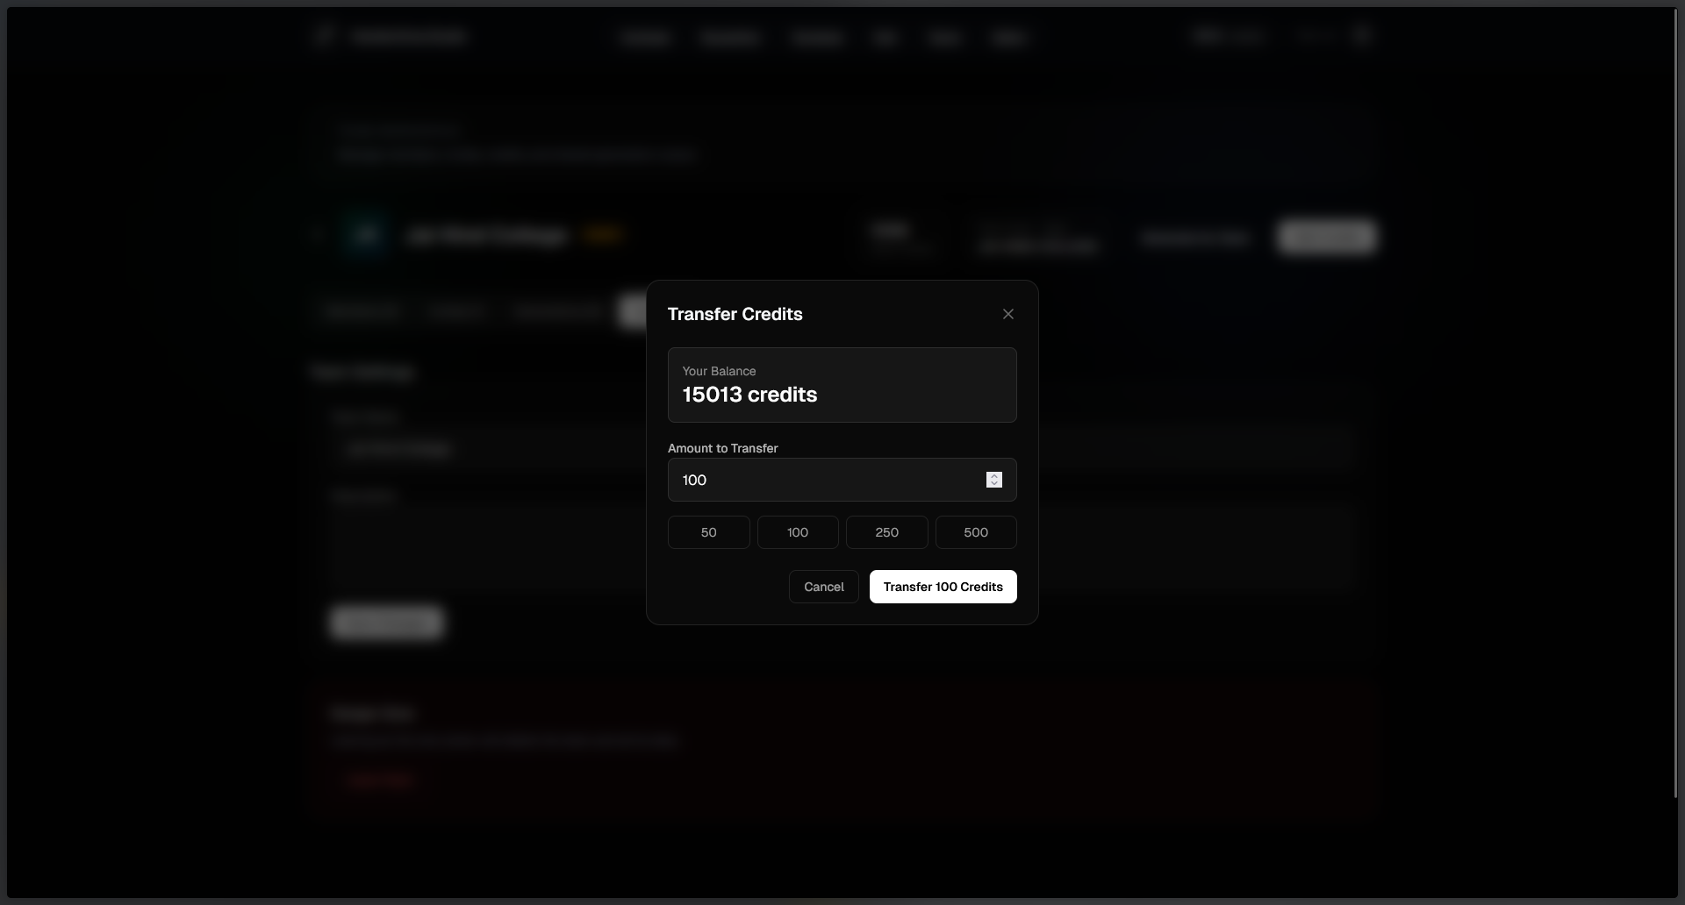

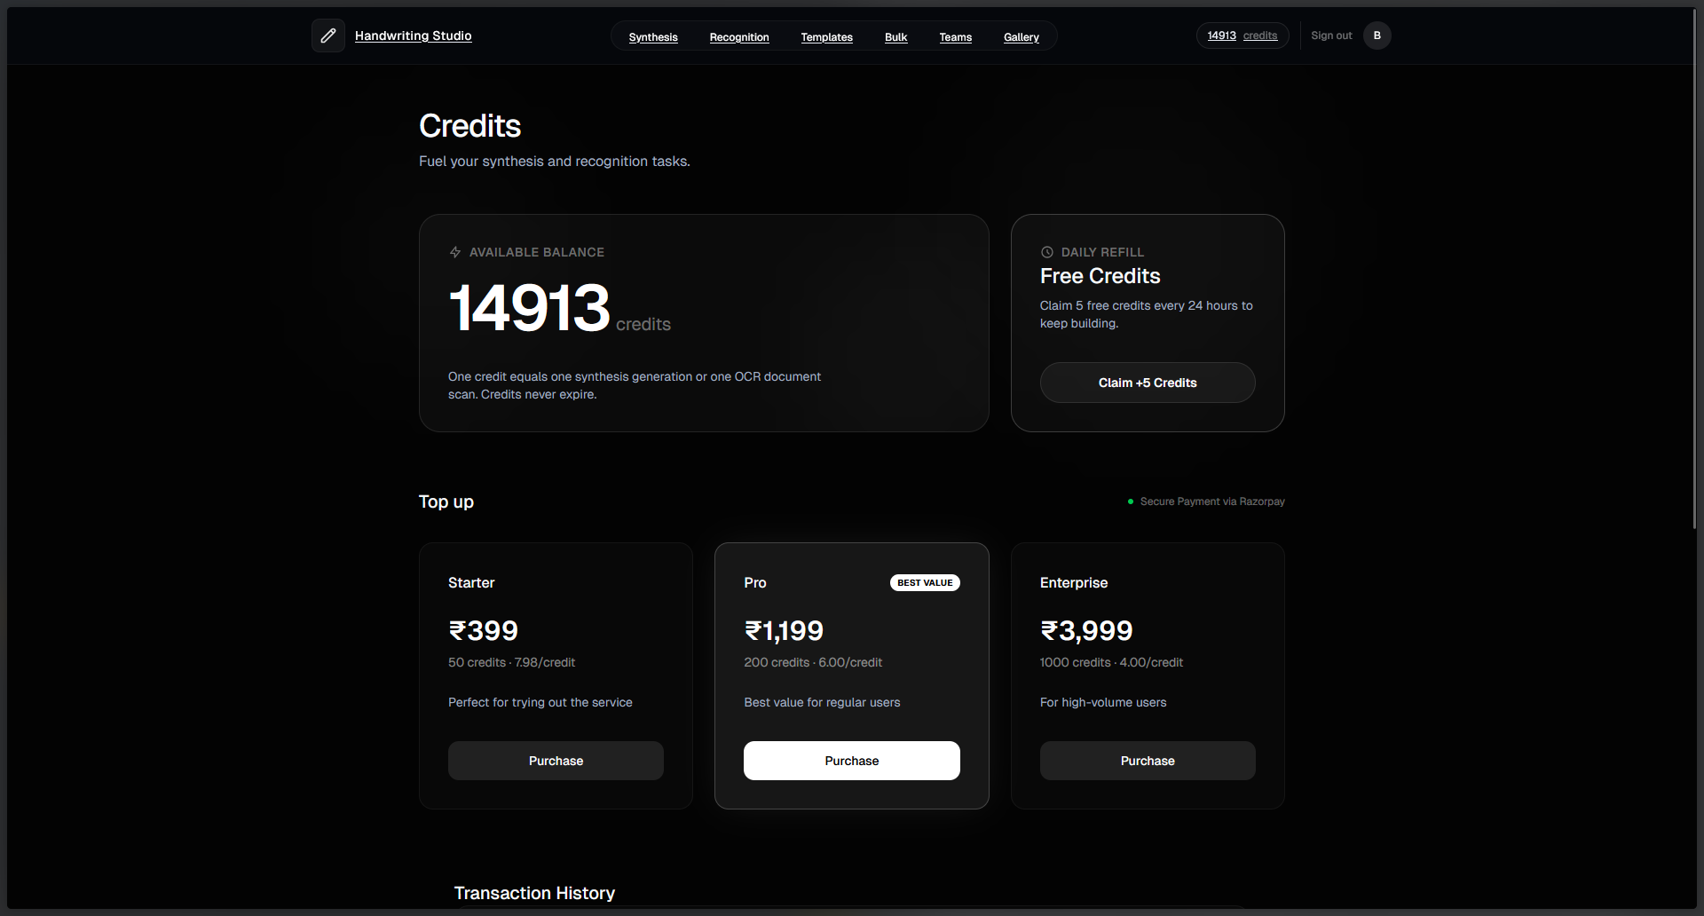

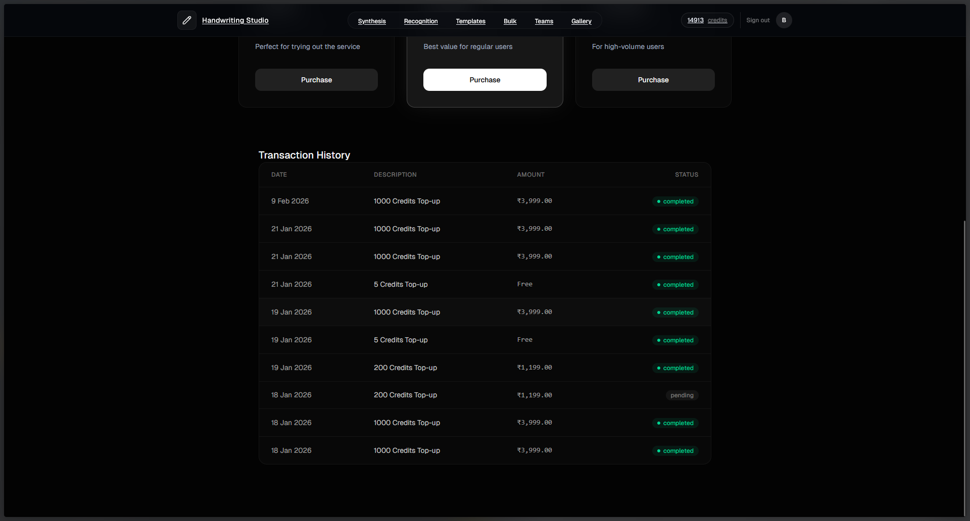

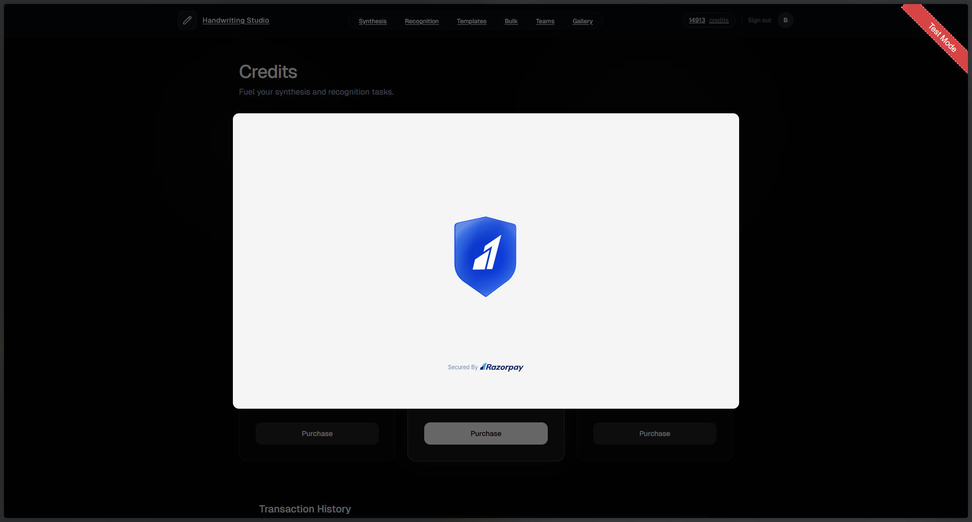

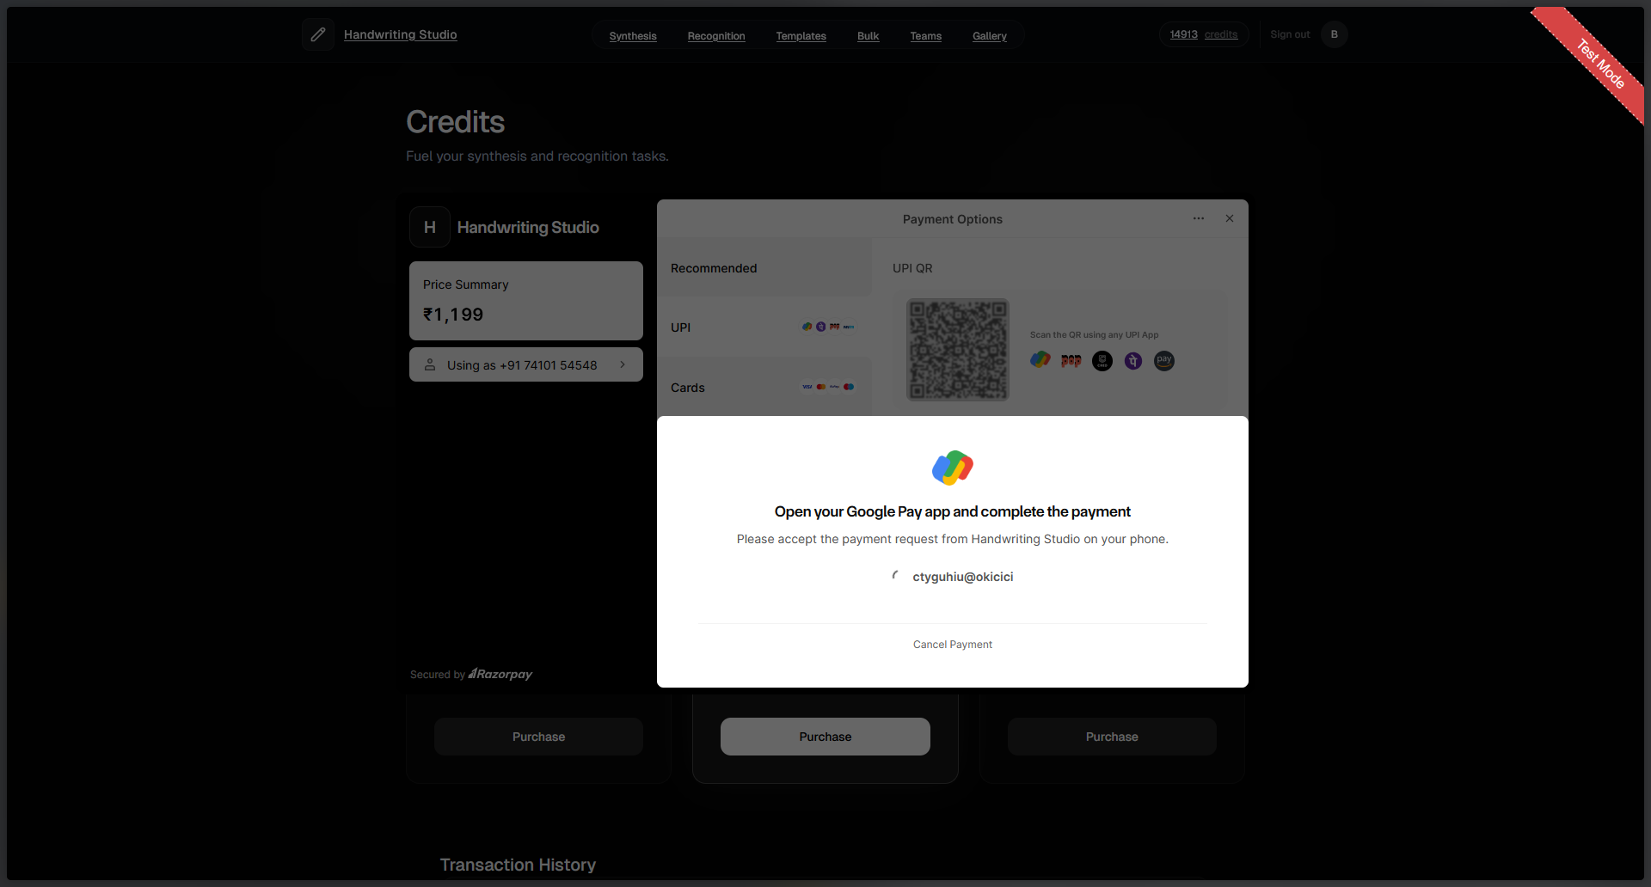

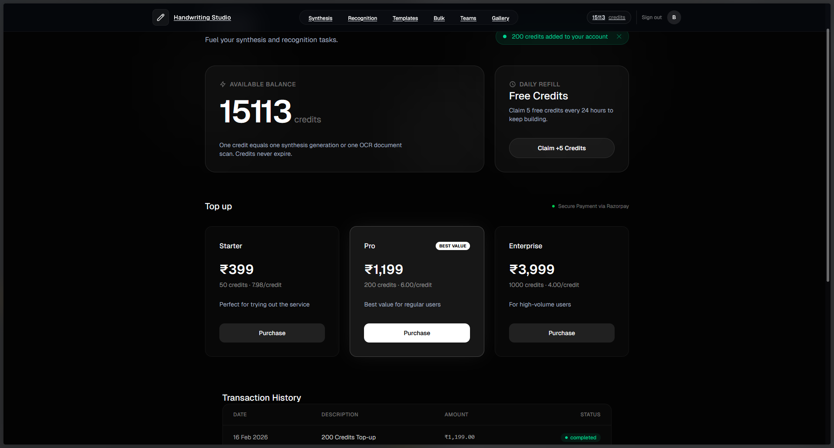
5.4 Test Cases Design
5.4.1 Authentication Test Cases
Test Case ID | Test Case Description | Pre-Conditions | Test Steps | Expected Result | Actual Result | Status
TC_001 | Verify user registration with valid details | User does not exist | 1) Open registration page. 2) Enter valid full name, email, password. 3) Submit form. | New user is created with unique userId; createdAt set to current time; credits = 10 | As expected | Pass
TC_002 | Verify registration fails for duplicate email | A user with same email exists | 1) Open registration page. 2) Enter existing email + valid details. 3) Submit. | Registration rejected; "email already in use" error shown. | As expected | Pass
TC_003 | Verify login with valid credentials | User account exists and verified | 1) Open login. 2) Enter valid email & password (or Google OAuth). 3) Submit. | User session created; redirected to Dashboard. | As expected | Pass
TC_004 | Verify login fails with wrong password | User exists | 1) Open login. 2) Enter valid email + wrong password. 3) Submit. | Error shown; no session created. | As expected | Pass
TC_005 | Verify Google OAuth login | User has Google account | 1) Click "Continue with Google". 2) Complete OAuth flow. | User authenticated; account linked if new. | As expected | Pass

5.4.2 Synthesis Generation Test Cases
Test Case ID | Test Case Description | Pre-Conditions | Test Steps | Expected Result | Actual Result | Status
TC_006 | Generate handwriting with valid text | User logged in; credits > 0 | 1) Enter "Hello World". 2) Select style 9. 3) Click Generate. | SVG generated; displayed in preview; 1 credit deducted. | As expected | Pass
TC_007 | Verify empty text rejection | User logged in | 1) Leave text field empty. 2) Click Generate. | Validation error: "Text cannot be empty" | As expected | Pass
TC_008 | Verify invalid character rejection | User logged in | 1) Enter "Hello @World". 2) Click Generate. | Validation error listing invalid characters. | As expected | Pass
TC_009 | Verify line limit enforcement | User logged in | 1) Enter text with 25 lines. 2) Click Generate. | Validation error: "Maximum 20 lines allowed" | As expected | Pass
TC_010 | Verify character limit per line | User logged in | 1) Enter line with 80 characters. 2) Click Generate. | Validation error: "Line exceeds 75 characters" | As expected | Pass
TC_011 | Verify insufficient credits error | User logged in; credits = 0 | 1) Enter valid text. 2) Click Generate. | Error: "Insufficient credits"; generation blocked. | As expected | Pass
TC_012 | Verify style range (0-12) | User logged in | 1) Attempt style = 15 via API. | Validation error: style must be 0-12 | As expected | Pass
TC_013 | Verify bias range (0.0-1.5) | User logged in | 1) Set bias = 2.0. 2) Click Generate. | Validation error: bias must be 0.0-1.5 | As expected | Pass

5.4.3 Gallery Test Cases
Test Case ID | Test Case Description | Pre-Conditions | Test Steps | Expected Result | Actual Result | Status
TC_014 | Save generation to gallery | User logged in; generation exists | 1) Generate handwriting. 2) Click "Save to Gallery". | Generation saved with unique id; appears in gallery. | As expected | Pass
TC_015 | View gallery items | User logged in; has saved items | 1) Navigate to Gallery tab. | All user's generations displayed in grid view. | As expected | Pass
TC_016 | Mark generation as favorite | User logged in; item exists | 1) Click heart icon on item. | isFavorite set to true; icon filled. | As expected | Pass
TC_017 | Add tags to generation | User logged in; item exists | 1) Click tag icon. 2) Enter "important". 3) Save. | Tag added to generation's tags array. | As expected | Pass
TC_018 | Delete generation | User logged in; item exists | 1) Click trash icon. 2) Confirm deletion. | Generation removed from database; removed from view. | As expected | Pass
TC_019 | Filter by favorites | User has favorites | 1) Click "Favorites" filter. | Only items with isFavorite=true shown. | As expected | Pass
TC_020 | Search generations by text | User has generations | 1) Enter search term. 2) Press Enter. | Only matching generations displayed. | As expected | Pass

5.4.4 Realistic Rendering Test Cases
Test Case ID | Test Case Description | Pre-Conditions | Test Steps | Expected Result | Actual Result | Status
TC_021 | Apply realistic rendering | User logged in; generation saved | 1) Select generation. 2) Click "Make Realistic". 3) Select paper=cream, ink=ballpoint. 4) Apply. | Realistic PNG generated; realisticPng field populated. | As expected | Pass
TC_022 | Verify paper type options | User on realistic modal | 1) Open paper type dropdown. | Options: white, cream, aged, lined, grid, recycled. | As expected | Pass
TC_023 | Verify ink type options | User on realistic modal | 1) Open ink type dropdown. | Options: ballpoint, gel, fountain, marker, pencil. | As expected | Pass
TC_024 | Verify wear level bounds | User on realistic modal | 1) Adjust wear level slider. | Slider constrained to 0.0-1.0 range. | As expected | Pass
TC_025 | Download realistic PNG | Realistic rendering complete | 1) Click "Download PNG". | PNG file downloaded with paper texture and ink effects. | As expected | Pass

5.4.5 Batch Processing Test Cases
Test Case ID | Test Case Description | Pre-Conditions | Test Steps | Expected Result | Actual Result | Status
TC_026 | Create batch job | User logged in; credits >= variants | 1) Enter text. 2) Select 3 styles. 3) Click "Generate Batch". | BatchJob created with status=PENDING; 3 generations queued. | As expected | Pass
TC_027 | Verify batch progress tracking | Batch job processing | 1) View batch jobs panel. | Progress bar updates; completedCount increments. | As expected | Pass
TC_028 | Verify batch completion | All variants generated | 1) Wait for batch to complete. | Status=COMPLETED; all generations in gallery. | As expected | Pass
TC_029 | Verify insufficient credits for batch | User credits < variants | 1) Select 5 styles. 2) Have only 3 credits. | Error: "Insufficient credits for batch"; job not created. | As expected | Pass
TC_030 | Verify variant limit (1-13) | User logged in | 1) Try to select 15 styles via API. | Validation error: max 13 variants allowed. | As expected | Pass

5.4.6 API Integration Test Cases
Test Case ID | Test Case Description | Pre-Conditions | Test Steps | Expected Result | Actual Result | Status
TC_031 | Verify API health check | API server running | 1) GET /health endpoint. | Response: status=healthy, model info returned. | As expected | Pass
TC_032 | Verify unauthorized API access | No session token | 1) Call protected endpoint without auth. | 401 Unauthorized error returned. | As expected | Pass
TC_033 | Verify API rate limiting | Multiple rapid requests | 1) Send 100 requests in 10 seconds. | Rate limiting applied; 429 Too Many Requests after threshold. | As expected | Pass
TC_034 | Verify CORS configuration | Request from allowed origin | 1) Make request from frontend domain. | Request allowed; proper CORS headers returned. | As expected | Pass
TC_035 | Verify file upload limits | User uploading file | 1) Try to upload 10MB SVG file. | Error: file exceeds 4MB limit. | As expected | Pass

5.4.7 Security Test Cases
Test Case ID | Test Case Description | Pre-Conditions | Test Steps | Expected Result | Actual Result | Status
TC_036 | Verify ownership check on gallery | User A and User B exist | 1) User A tries to access User B's generation by ID. | NOT_FOUND error returned (not FORBIDDEN). | As expected | Pass
TC_037 | Verify password hashing | User registered | 1) Check database for password field. | Password stored as bcrypt hash, not plaintext. | As expected | Pass
TC_038 | Verify session expiration | Session exists | 1) Wait for session to expire. 2) Try to access protected route. | Redirect to login; session invalidated. | As expected | Pass
TC_039 | Verify XSS prevention | User logged in | 1) Enter <script>alert('xss')</script> as text. | Text escaped/sanitized; no script execution. | As expected | Pass
TC_040 | Verify SQL injection prevention | User logged in | 1) Enter '; DROP TABLE users; -- as text. | Query parameterized; no SQL injection. | As expected | Pass

6 Conclusion
6.1 Conclusion
The Handwriting Synthesis Web Application demonstrates how a focused, AI-powered system can transform digital text into realistic, personalized handwritten output with minimal user friction. By combining deep learning-based stroke generation (LSTM with Mixture Density Networks), flexible style customization (13 unique handwriting styles, adjustable neatness bias), and realistic post-processing effects (paper textures, ink variations, wear simulation), the application removes the common pain points of manual handwriting digitization. Neural handwriting generation via TensorFlow-based LSTM produces continuous stroke coordinates with natural-looking output, while multi-format support (SVG, PNG, PDF) and a robust T3 Stack architecture (Next.js 15, tRPC, Prisma, PostgreSQL) deliver responsive, type-safe experiences with real-time preview and seamless authentication. Background processing through Inngest enables asynchronous batch generation with progress tracking, and a comprehensive gallery management system allows users to save, organize, tag, and favorite their generations. Overall, the system centralizes creative handwriting tasks, improves productivity for users needing handwritten content, and scales to varied use cases with a modular, cloud-ready architecture that successfully bridges digital convenience with the personal touch of handwritten text.
6.2 Limitations of the System
- Character Set Constraints: The neural model does not support letters Q, X, and Z (uppercase) due to underrepresentation in training data. Only basic ASCII characters (a-z, A-Z, 0-9, common punctuation) are supported—no Unicode, accented letters, emojis, or special symbols. Input is limited to 20 lines with 75 characters per line (1,500 characters total).
- Style and Output Constraints: Only 13 pre-trained handwriting styles (0-12) are available with no custom style training capability. Each generation uses a single style throughout—mixed styles within one document are not supported. True cursive handwriting with proper letter connections is limited by character-by-character generation.
- Performance and Scalability: TensorFlow model requires significant memory (~500MB) with 5-10 second load times on first request, creating cold-start impacts. Complex or lengthy text (approaching 1,500 characters) may take 10-15 seconds to generate. The synthesis API processes requests sequentially per model instance, requiring horizontal scaling for high concurrent loads.
- Platform Dependencies: Reliability depends on external services (UploadThing for file storage, Inngest for background jobs, PostgreSQL hosting). Outages or API changes in these services can affect functionality. SVG rendering and color picker components require modern browser support—IE11 and legacy Edge are not supported.
- Security and Privacy Considerations: User-generated text content is stored in the database for gallery functionality without end-to-end encryption at rest. Sensitive or confidential text should not be processed through the system, though connections are secured via HTTPS.
- Mobile and Offline Experience: While the UI is responsive, complex parameter controls (color picker, sliders) are optimized for desktop interaction. The application requires an active internet connection for all functionality—offline caching or progressive web app features are not implemented.
- Output Quality Variations: Some handwriting styles produce more consistent output than others (styles 0, 9, and 12 are most reliable, while others may show occasional artifacts). Very long lines may show slight baseline drift or stroke density variations during extended sequence generation.
6.3 Future Scope of the Project
- Custom Handwriting Training: User handwriting capture for uploading personal samples to train personalized style models. Style transfer learning to fine-tune the base LSTM model on user-provided samples with minimal data requirements (10-20 samples). Handwriting analysis dashboard providing insights about characteristics (slant, pressure, spacing) and parameter suggestions.
- Extended Character Support: Full Unicode support for international character sets (accented Latin characters, Cyrillic, Greek, CJK characters with separate training). Mathematical symbols for educational use cases (±, ×, ÷, √). Emoji integration alongside handwritten text for modern communication styles.
- Advanced Document Features: Multi-page PDF generation with consistent styling, headers, footers, and page numbers. Template library with pre-designed documents (letters, notes, postcards, invitations) and customizable handwritten regions. Dedicated signature generation mode and mixed media combining handwritten text with typed text, images, and diagrams.
- AI-Powered Enhancements: Natural language processing for smart text formatting, automatic line breaking at phrase boundaries, and sentiment-based style recommendations. Handwriting-to-text OCR for uploading handwritten images and extracting text for editing and re-synthesis. Style recommendation engine suggesting handwriting styles based on document type, recipient, or occasion.
- Collaboration Features: Team workspaces with shared galleries and role-based access control (viewer, editor, admin). Community marketplace for sharing and discovering handwriting styles and document templates. Version history tracking with revert capabilities and commenting/annotation features for team collaboration.
- Platform Expansion: Native mobile applications (iOS/Android) with offline generation, camera integration for sample capture, share sheet integration, and widget support. Desktop applications (Electron-based for Windows, macOS, Linux) with system tray integration, clipboard monitoring, and local file system access. Browser extension (Chrome/Firefox) for synthesizing selected text on any webpage.
- Integration Capabilities: Public REST API with OAuth 2.0 authentication for third-party integrations. Webhook support for real-time generation completion notifications. Pre-built connectors for Zapier/Make automation platforms. Direct CRM integration (Salesforce, HubSpot) for personalized handwritten communication. E-commerce plugins (Shopify, WooCommerce, Etsy) for handwritten thank-you notes and packaging inserts.
- Analytics and Insights: Usage analytics dashboard with generation counts, trends, most-used styles, credit consumption patterns, and peak usage times. A/B testing tools for comparing handwriting styles and parameters. Automated quality assessment with parameter adjustment suggestions.
- Enterprise Features: Single Sign-On (SSO) with SAML 2.0 and OpenID Connect support. Role-based access control (RBAC) for granular team permissions. Comprehensive audit logging for compliance (SOC 2, GDPR). Regional data storage options for geographic compliance requirements. Bulk generation and export capabilities for marketing campaigns. White-label solution with customizable branding for enterprise customers.
- Performance Optimizations: Edge deployment of synthesis models (Cloudflare Workers AI, AWS Lambda@Edge) for reduced latency. INT8 quantization for faster inference with minimal quality loss. Real-time streaming of SVG strokes as they are generated for immediate visual feedback. Intelligent caching of common text patterns and style combinations for instant retrieval.

7 Bibliography
Frameworks & Core
- Next.js — https://nextjs.org/docs
- React — https://react.dev/learn
- React DOM — https://react.dev/reference/react-dom
- TypeScript — https://www.typescriptlang.org/docs
- server-only — https://www.npmjs.com/package/server-only
Build Tools & Monorepo
- Turbo — https://turbo.build/repo/docs
- Vite — https://vite.dev/guide
- Bun — https://bun.sh/docs
- PostCSS — https://postcss.org
- Autoprefixer — https://github.com/postcss/autoprefixer
Auth & Database
- NextAuth.js / Auth.js — https://authjs.dev
- @auth/prisma-adapter — https://authjs.dev/reference/adapter/prisma
- Prisma — https://www.prisma.io/docs
- @prisma/client — https://www.prisma.io/docs/orm/prisma-client
API & Data Fetching
- tRPC — https://trpc.io/docs
- @trpc/client — https://trpc.io/docs/client/introduction
- @trpc/server — https://trpc.io/docs/server/introduction
- @trpc/react-query — https://trpc.io/docs/client/react
- @tanstack/react-query — https://tanstack.com/query/latest/docs/framework/react/overview
- SuperJSON — https://github.com/blitz-js/superjson
UI & Styling
- Tailwind CSS — https://tailwindcss.com/docs
- @tailwindcss/postcss — https://tailwindcss.com/blog/tailwindcss-v4-beta
- Radix UI Primitives — https://www.radix-ui.com/primitives/docs
  - @radix-ui/react-dialog — https://www.radix-ui.com/primitives/docs/components/dialog
  - @radix-ui/react-select — https://www.radix-ui.com/primitives/docs/components/select
  - @radix-ui/react-slider — https://www.radix-ui.com/primitives/docs/components/slider
  - @radix-ui/react-slot — https://www.radix-ui.com/primitives/docs/utilities/slot
  - @radix-ui/react-switch — https://www.radix-ui.com/primitives/docs/components/switch
  - @radix-ui/react-tabs — https://www.radix-ui.com/primitives/docs/components/tabs
- Lucide React — https://lucide.dev/guide/packages/lucide-react
- tailwind-merge — https://github.com/dcastil/tailwind-merge
- tailwind-variants — https://www.tailwind-variants.org
- class-variance-authority — https://cva.style/docs
- clsx — https://github.com/lukeed/clsx
Fonts
- @fontsource-variable/caveat — https://fontsource.org/fonts/caveat
- @fontsource-variable/outfit — https://fontsource.org/fonts/outfit
- @fontsource/bebas-neue — https://fontsource.org/fonts/bebas-neue
- @fontsource/courier-prime — https://fontsource.org/fonts/courier-prime
- @fontsource/space-mono — https://fontsource.org/fonts/space-mono
Animations & 3D
- Motion (Framer Motion successor) — https://motion.dev
- Spline (@splinetool/react-spline) — https://spline.design/docs
Forms & Validation
- Zod — https://zod.dev
- @t3-oss/env-nextjs — https://env.t3.gg/docs/nextjs
File Uploads & Storage
- UploadThing — https://docs.uploadthing.com
- @uploadthing/react — https://docs.uploadthing.com/getting-started/appdir
- react-dropzone — https://react-dropzone.js.org
Background Jobs & Workflows
- Inngest — https://www.inngest.com/docs
Payments
- Razorpay (Node.js SDK) — https://razorpay.com/docs/api
Routing
- React Router DOM — https://reactrouter.com/en/main
Security
- bcryptjs — https://github.com/dcodeIO/bcrypt.js
Python Backend - Web Framework
- FastAPI — https://fastapi.tiangolo.com
- Uvicorn — https://www.uvicorn.org
- Pydantic — https://docs.pydantic.dev
- python-multipart — https://github.com/andrew-d/python-multipart
Python Backend - AI/ML Frameworks
- TensorFlow (2.15.0) — https://www.tensorflow.org/api_docs
- tf-keras (Keras 2.15.0) — https://keras.io/api
- TensorFlow Probability — https://www.tensorflow.org/probability
- PyTorch — https://pytorch.org/docs/stable/index.html
- Transformers (Hugging Face) — https://huggingface.co/docs/transformers
Python Backend - OCR & Text Processing
- TrOCR (via Transformers) — https://huggingface.co/docs/transformers/model_doc/trocr
- EasyOCR — https://github.com/JaidedAI/EasyOCR
- PySpellChecker — https://github.com/barrust/pyspellchecker
- autocorrect — https://github.com/filyp/autocorrect
Python Backend - Image Processing & SVG
- Pillow (PIL) — https://pillow.readthedocs.io
- OpenCV (opencv-python-headless) — https://docs.opencv.org
- CairoSVG — https://cairosvg.org
- svgwrite — https://svgwrite.readthedocs.io
Python Backend - Scientific Computing
- NumPy — https://numpy.org/doc
- SciPy — https://docs.scipy.org/doc/scipy
- Matplotlib — https://matplotlib.org/stable/index.html
Tooling (Development)
- ESLint — https://eslint.org/docs/latest
- @eslint/js — https://www.npmjs.com/package/@eslint/js
- TypeScript ESLint — https://typescript-eslint.io
- eslint-plugin-react-hooks — https://www.npmjs.com/package/eslint-plugin-react-hooks
- eslint-plugin-react-refresh — https://github.com/ArnaudBarre/eslint-plugin-react-refresh
- globals — https://github.com/sindresorhus/globals

